Darnton, Robert. “What Is the History of Books?” 1982 (BHR 9)

- Development of book history; various disciplines
- Bookseller, example of circuit from author to reader
- Different components of book history

1. Development of book history, various disciplines
- History of exposure to the printed word over 500 years, 9
- Early questions for book history, unrelated, 9
- Analytical bibliography, 9 – explain
- New book history: production, social, ideological, 10
- Literary experience of ordinary readers, 10
- Referring to work over the last two decades, 10
- Organize field: Communications circuit from author to publisher, etc., 11-12
- > diagram, 12

Discuss: What additional elements to the diagram are required now, in 2011? How integrated?

2. Bookseller, example of circuit from author to reader
- Example of Rigaud of Montpellier, ordering Voltaire, from 1770, 11
- -- explaining why this book ordered, what problems incurred, etc., 13
- Rigaud’s relations with other booksellers, 14
- Contraction of trade, 1770s 1780s, 14
- Voltaire’s strategy for disseminating his ideas, 15
- Two routes for shipping books from Neuchatel, 15
- Effect on readers and reading unknown, 16 (what we most want to know! – but see studies by Rose, Colclough)
- Montpellier readers, avant garde, such as d’Holbach
- Rigaud’s history; prosecution of illegal books, 17

3. Different components of book history
- Other approaches to book history, but circuit concept must be central, 17
- Author history: remains obscure; what was a literary career? 17-18
- Publishers: historical questions, e.g., subscription lists, advertising, 18
- Printers: material condition of books, editions; journeyman printers, 19
- Shipping: high cost from weight of paper; shifts in routes; smuggling, 19
- Readers: reading “remains mysterious,” 20
- -- note: no empirical studies mentioned, 20
- Changes in reading over time, from group to individual, etc., 20
- How far books constrain readers, etc., 21
- Reading habits, silent reading, bourgeois culture, 21
- Shift from intensive to extensive reading, 21
- Growth of literacy; cultural influence works up as well as down classes, 21
- Who was reading what, when (e.g., working class readers in Britain), 22
- Bookselling international; so should study of books be, and interdisciplinary, 22

Discuss: issues arising from these points for present-day reading and readers -- which points are still relevant; what has changed; how could it be studied (empirically . . . ?)?

Darnton, Robert. “First Steps Toward a History of Reading,” The Kiss of Lamourette: Reflections in Cultural History. New York: W.W. Norton, 1990. 154-187.

When bishop Antoine Lamourette, a deputy in the French Revolution, proposed fraternal love as the key to uniting divided factions, his speech moved members of the legislative assembly to hugs and kisses. (Amazon)

Ovid on reading a love letter. Distance of Rome from us: on reading. “Both familiar and foreign, it is an activity that we share with our ancestors yet can never be the same as what they experienced.” Assumes difference: “our relation to those texts cannot be the same as that of readers in the past” (155)

Problem of translation (Latin into English). But contrast atomistic vs. holistic approach to text, and whether holistic survives shift in language and culture. Whether applies only in the case of literary texts. E.g., Menocchio example non-literary.

Search the record for individual readers – e.g., Menocchio in records of the Inquisition (155)

Darnton’s work on Rousseau reader Jean Ranson: “incorporated Rousseau’s ideas in the fabric of his life” (156).
In England cf. Richard Lovell Edgeworth (1744-1817); Thomas Day (1748-1789)?
Rousseau “instructed his readers how to read him. . . . The new way of reading worked so well . . .” (156) But now “no modern reader can weep his way through the six volumes of La Nouvelle Heloise . . .” (156).

No modern equivalent?

La Nouvelle Heloise
“a critical account of contemporary manners and ideas is interwoven with the story of the passionate love of the tutor St Preux and his pupil Julie, their separation, Julie’s marriage to the Baron Wolmar and the dutiful, virtuous life shared by all three on the Baron’s country estate.” (Oxford Companion)

From 1st preface to La Nouvelle Heloise (1803 English translation)

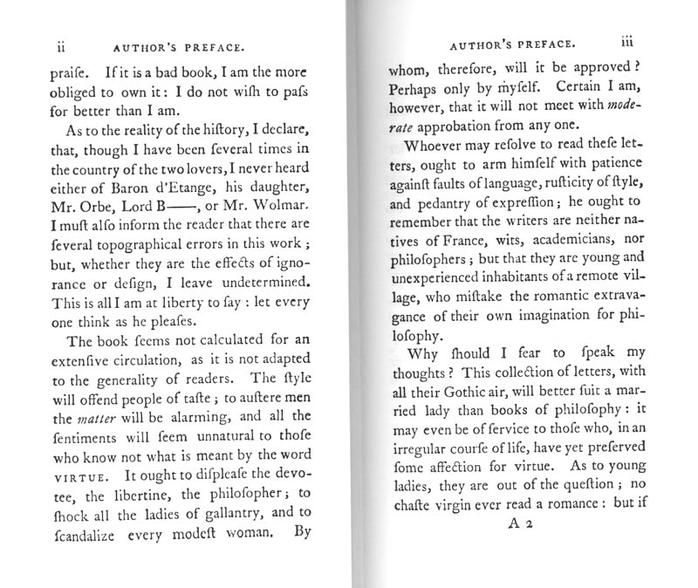
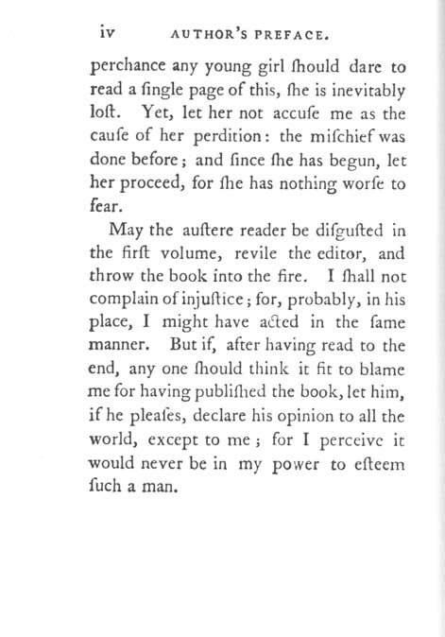

Rousseau “instructed his readers how to read him…”
-- Preface: lists all those who will be displeased by the novel; those who know nothing of virtue. That the virgin who reads it is already lost.
(Are you intrigued?)

From 2nd preface à

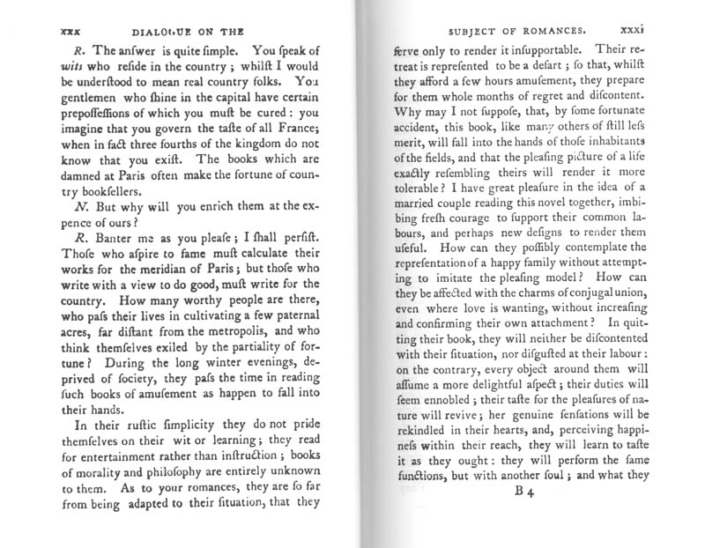

Darnton: that the Rousseau/Ransom example and that of Menocchio “suggest that reading and living, construing texts and making sense of life, were much more closely related in the early modern period than they are today” (157). Evidence?

Study “actual suicide notes, diaries, and letters to the editor. The correspondence of authors . . .” etc. (157)

Today? E.g., Trekkers; slash fiction, etc.
What other modern examples come to mind? – where reading shapes or determines living?

Research methods: macro and micro (158). Macro:
-- book catalogues, etc. Changes between times of:
Descartes (1596-1650); philosopher
Bougainville (1729-1811); traveller, circumnavigated the world 1766-69

Reading “fever” in Germany towards end of 18th C (159); and in all countries a decline in religious reading and increase in novels, also increase in travel books and natural history (160-1); by end of 19th Century 70-80% of books borrowed were light fiction (161). “the world of reading had been transformed” (161).

Gothic – cf. Northanger Abbey (begun 1798). Gothics à

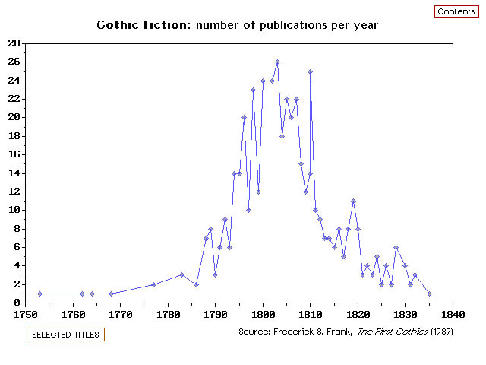
Microanalysis. Library lists of individuals; no Rousseau Social Contract (162).
Other methods of studying reading, such as notarial records, possibly not very accurate (162-3); subscription lists [example of Bourrit] (163-4);
lending lists from libraries, such as Wolfenbüttel, more illuminating, showing democratization of readers in the 1760s and shift towards fiction (164).

Bourrit, Marc Theodore. A Relation of a Journey to the Glaciers in the Dutchy of Savoy. Norwich R. Beatniffe, 1776; subscribers à

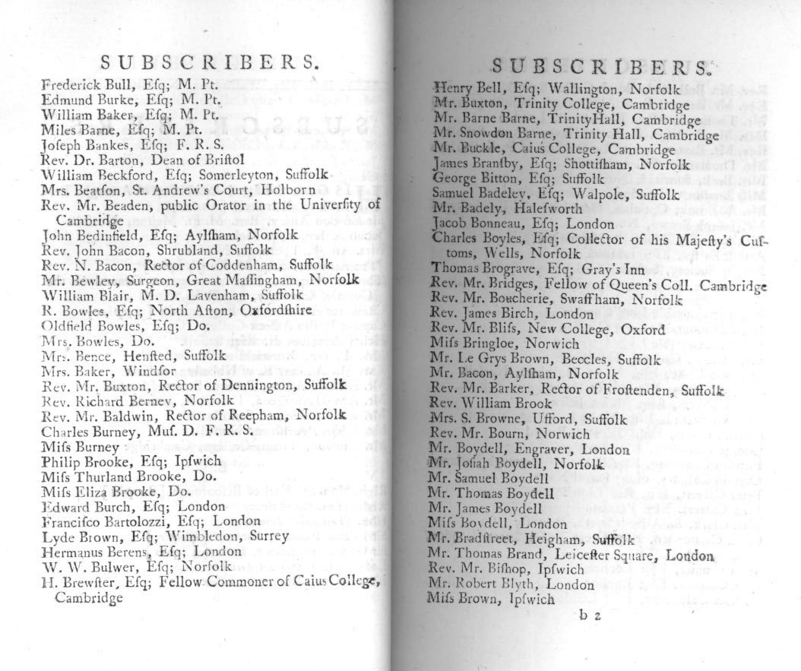

The reading “revolution” supposed to have occurred towards the end of the 18th C.: Engelsing (165); Darnton sceptical, as readers of Rousseau seem more intensive not less. But cf. David Hall on reading habits of New Englanders from 1600 to 1850, becoming extensive reading after 1800. (And see Wittmann, reading for February 28th)

“Perhaps a fundamental shift in the nature of reading took place at the end of the eighteenth century” (167).

The place of reading, importance of – from medieval library with chained books, to hiker with book in backpack (167). Pictures of readers show social history of reading, e.g., Fragonard “La Liseuse” (1770-72), etc. Reading a common social activity in early modern Europe (168).

Reading clubs, in France and Germany from early 18th C. Booksellers turned their stock into a library, provided quiet rooms, charged a subscription. Coffeehouses (169-70).

Bookshop: Rowlandson print à
(a satire on William Gilpin)
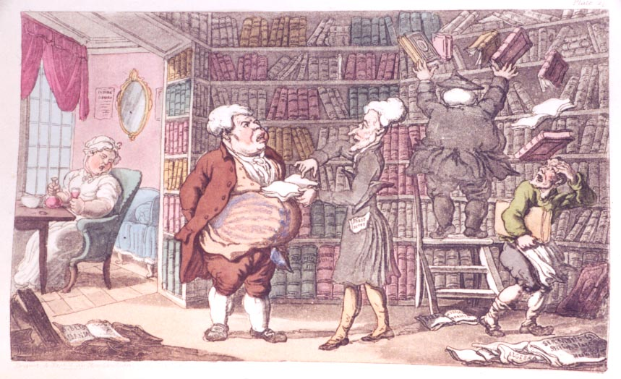

The Tour of Dr. Syntax in Search of the Picturesque (1809)

Lack of empirical work on what reading is, the how and why (171). Too much variance
[but study literary reading?]

[Last part of ppt. not shown.]

DSM/Jan 25 2012

