Geophysics 224 - 2006

Lab 2 – Gravity exploration - Two-dimensional modelling

1. Introduction

It is a useful exercise to study the gravitational effects of simple shapes such as spheres and cylinders. However, in interpreting real data, it is usually necessary to use 2-D and 3-D computer modelling. In this lab you will use a simple program to interpret some gravity data.

2. Chicxulub Impact Crater

The goal of this exercise is to find a density model that will reproduce the Bouguer anomaly data collected across the Chicxulub Impact Crater.

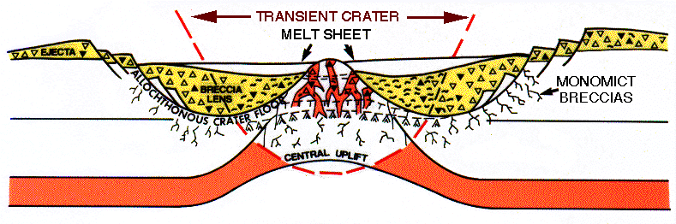
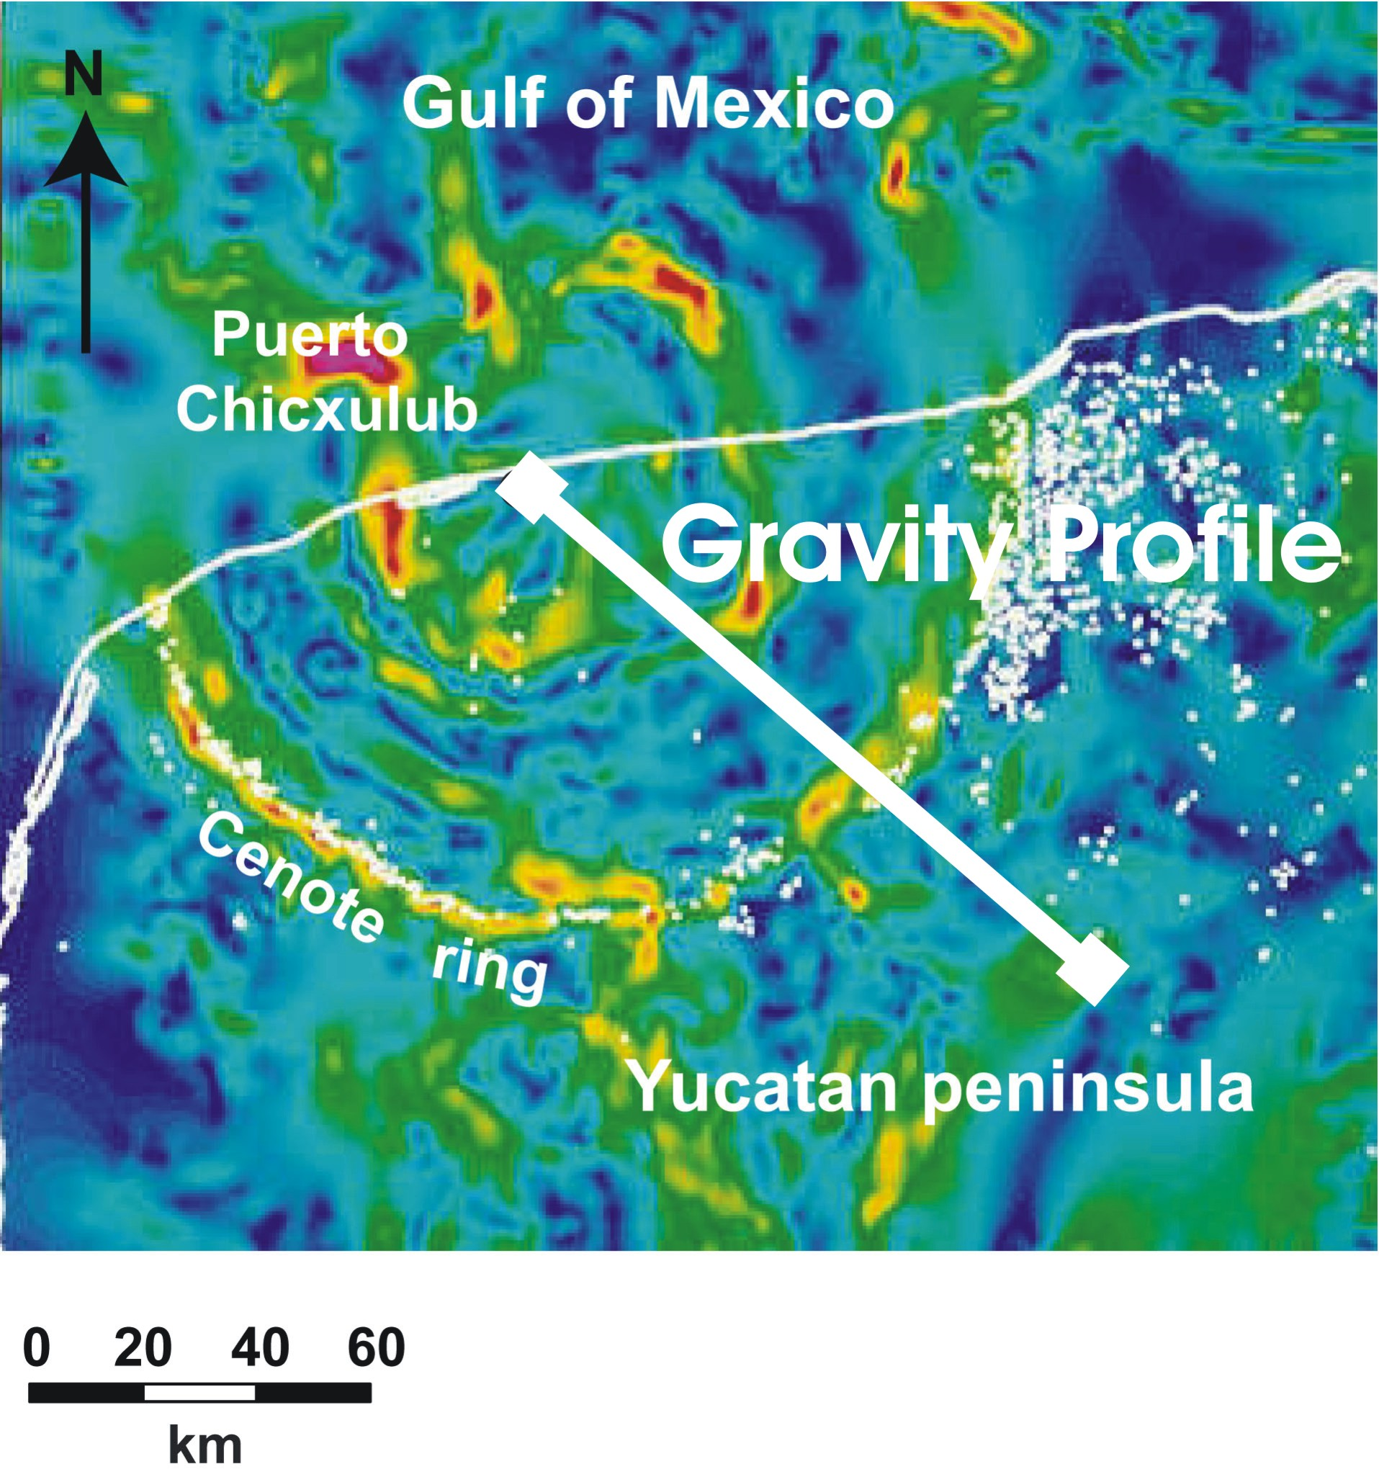
Gravity Profile
A low (negative) Bouguer anomaly is observed over the crater. This is due to lower density sedimentary rocks that were deposited after the impact. Thus the gravity data can tell us the depth of the basement rocks. The data begin at the centre of the crater and extend southeast.

The Bouguer anomaly data are listed in the file ImpactCrater.txt and the format is

distance (m) g_{B} (mgals) Error (mgals)
2e+005 650.85 2
2.5061e+005 643.38 2
3.0122e+005 636.95 2

The density model is defined in file ImpactCrater_mod.txt with the following format.

3200. Background density (kg m⁻³)
1 Number of polygons
2670. Density of first polygon
5 Number of corners
-200 0 Horizontal, vertical co-ordinates of corner (km)
-200 40
1650 40
1650 0
-200 0 The last point of each polygon has to be same as first point
Ersan will demonstrate the following steps at the beginning of the Lab at 2 pm

Using the gravity modeling program grav2006.m

- Download ZIP file from the class web page (filename is Lab2_Matlab5.zip)

- Extract files from ZIP file to c:/matlab5/work on your PC

- Start MATLAB by clicking on the MATLAB icon

- Type “grav2006” in the MATLAB window

- You can change the model by editing the locations of the corners of the polygons in the file ImpactCrater_mod.txt. You can use WORDPAD to do this.

- The first and last corner for the polygon are the same

- The polygon must be defined anti-clockwise.

- You will need to edit the model several times to fit the data. At each stage, look carefully at the measured data and the value predicted by the model.

If the predicted gravity is greater (more positive) than the measured gravity at a given station, then you will need to make the model less dense below that stations.

Conversely, if the predicted gravity is less (more negative) than the measured gravity at a given station, then you will need to make the model more dense below that station.

- Include a printout of your model and the data fit with your write up.

For the Chicxulub gravity data, try the following.

(2a) Draw a polygon to represent the low density rocks (2400 kg m⁻³) that now fill the crater. Use a background density 2800 kg m⁻³ and draw a polygon with density 2400 kg m⁻³ .

You’ll need at least 5-10 corners to get a reasonable fit. The upper surface of the polygon should be at z = 0 m.

How does the depth of basement rocks vary along the profile?

(2b) Repeat the exercise for a polygon with density of 2200 kg m^{-3.} Explain the differences between the two models.

3. Alberta Basin transect

The Geological Survey of Canada gravity data base covers the whole Canada with 660,000 data points. Free air and Bouguer correction have been applied to these data. In this example you will try to find a density model for a profile that crosses Alberta from NE to SW.
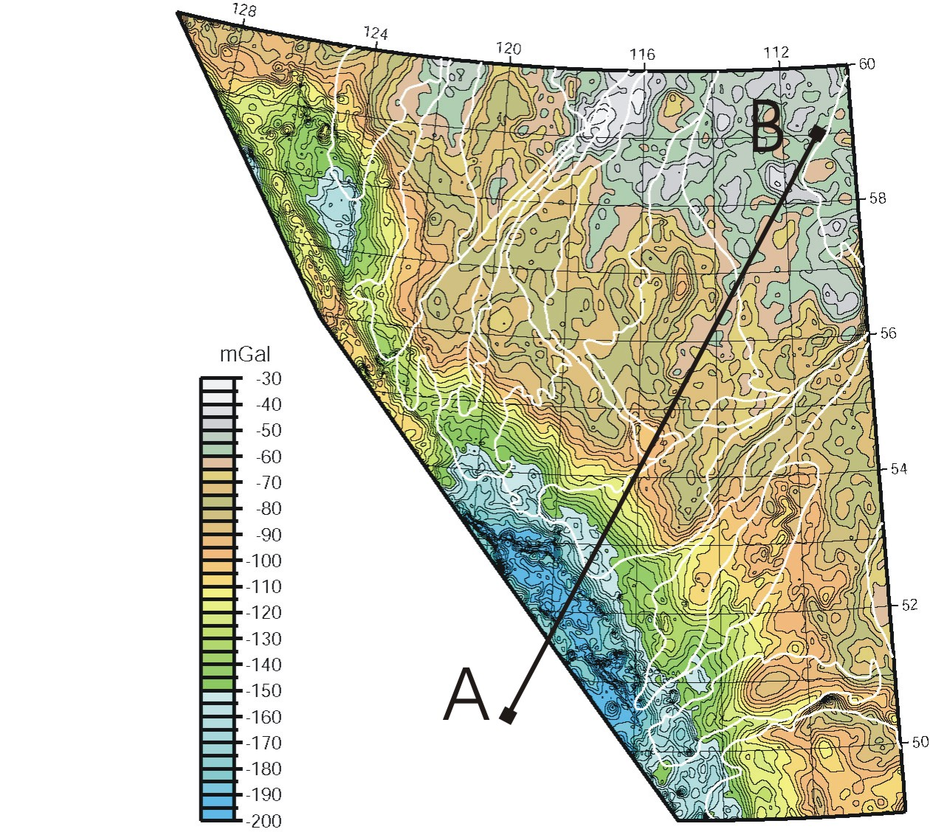

The Bouguer anomaly data are listed in the file alberta_bc_1.txt
Load the model file alberta_bc_1_mod.txt. This is plotted below and uses two polygons.

(1) Darker (upper) polygon shows a simplified sedimentary basin (2100 kg m⁻³)
(2) Lighter (lower) polygon shows the mantle (3200 kg m⁻³).

White background represents the crust (2670 kg m⁻³) and the Moho is at a depth of 35 km.

The Bouguer anomaly data decrease along the profile from B to A.

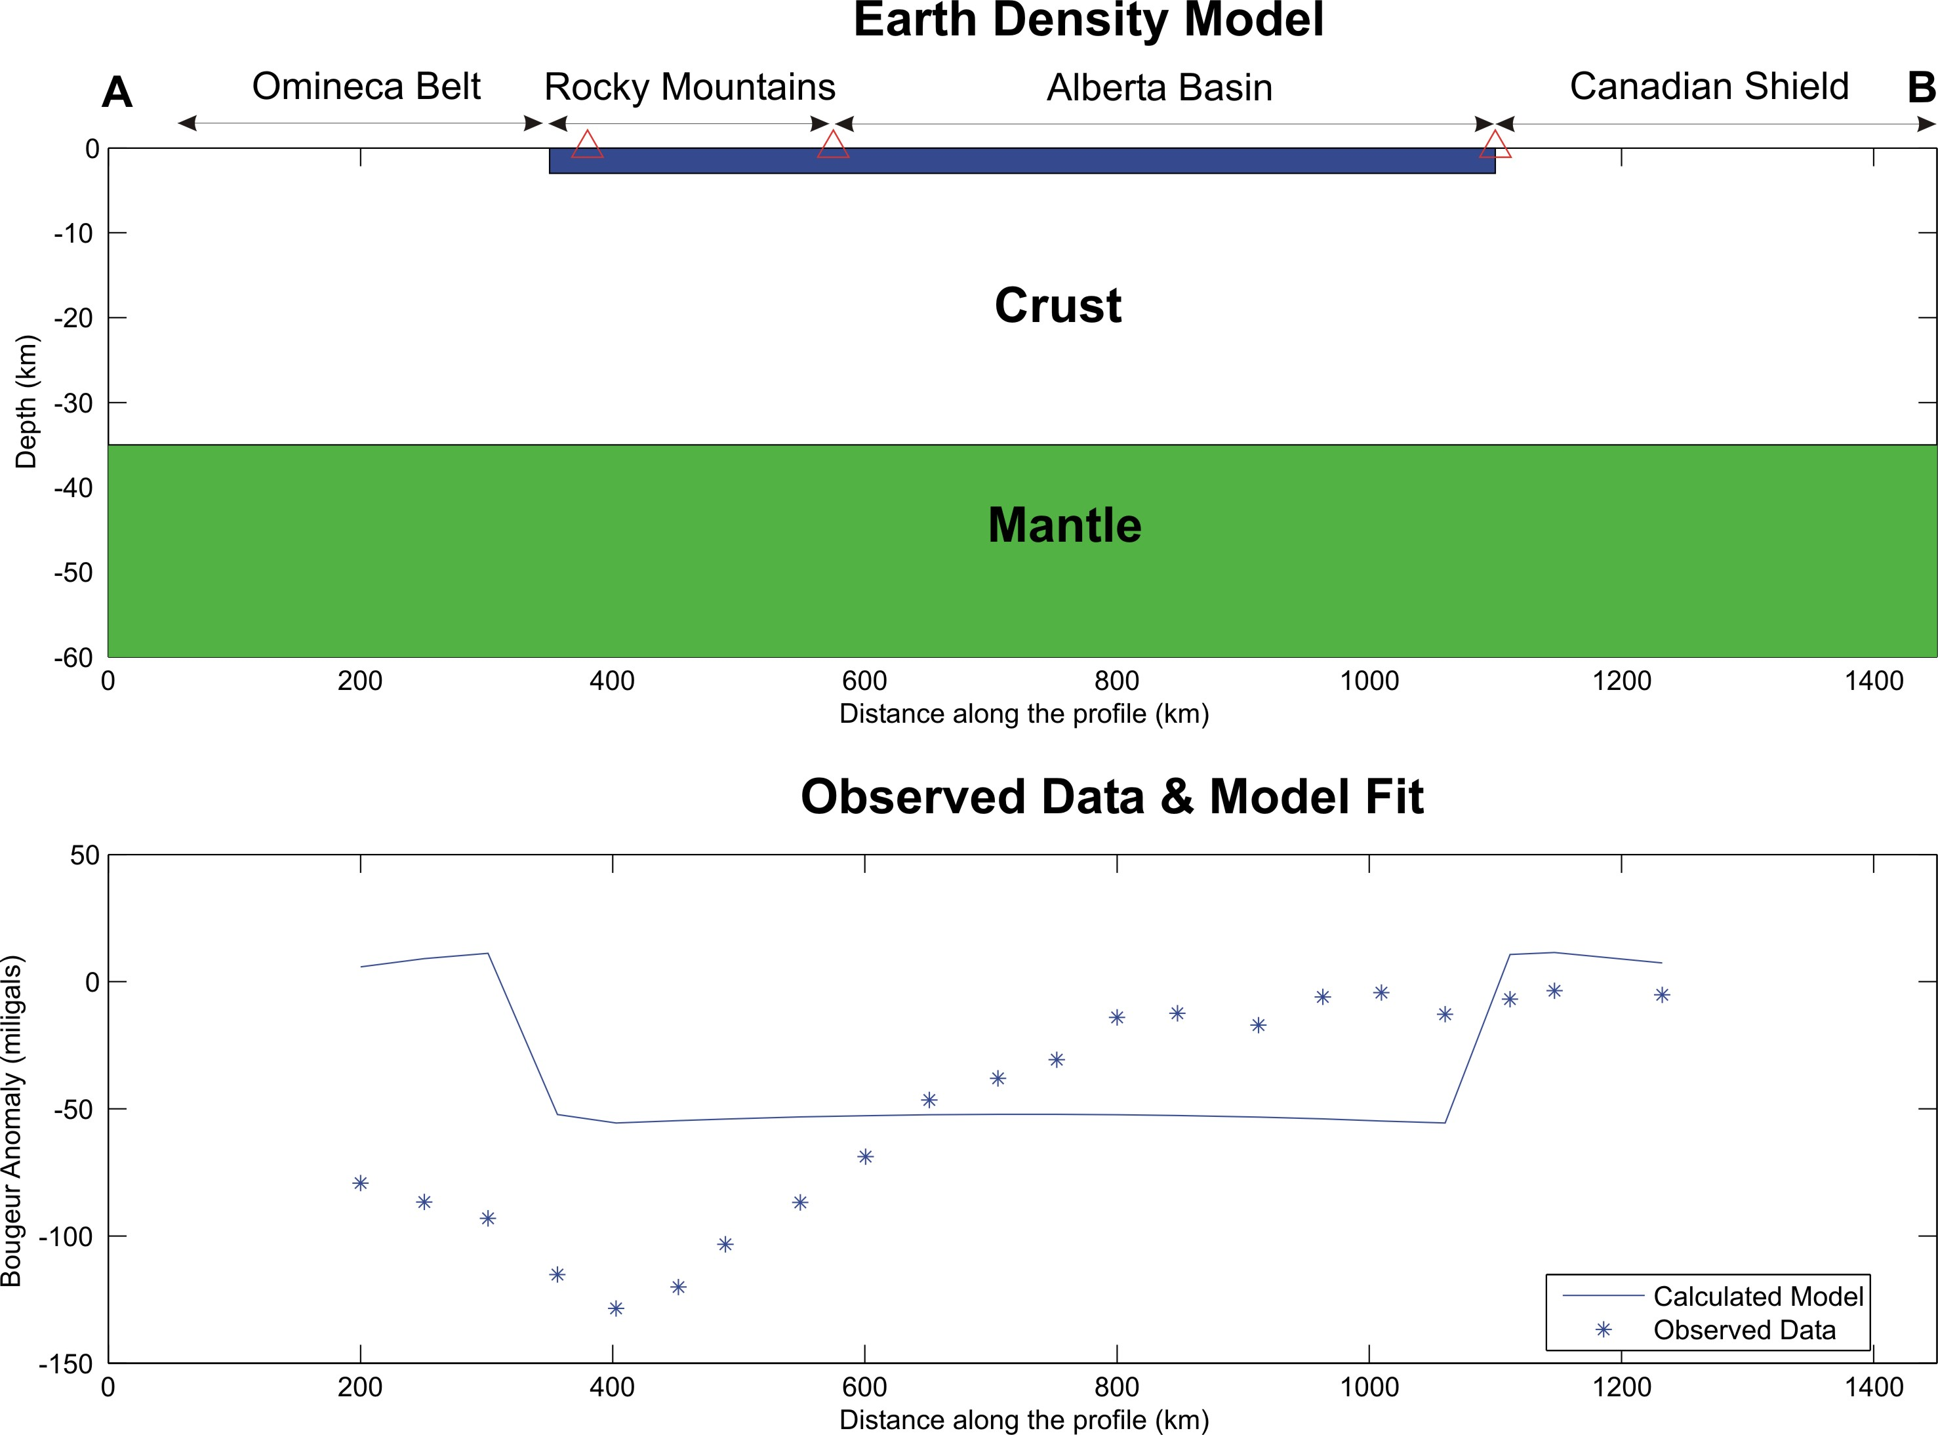
Note: Triangles on the plots represent from Left to Right (a) Rocky Mountain Trench, (b) Front Ranges and (c) NE edge of the sedimentary basin around Fort McMurray.

(3a) Load the model file alberta_bc_1_mod.txt. Edit this model and try to fit the observed gravity data by only changing the shape of the sedimentary basin.

You will need 5-10 points to fit the data.

Can you do this with the basin confined between the known edges mapped at the surface?

(3b) We know that the crust gets thicker beneath the Rocky Mountains. Load the model file named alberta_bc_2_mod.txt that has the approximate shape of the basin already drawn.

Try to fit the gravity data by changing both crustal thickness and the shape of the sedimentary basin.

(3c) Which model is more reasonable? Why? What can you say about the geometry of the crust in terms of isostacy?

