Geophysics 224
Lab 7 : Seismic Data Interpretation

March 29, 2006

INTRODUCTION

A large amount of the oil worldwide is found in foreland basins. Sedimentary rocks are folded and fractured by compression and structural, stratigraphic and mixed types of traps are formed. The figure below shows an example of structural trap in this type of basin in Russia. The main hydrocarbon accumulation is trapped in an elongated overthrust fold, with a thrust fault forming the edge of the trap in some sands. Smaller accumulations are found bellow the fault in the truncated formation.

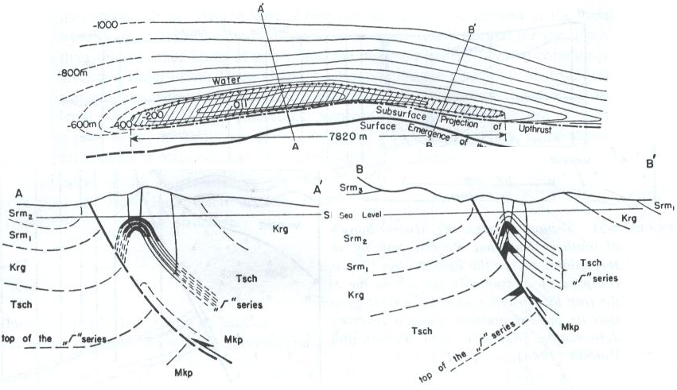
Modified from Levorsen 1967.

Seismic profiles and 3-D seismic surveys are carried out in prospect areas where hydrocarbon traps may be present. After acquisition and processing, a final seismic profile (in the 2D case) or data cube (in the 3D case) is obtained. Geophysicists and geologists interpret this data to develop a geologic model and propose exploitation schemes with help of engineers and other geoscientists.

Interpretation

The area we will study in this lab is in a fold and thrust belt in Wyoming formed during the Laramide orogeny. In 1945 the Conoco Unit #41 well was drilled at a location that was based on potential field methods and field geology. Oil traces were found in the Madison reservoir. The well was abandoned months later.

In 1980 a 2D seismic line was acquired in the same area. After extensive data processing that included:

[1] editing and muting
[2] CMP sorting and static corrections,
[3] CMP stacking,
[4] NMO correction,
[5] deconvolution and
[6] time migration,

A final zero offset profile was obtained. The density and velocity logs from the abandoned well were used to make a synthetic seismogram in order to tie the data. Also a vertical seismic profile (VSP) was also recorded. Based on this information, your task is to interpret this seismic line based on the markers identified in the well.

The ultimate goal is suggest new well locations.

To do this you should use the following steps:

- The figure shows the location of 8 markers in the Conoco Unit #41 well. Trace these 8 reflectors across the section. Note that they are offset by two major thrust faults. Identify the reflections on the section as well as the faults. To do this you should use erasable coloured pens on the transparencies. This will allow you to change your mind!

- What structures are imaged on this profile?

- Using the VSP information at Conoco Unit #41, convert to depth all markers at this well.

- What are the most likely areas where oil might be found? Propose new well location(s). How deep will we have to drill?

- What kind of seismic artifacts can be seen on the section?

- Summarize the assumptions made in your analysis.

VSP data at borehole Conoco #41:
z(m) | t(s)
500 | 0.15
1000 | 0.35
1500 | 0.45
2000 | 0.55
2500 | 0.75
3000 | 0.85
3500 | 1
4000 | 1.05
Good luck!

References:
LEVORSEN, A. geology of Petroleum. 1965.

