Geophysics 424 A1 Final exam

Electromagnetic and Potential field methods

Date : Friday December 12th 2003
Instructor : Dr. Martyn Unsworth
Time allowed : 3 hours

Total points = 100

Instructions

Attempt all three (3) questions.

Notes and books may not be used.

Calculators may be used. Cell phones, pagers, palm pilots and all other electronic devices must be switched off and stored.

All questions must be directed to the invigilator.

Maxwell’s equations (ignoring displacement current)

(1) 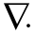E = ρ/ε Coulombs Law

(2) B = 0 Continuous magnetic flux.

(3) 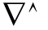B = μ J Ampère’s law (pre-Maxwell)

(4) E = - 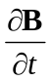 Faraday’s Law

E = electric field strength J = electric current density
B=magnetic flux density H = magnetic field strength
μ=magnetic permeability
B= μH μ = μ₀ = 4π x 10⁻⁷ H/m

Skin depth 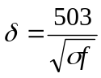
where f is the frequency in Hz and σ is the conductivity in S/m, δ is in metres

Question 1 : Applications of EM methods (Total points =36)

1(a) VLF (12 points)

The VLF method is used to detect basement conductors in the Canadian Shield.

Transmitter frequency = 20 KHz
Bedrock resistivity = 10,000 Ωm Target resistivity = 1 Ωm

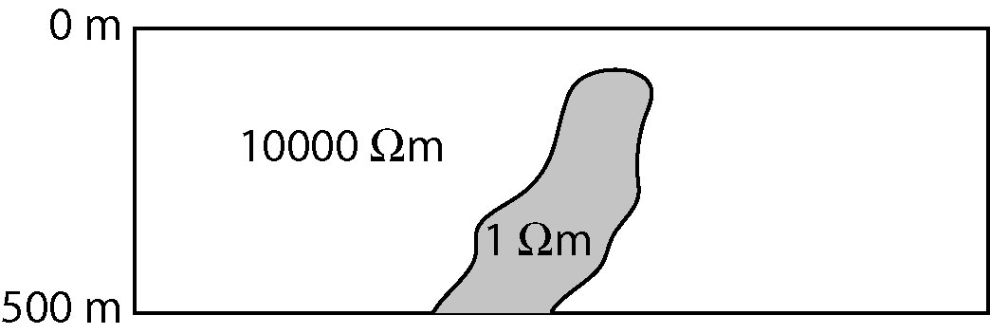

- Sketch the data that is measured in a ground based VLF survey (magnetic fields measured only)

- How is VLF data used to locate the horizontal position of the conductor?

- What is the maximum depth at which the target can be detected?

- What is the ideal orientation of the basement conductor and the EM fields of the transmitter?

1(b) Magnetotellurics (12 points)

MT data are being used to image a thrust fault that has placed carbonates (100 Ωm ) above the sedimentary rocks of a potential hydrocarbon reservoir (10 Ωm). You have an MT system that measures 1000-0.001 Hz.

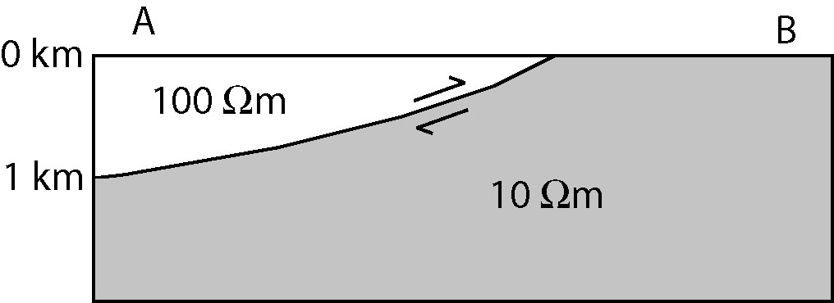

- Sketch the apparent resistivity and phase data at sites ‘A’ and ‘B’

- Explain how MT data tell us the depth of the underthrust 10 Ωm layer

- What is the maximum depth at which the 10 Ωm layer can be detected?

- Draw the geometry of field components for TE and TM modes.

1(c) Time domain electromagnetics (airborne) (12 points)

Time domain airborne EM measurements are used to locate massive sulphides.
The instrument measures the secondary voltage at 4 times after the primary field is switched off.



- Sketch the data recorded as the TX and RX are flown across the target.

- What controls the maximum depth of exploration?

- How are surface conductors distinguished from deeper conductors?

Question 2 : Maxwell’s Equations (Total points = 32)

A plane electromagnetic wave is travelling vertically downwards in the air in the z-direction. The wave has an angular frequency, ω, and the electric field is oriented in the x-direction. At this location, the surface of the Earth is at z = 0 and

Magnetic permeability of air and Earth = μ = μ₀ = 4π x 10⁻⁷ H/m
Dielectric permittivity of air and Earth = ε = ε₀ = 8.85 x10⁻¹² F/m
Electrical resistivity of Earth = ρ = 1/σ = 100 Ωm
Frequency of wave = 1 Hz

The incident wave in the air can be described by E_{x} (z,t) = A exp (-ik_{o}z) exp (-iωt)
the reflected wave in the air is given by E_{x} (z,t) = B exp (ik_{o}z) exp (-iωt)
and in the Earth the transmitted wave is E_{x} (z,t) = C exp (-k₁z) exp (-iωt)

where k_{o} = 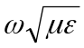 and k₁= (1-i) 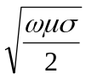

- Starting from Maxwell’s equation’s, show that 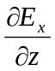= -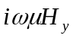
(5 points)

- Use the relevant boundary conditions to derive an expression for C in terms of k_{o}, k₁ and A. (10 points)

- Derive an expression for the impedance of the Earth,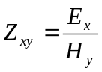 (5 points)

- The apparent resistivity is defined as 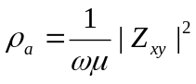.
Use your answer to show that in this case, that ρ_{a} = ρ (5 points)

(e) Use the equations listed above to derive the expression for the skin depth (δ)

(7 points)

Question 3 : Horizontal loop-loop EM measurements
(Total points = 32)

“A frequency domain, loop-loop EM system measures the mutual induction between the transmitter(TX) and the receiver(RX)”

- Explain this statement, including a definition of mutual induction. (4 points)

- How will a conductive ore body will be detected by such a system? (4 points)

- Relative movement of the TX and RX produces noise. How can this be explained on the basis of mutual induction? (3 points)

- The attached figure shows three basement conductors. A ground EM survey uses co-planar (horizontal) transmitter and receiver loops that are 20 m apart with a frequency of f =1060 Hz.

Sketch the in-phase and quadrature responses.
Be quantitative where possible.

The attached shows the characteristic curves for this geometry. Remember that the percentage value are for the maximum response when the TX and RX are above the target.

Response parameter Q = p = μωσWl Depth parameter, D = z / l

W = width of conductor, l = TX-RX separation,
σ = conductivity of conductor ω = TX frequency (rad /s)
z = depth to conductor

(15 points)
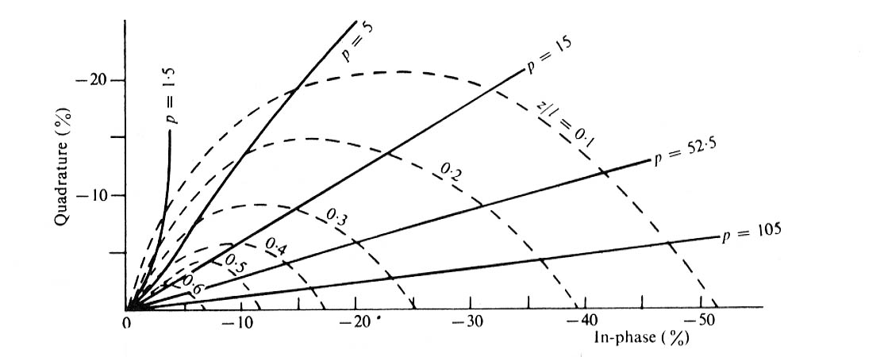

- The characteristic curves show that a good conductor gives a secondary field that is in-phase. Explain the physics of this observation.

A full mathematical analysis is not needed.
(6 points)



