Notes for video 2.3. http://tinyurl.com/rr480/videos/tableconcepts

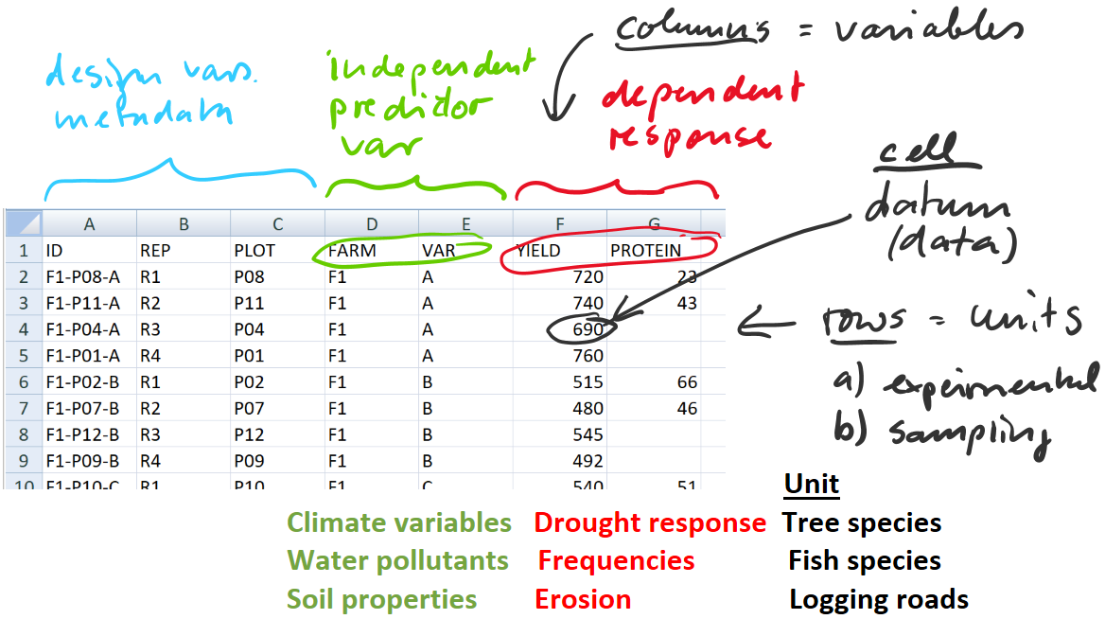

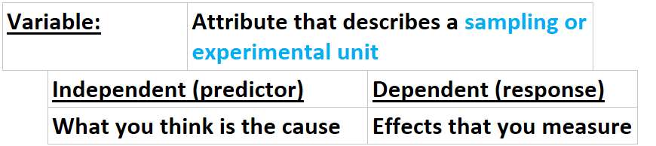
Experimental or sampling unit: | Individual, object, thing, location that you measure or study
Data: |  | Values of variables (what you measure or record)

