**Notes for video 5.3.:** <http://tinyurl.com/rr480/videos/history>







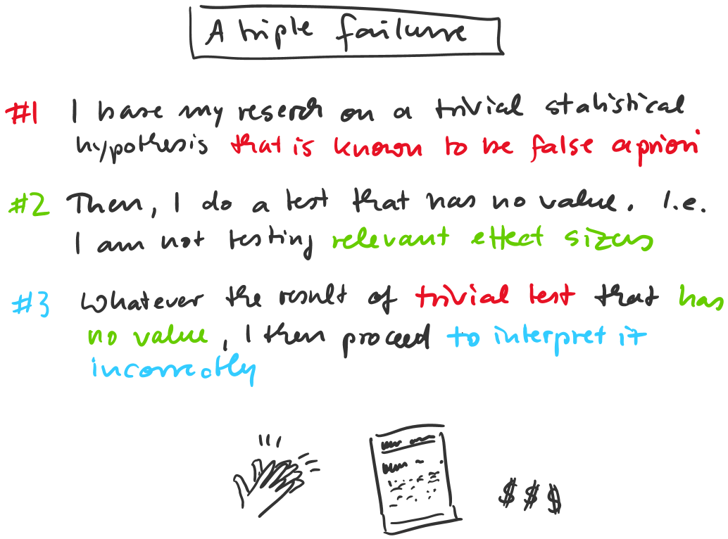

**Further reading:**

<http://tinyurl.com/y33ozm9p>

<http://tinyurl.com/y4p7olfh>

<https://tinyurl.com/nxkqtwk>