Anesthesiology Physician Wellness Enrollment
https://eclass-cpd.srv.ualberta.ca/course/view.php?id=727 and it will take you to the course enrolment page if you have a CCID. If you do not want to you your CCID (ualberta email) then you will need to create an account with an external email address.
Once you confirm your external email address, you will be able to search for the course.
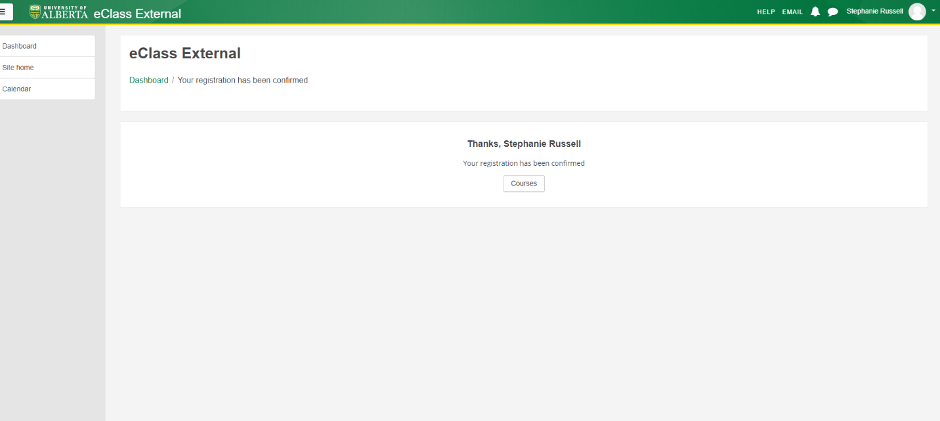
The course name is Anesthesiology Physician Wellness – using any part of the course name should bring it up
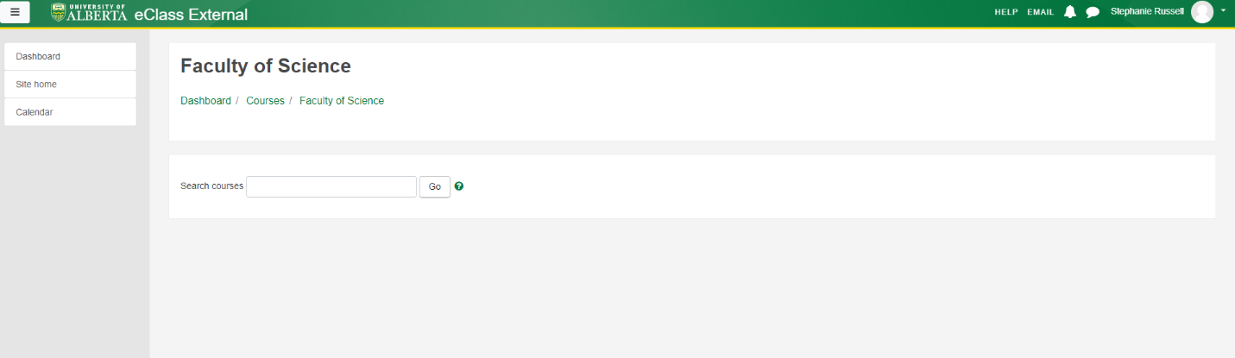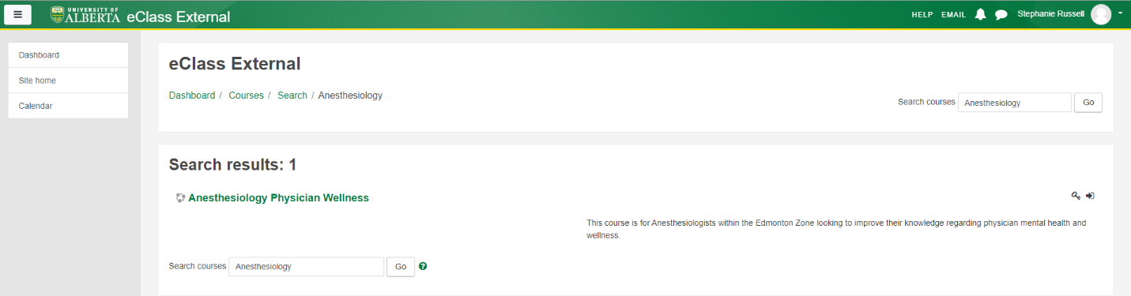

Once it brings up and course and you select it, you can enroll as a student.

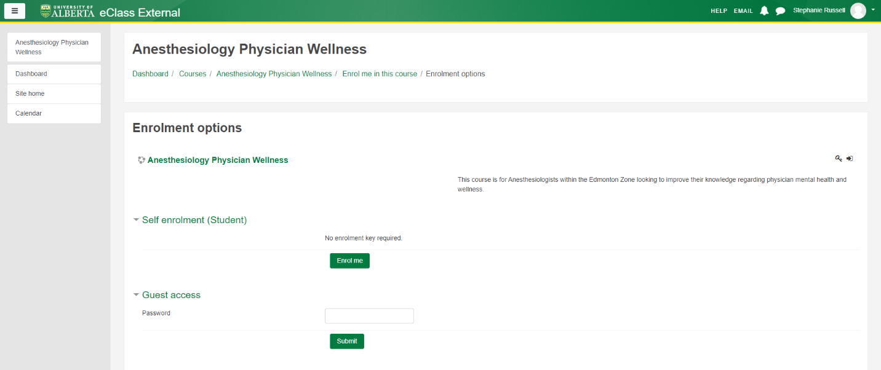
Once enrolled, it will bring you to the course dashboard.
