Submit completed application package to the Program Coordinator, Ms. Nicole Kosturic, via email at nkosturi@ualberta.ca, Office of Research before
Monday, February 19, 2024 (11:59 p.m.)
(A) STUDENT CV INFORMATION—to be completed by the student

Student name (LAST name, First name): | ID Number: | Class of 20__:
Home phone #: | Work phone #: | E-mail:

Undergraduate degree | Time frame | Department | Institution

Graduate degree: | Time frame: | Department: | Institution:
Title of thesis: |  | Supervisor:

Previous research if applicable—previous research is not required
Previous research experience (position): | Time frame: | Department: | Institution:
Title of project: |  | Supervisor:
Previous research experience (position): | Time frame: | Department: | Institution:
Title of Project: |  | Supervisor:

(B) PROPOSED RESEARCH PROJECT—to be completed by the student

Title of project: |  | Supervisor (must be UofA faculty member): | Department:
Research Option (A, B or C): | Expected defense date in Nov. of your 3rd or 4th year:

Proposed Research: To be written by the student in consultation with the supervisor. The proposed research must be novel, hypothesis-driven and be of sufficient depth to require 24 weeks of data collection/analysis. Any previous research done in this area by the student (if applicable) may be included as background rationale for this proposal but cannot be included as results in the final report. This section must not exceed specified limits. The proposal may be attached separately with single spaced, 1” margins, 12-font formatting.

(1) Background introduction and rationale (~2 paragraphs, maximum 400 words):

(2) Hypothesis (maximum 2 sentences):

(3) Methods (~1 page, maximum 600 words):
For clinical projects describe study design, inclusion/exclusion criteria, data collection, statistical analysis (including power calculation) and expected outcomes. If the project involves patient recruitment or biospecimen accrual, include a feasibility assessment. Eg. “We will recruit x number of patients. We have y patients every week in our clinic and we can meet our target in z weeks. Our mitigation strategy is….”

For Biomedical research projects include methodology, data analysis, statistical analysis and expected outcomes.

(4) Integration into supervisor’s research activities (1 paragraph, maximum 150 words):
Describe how your project is linked to your supervisor’s research program.

(5) Role of student (1 paragraph, maximum 150 words): Often student projects are embedded within larger team projects. When this is the case, describe your specific activities and describe what parts of the project will be conducted by others.

(6) References (unlimited):

(C) SUPERVISOR CV INFORMATION—to be completed by the supervisor

- Supervisors can only submit one student application per cycle.
- Supervisors must have an A1.1 or C1.1 primary faculty appointment at the University of Alberta as defined by https://policiesonline.ualberta.ca/PoliciesProcedures/Procedures/Recruitment-Policy-Appendix-A-Definition-and-Categories-of-Academic-Staff-Administrators-and-Colleagues.pdf).
- Supervisors will provide continuous supervision and mentorship and have sufficient operating funds to support the proposed research.
- Supervisors ensure that the student applies for external scholarship support for research conducted in the summer months. Supervisors are willing to provide direct student stipend support for summer research in the event that the student is unsuccessful in obtaining external scholarship support.

Supervisor name (LAST, First): | Degree: | UofA Department:
Academic Position: | Work phone #: | E-mail:

List of grant support (past 5 years):

Publications (most relevant 3 papers from past 5 years):

Trainees (most relevant 3 trainees from past 5 years): Indicate primary/co-supervision, undergraduate/graduate/post-graduate, trainee outputs (e.g. publications/abstracts):

Training Environment and mentorship plan: Describe the training environment and the benefits to the student. Specifically, describe your mentorship plan.

Supervision details: What arrangements are there for supervision by the supervisor in person? If supervisor’s lab members are involved in the day-to-day supervision of the student, please indicate the name and position of the responsible lab member. Supervisors can only submit one student application per cycle.

MD/Special Training in Research (STIR) Program Requirements: The MD/STIR program requires 24 weeks of research to be conducted full-time in the summers (Option A) or a combination of summer and academic year (Options B or C). Indicate the research option timeline for this application.
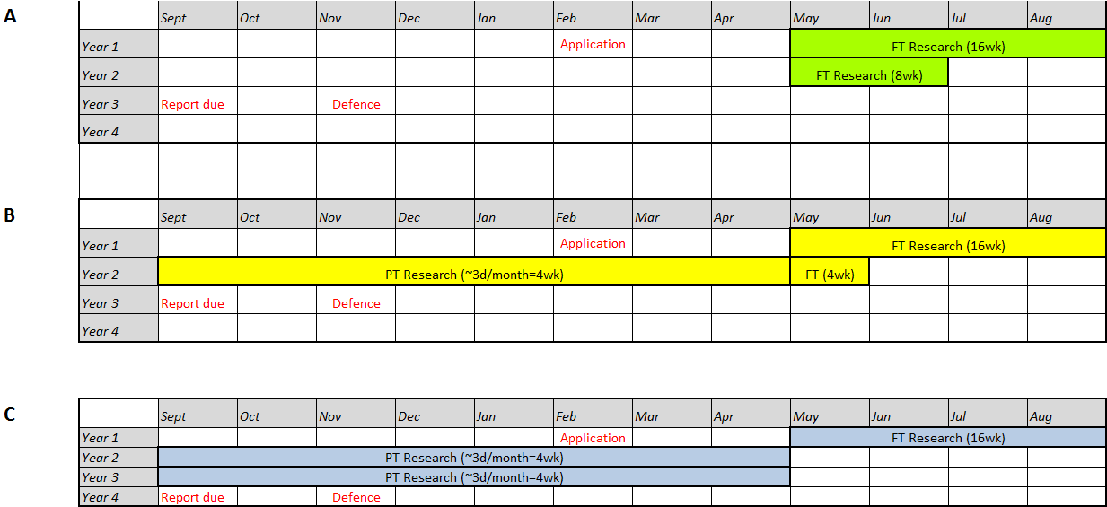
This student will be following Research Option A, B or C: _______

Summer stipend support: The Supervisor must ensure the student is supported by a stipend for research conducted in the summer. All students must apply to an Alberta Innovates summer studentship award. The Supervisor must arrange financial support if the student is unsuccessful in obtaining a scholarship.
This student has applied to Alberta Innovates summer studentship competition
Yes or No (if No, reason must be given):

If yes, indicate date submitted:
Supervisor must indicate source of student summer stipend support if student is unsuccessful in securing any studentship awards.

Ethics Approval. The supervisor is responsible for acquiring/maintaining ethics approval for this project. The student must ensure that ethics approval documentation is attached to this application.
Indicate “yes” or “no” if the project requires:
Human ethics:
Animal ethics:
Biohazards:
If YES to any of the above, a copy of the ethics approval or proof of application to ethics MUST be attached. If ethics is pending, then proof must be provided prior to starting the project. The student applicant will not be accepted into the program until all ethics approval is received.

(D) SIGNATURES

The Student Applicant understands that successful completion of the MD Special Training in Research Program requires:
- Maintenance of good academic standing throughout the MD Program.
- Proof of ethics approval for studies involving animal or human subjects (MUST accompany the application).
- Twenty-four (24) weeks of hypothesis-driven research to be conducted by Option A, B or C as indicated in the application.
- At least one oral presentation to be arranged in consultation with the supervisor at any time prior to the final defense (lab meeting, research group meeting, etc.).
- One presentation at the MD-STIR Journal Club, during the first summer. Presentation dates will be scheduled by the Office of Research FoMD.
- One informal oral presentation (“3-minute pitch) during the first summer. Presentation dates will be scheduled by the Office of Research, FoMD.
- Submission of Midterm report form to the Office of Research, FoMD by July 1 of the first summer (form available on website). This is a firm deadline after this date no reports will be accepted.
- Poster presentation at FoMD Summer Student Research Day in the fall after the first summer, or at another research meeting that requires submission of a written abstract and has been approved by the Chair of the Research Committee.
- Submission of a final report to the MD Research Committee on the last Monday in September in the relevant year. This is a firm deadline after this date no final reports will be accepted.
- Supervisor submission of a confidential student evaluation directly to the Office of Research, FoMD (form available on website).
- An oral presentation to be given to the MD Research Committee in the relevant year as scheduled by the Office of Research, FoMD. It is mandatory for the supervisor to attend the final oral defense. If unable to attend, will have to send a delegate on their behalf.
- Oral defense to the MD Research Committee and demonstration of understanding of the basis and selection of methodologies, the interpretation of results and impact of any findings.
- An exit interview will be organized for the students by the Office of Research, FoMD, the day following the final oral presentation.
- Failure to comply with above requirements may result in termination of the Program.

My signature verifies that I have read and understand the requirements and expectations of the MD with Special Training In Research Program.

Signature of MD STIR Applicant: Date:

The supervisor has read the requirements listed above and agrees to participate and mentor the named student in the MD/STIR program. The supervisor will directly supervise the student and/or has named a designate to supervise the student. The supervisor and student have made arrangements for financial support for the summer months.

My signature verifies that I have read and understand the requirements and expectations of the MD with Special Training in Research Program.

Signature of Supervisor: Date:

Protection of Privacy: - The personal information requested on this form is collected under the authority of Section 33 (c) of the Alberta Freedom of Information and Protection of Privacy Act and will be protected under Part 2 of that Act. It will be used for the purpose of admission into the MD with STIR program. Direct any questions about this collection to: Nicole Kosturic, Program Coordinator, Faculty of Medicine & Dentistry, Office of Research, via email at nkosturi@ualberta.ca; phone 780.492.8365.

