

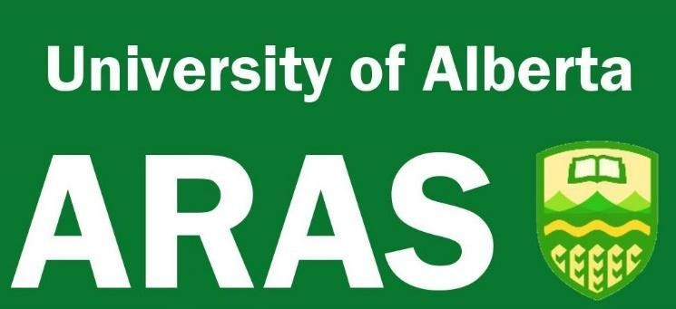

The Association of Professors Emeriti (APE) was established in 1986 and became the Association of Retired Academic Staff (ARAS) in 2021.

WHO CAN JOIN?
All categories of staff represented by the Association of Academic Staff: University of Alberta are eligible for membership. Additionally, other academic employees not represented by AASUA are welcomed to membership. These include former Presidents, Vice-Presidents, Deans, management and professional staff, adjunct faculty, and other academic colleagues not paid by the University of Alberta. Spouses/companions of members are welcome to attend all activities of the Association and can continue membership after a member's death. We welcome inquiries from current retirees, those in the process of phasing out, as well as those contemplating retirement in the not-too-distant future and encourage them to join us.

WHAT GOES ON IN ARAS?
Aside from the good fellowship one finds in associating with one’s retired colleagues, the primary activities of members are found in the operation of Special Interest Groups which meet monthly. During the year from Fall to Spring, the active groups are Current Affairs, Travel, and Book Club. The Dining Out group meets monthly year-round, with members taking turns suggesting a dinner at a favourite restaurant. New interest groups are formed when there is sufficient interest among the members.
Each month, from Fall through Spring, there is a monthly “Lunch With…” presentation featuring an invited speaker talking on any one of a range of stimulating topics. Then, in mid December ARAS organizes its Annual Christmas Brunch at the University Club which brings together the membership in an often noisy and good- humoured meeting of minds.

WHAT ELSE DO WE OFFER OUR MEMBERS?
Our office is located in Room 6-30 at University Terrace (8303 112 Street). We have access to meeting rooms where our interest groups and the Executive Committee can hold their meetings. Once or twice a week the Association’s Office Assistant is on site helping to satisfy members’ communications needs.
Members are informed of the Association’s activities through a weekly Newsletter sent as Email. They also receive Epilogue, the Association’s quarterly newsletter, which describes upcoming events and contains articles on a variety of topics of general interest.

WANT TO MAINTAIN CONTACT?
ARAS is an active contributing member to the College and University Retiree Associations of Canada (CURAC) which is a national organization dedicated to the welfare of retired academics and their families. ARAS also has observer status on the Council of the AASUA, keeping an active watch on developments of interest at the University of Alberta.

WHAT DOES IT COST?
The annual membership fee is currently $30.00 for individuals residing in Edmonton and its vicinity, and $10 for those living outside that area. New members are free for the first year.

INTERESTED?
Please visit our website:

https://www.ualberta.ca/association-retired-academic-staff

There you will find an online sign-up form. Membership fees can be made via e-transfer to our email: emirhse@ualberta.ca
You can also sign up using our printable form and mailing in a cheque made payable to “Association of Retired Academic Staff”. Payments received after June 1st will be credited to the following calendar year.
CONTACT
