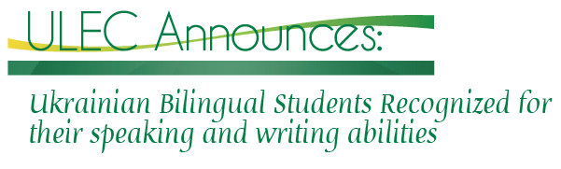
Alberta Graduates of Ukrainian Bilingual Program Qualify for University
Studies in Ukraine

21 January 2015—The knowledge of foreign languages is considered a great asset for effective business, political relations, educational advancement, and cultural heritage. In Alberta, many students now have the opportunity to take language exams set by foreign countries or institutions including those in China, France, Germany, Japan, Spain, and Ukraine. Thanks to the efforts of Alberta educators, the Ukrainian Language Entrance Exam for International Students has been offered to students in grades 11 and 12 of Alberta’s Ukrainian Bilingual Program (UBP) since 2006.
In 2014, twenty Alberta students took the exam, and almost all received a score well over 60%. The students study in three school districts, in which the UBP is offered—Edmonton Public Schools (M. E. Lazerte High School), Edmonton Catholic Schools (Austin O’Brien High School), and Elk Island Catholic Schools (Archbishop Jordan High School).
The exam is designed to measure students’ language competency in other than a school setting, provide students an international credential for their course of studies, encourage them to take pride in the growth of their language development, and increase the attractiveness and enrollment in the UBP. Upon high school graduation, students with a score of 80% or higher are considered adequately prepared to attend university courses in Ukraine, while those with a 60‒80% mark would be accepted but required to continue language learning.
The exam was developed in accordance with the Common European Framework of Reference (CEFR) for Languages at the B1 level (CEFR consists of six levels: A1, A2, B1, B2, C1, and C2). It is conducted in both a group and one-on-one setting. The written part, taken in a group setting over a one hour time period, focuses on the assessment of vocabulary and grammar, writing, reading and listening skills. The individual oral component consists of an oral presentation and interview, thus revealing students’ oral competency in different settings. Ms. Olena Hartsula, Ukraine’s language and culture advisor to Alberta Education, has conducted the oral assessment for the past two years.
The Ukrainian Language Entrance Exam for International Students is the achievement of an ongoing collaboration between educational institutions in Alberta and Ukraine. The exam is developed by the Preparatory School for International Students at the Ivan Franko National University of Lviv (PSIS) which provides a detailed analysis of exam results including a documentation of achievements and weaknesses, and suggestions as to how to improve participants’ language skills. In his response to the recent exam, PSIS director Dr. Viktor Krevs noted that “the results of the exam proved the suitable level of teaching Ukrainian at Alberta schools and the high motivation of students to learn Ukrainian.”
The staff of the Ukrainian Language Education Centre (Olenka Bilash, Alla Nedashkivska, Mykola Soroka, and Halyna Klid) provides institutional support by coordinating and promoting the exam while parents and community organizations provide funding for the exam.
The students who passed the exam were awarded certificates by PSIS confirming their level of language competency. Melody Kostiuk, international language consultant and curriculum and resource support for Edmonton Public Schools, after attending the award ceremony pointed out how beneficial this exam is for students’ future: “The exam provides the attestation of students’ Ukrainian language proficiency which can provide them with opportunities to work, study or live in Ukraine and can be used to enrich a résumé.”
Among other educators who helped prepare students and organize the exam were: teachers from the UBP—Stephanie Dowson, Daria Porochiwnyk, Peter Zmewsky, and Vlodko Boychuk; and international language consultants Magdalena Tundak and Laurie Kardynal-Bahri from the Edmonton Catholic Schools and Elk Island Catholic Schools respectively.
Photos: (1) Nicholas Galech and Stefania Kostiuk, M. E Lazerte High School graduates, receiving their certificates during the award ceremony at the school; (2) The PSIS team: Vira Kovalenko and Viktor Krevs, director.

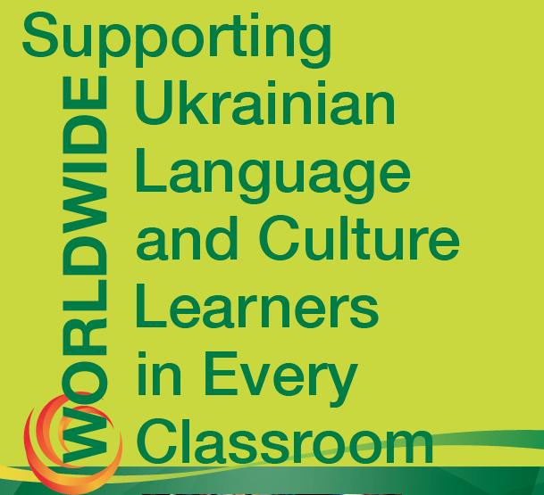
The Ukrainian Language Education Centre promotes and develops Ukrainian language education in Canada and abroad by: supporting bilingual programs and professional development of Ukrainian-language teachers and instructors; creating learning and teaching resources at both the secondary and post-secondary levels; conducting research on topics related to Ukrainian-language education and related fields; and fostering international links and community engagement. If you would like more information on the Centre, please visit our website, facebook page or contact us by email.
Методичний центр української мови сприяє розвитку україномовної освіти в Канаді й за кордоном шляхом підтримки двомовних програм і підвищення професійного рівня учителів української мови, створення навчальних і методичних матеріялів для середньої і вищої освіти, проведення досліджень на теми україномовної освіти і суміжних ділянок, а також плекання міжнародніх зв’язків і громадської підтримки. Детальнішу інформацію про центр можна знайти на веб-сторінці, сторінці фейсбуку або через е-пошту.

