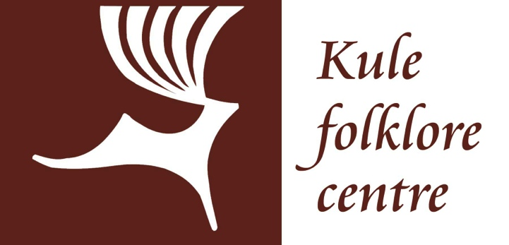

Director’s Report
for the
Kule Folklore Centre
(Peter and Doris Kule Centre for Ukrainian and Canadian Folklore)
University of Alberta

KuFC Meeting of the Board of Directors
May 9, 2017

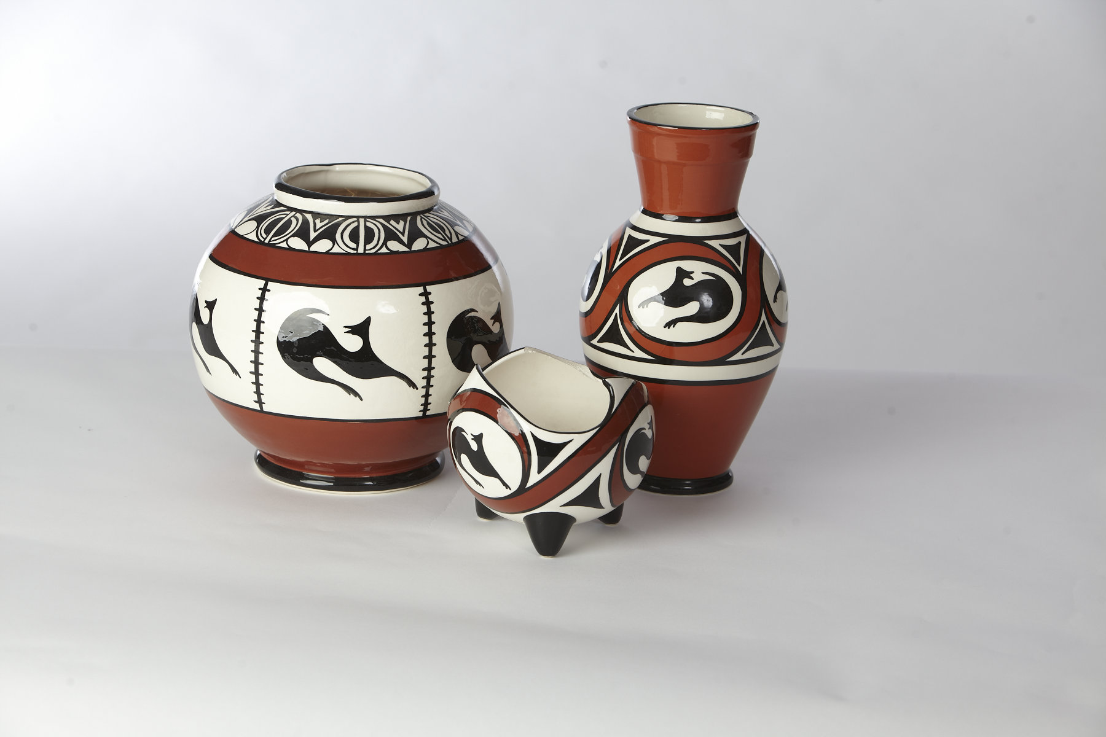

Executive Report:

The Peter and Doris Kule Centre for Ukrainian and Canadian Folklore (KuFC) is a unique research unit in the University of Alberta. It is one of the premier institutions for the study of Ukrainian culture outside of Ukraine and has forged strong links with folklore and ethnographic institutions across Canada, Ukraine and other parts of the world. The Centre houses the Bohdan Medwidsky Ukrainian Folklore Archives (BMUFA) is the largest North American repository of Ukrainian and Canadian-Ukrainian folklore materials. It provides many services for the Ukrainian Canadian community of Alberta and beyond. The KuFC operates with eight endowments, which produce an annual spending allocation of approximately $383,000. The Centre was formalized in 2001 and received its current name in 2006, though it is based upon endowments and archives existing since the 1980s. The KuFC has expanded over the years, with important new endowments and an enlarged mandate to engage with Canadian folklore as well as its core mandate to study Ukrainian folklore.

Faculty associated with the KuFC include Natalie Kononenko (Kule Chair in Ukrainian Ethnography), Andriy Nahachewsky (Huculak Chair of Ukrainian Culture and Ethnography), Jelena Pogosjan (Director of the KuFC), and Micah True (professor in French and Canadian folklore). Bohdan Medwidsky is a Professor Emeritus, founder of the folklore program, and remains very active in the Centre’s life.

2016-2017 was a pivotal year at the KuFC as we said goodbye to our long term Director, Andriy Nahachewsky and welcomed a new Director, Jelena Pogosjan. Our Archival Assistant, Maryna Chernyavska became the Bohdan Medwidsky Ukrainian Folklore Archives’ full-fledged Archivist – a promotion well deserved. Larisa Sembaliuk Cheladyn was hired as a temporary Community Liaison. Lynnien Pawluk continues to serve as the Administrator of the Centre. The Centre went through an extensive faculty review where it came out very favourably. In 2016, the Centre became an independent research unit within the Faculty of Arts – it is no longer associated with the Department of Modern Languages and Cultural Studies (MLCS), but reports to the Faculty of Arts and enjoys support of the Arts Collaboration Enterprise. The KuFC receives infrastructure support from the MLCS, connected to it with obligations from gift agreements. Staff, the Archives, scholarships and projects are funded through the Centre’s own endowment resources and grants.

The Centre:

- conducts research in Ukrainian and Canadian folklore;
- grows and maintains the Bohdan Medwidsky Ukrainian Folklore Archives;
- supports researchers and students with scholarships and awards;
- supports undergraduate and graduate courses in Ukrainian folklore and vernacular culture;
- engages with diverse communities through publications, exhibits, lectures, workshops and more.

Organizational Chart and Endowments for the Kule Folklore Centre
As of 1 April 2017
Ukr. Folklore Program Development Fund (1985)
Kuryliw Family Scholarship Fund (1987)
Bohdan Medwidsky Ukrainian Folklore Archives (1989)
Huculak Chair of Ukrainian Culture and Ethnography
Kule Folklore Centre Endowment
(2006, Ukr+Cdn)
Kule Chair
Endowment (2003)
Kule Fellowship Fund
(2006, Ukr+Cdn)
Kawulych Family Endowment (2007)
Ukrainian Pioneers Endowment (2008)
Future endowments
Kule Chair
of Ukrainian Ethnography
50%
Professor in French and Canadian Folklore
General operations
$85K/yr
Huculak Chair, operations, scholarships, projects
$107.4K/yr
Kule Chair, KuFC admin, archivist, scholarships, projects
$97K/yr
Assistantships; Scholarships
$35K/yr
Assistantships; Scholarships;
Post-doc
$35K/yr
Scholarships
$3.3K/yr
Archivist; archives
$12.2K/yr
Projects in Alberta
$3.3K/yr
Combined endowment
book value: $8,625,428

Operations
University of Alberta
Arts
Collaborative
Enterprise
Friends of the Ukrainian Folklore Centre
KuFC Board

Community Liaison
Faculty of Arts
Kule Folklore Centre
(Peter and Doris Kule Centre
for Ukrainian and Canadian Folklore)
Director
Andriy Nahachewsky, Director until June 30, 2016:

Archivist

Coordinator
Endowed Chairs
Awards,
Scholarships, Fellowships
Projects

Dr. Nahachewsky served at the Director of KuFC from its inception 15 years ago to the end of June 2016. He occupies the Huculak Chair of Ukrainian Culture and Ethnography (since 1990).

Dr. Nahachewsky graduated cum laude with a BA in Ukrainian Studies from the University of Saskatchewan in 1979, then studied for one year at the Oleksandr Korniichuk Institute of Culture in Kyiv in 1980. He completed a BFA in Dance in 1982 from York University and his MA in Ukrainian Folklore from the U of A in 1985. He studied at the Centre for Dance Studies in the United Kingdom in 1988, and received his PhD in Ukrainian Folklore from the U of A in 1991.
Nahachewsky has some 50 publications to his credit including contributions to Ethnographica, Athens; Studia Musicologica, Budapest; Rodovid, Kyiv; Dance Research Journal, New York; and Journal of American Folklore. He has been very active as a performer, teacher, critic and choreographer of Ukrainian dance.
Dr. Nahachewsky's research focuses on ethnic dance, folk arts, and Ukrainian Canadian culture and ethnic identity. He currently is on sabbatical and will return in July 2017 as a professor in the Department of Modern Languages and Cultural Studies.
In his last fiscal term as Director from April 1, 2016 to June 30, 2016 Dr. Nahachewsky:
- prepared the KuFC for the Arts Faculty Review of the Centre and received the Review Committee’s Final Report. The Review highlighted many strengths of the KuFC, including an international reputation for excellence in Ukrainian Folklore research and unique archival resources. The committee noted the uniformly positive feedback it heard from community members, donors, and scholars; including one leading folklorist who described KuFC as the “best centre for the study of Ukrainian folklore and allied areas of interest outside of Ukraine”. Eight recommendations were made by the committee designed to ensure the continued success of KuFC under the terms of good academic governance and strategic management.
- assisted the administrative collaborative transition of KuFC from under MLCS to the Faculty of Arts.
- oversaw four graduate students who received graduate degrees with the specialization “Ukrainian Folklore”. Larisa Sembaliuk Cheldayn, Kateryna Kod, and Nataliya Bezborodova received their MAs in Ukrainian Folklore and Jiaying You received a joint PhD in Folklore and Anthropology. A fifth student, Vita Yakovlyeva, co-supervised by Dr. Nahachewsky, wrote a Ukrainian ethnographic dissertation in Anthropology.
- oversaw, along with the KuFC team, six research workers complete a myriad of archival initiatives – cataloguing and inventorying - in the Bohdan Medwidsky Ukrainian Folklore Archives (BMUFA). As no graduate students with a specialization in folklore studies had been accepted into the last two cycles of MLCS Graduate programming, researchers were hired to continue the progress of critical projects in BMUFA.
- worked closely with the Archivist Maryna Chernyavska in the continuing development of two platforms for web access for archival resources as well as the enhancement of internet finding aids for a unique specialized collection to become easily accessible to researchers and the public. Great strides were made in the digitization of several archival collections, and collections are continually accepted by BMUFA. 105TB of secure server space for three years plus infrastructure to support BMUFA’s web interface was received from Compute Canada. Andriy Nahachewsky also received a KIAS CRAfT grant that allows the development of an online archive model to make ethnographic materials of the Local Culture Project available to wide audiences. An agreement was also made with U. of A. Libraries to add the BMUFA catalogue to the publicly available searchable library resources.
- oversaw, along with the KuFC team: Maryna Chernyavska, Larisa Cheldayn and Lynnien Pawluk, the research and development of an exhibit dedicated to the 125th Anniversary of Ukrainians in Canada and entitled “Making a New Home” a sister project with the exhibit for the 120th Anniversary of Ukrainians in Canada, “Journey to Canada”.
- continued formalizing existing internal policies and procedures.
- oversaw, along with the KuFC team , the installation of an archival grade storage shelving system paid for by the generous support of the Friends of the Ukrainian Folklore Centre.
- Developed, along with the KuFC team, a 15th Anniversary Book celebrating the accomplishments of the Kule Folklore Centre since its inception.
- celebrated the 15th Anniversary of the Kule Folklore Centre with Academic stakeholders at Alumni House, U. of A. on April 22, 2016 where the BMUFA website, as well as the Sluzar Ukrainian Choral Music Website, were launched. The new exhibit was unveiled at this event.
- celebrated the 15th Anniversary of the Kule Folklore Centre with public stakeholders on May 13, 2016 at the Old Timers Cabin, Scona Hill.
- ensured a sustainable budget was left for the next Director.

Jelena Pogosjan, Director – July 1, 2016 - present:

After an extensive Director selection process, Jelena Pogosjan became Director of KuFC, beginning her three-year term on July 1, 2016.
This was a transitional year, and the KuFC worked on both, the projects and initiatives that started under the directorship of Dr. Nahachwesky, and the new projects and initiatives.

Administration:

- Maryna Chernyavska’s position was upgraded from support staff Archival Assistant to research academic staff Archivist. As the Bohdan Medwidksy Ukrainian Folklore Archives continue to grow, it was important to have a full time Archivist on staff to upgrade policies, archival storage systems, etc. The archivist will also engage more actively in academic research as well as in provincial, national, and international archival associations and organizations.

- Larisa Cheladyn was hired as a temporary Community Liaison who has been immensely helpful in raising the social media profile of the Centre, as well as conducting other outreach projects of the Centre. On behalf of the Centre, Larisa collaborated with the Ukrainian Students Union at U. of A. to hold their meetings at the KuFC space and she has set up a research space with a computer at the Centre for anyone wanting to use our Archive.

- A letter of intent for a “Signatures Areas of Research” application for Ukrainian Studies at the University of Alberta was submitted to the Faculty of Arts in collaboration with the Canadian Institute of Ukrainian Studies (CIUS). Although the letter of intent did not evolve into a full application, it was noted “UAlberta clearly has established research excellence in Ukrainian Studies. There are established institutional mechanisms for supporting this excellence, and a track record of attracting important funding.” The KuFC will continue to work on joint projects with CIUS.

- A conversation about the acquirement of both virtual and physical storage space was initiated at the university and elsewhere. We are discussing and entertaining a number of possible solutions in collaboration with the UAlberta Library and Collections (e.g. a concept of shared collections).

- Dr. Pogosjan has been working with Dr. Kononenko as well as in consultation with other faculty members from the MLCS, to review the Folklore Certificate proposal for a new submission.

- Student Awards were distributed to undergraduates and graduates studying Ukrainian Folklore.

PLEASE ATTACHED THE KULE FOLKLORE CENTRE AWARDS SCHEDULE 2016
PLEASE ATTACHE THE FRIENDS DANCE AND STUDENT AWARDS SCHEDULE HERE

On-going Projects: WILL BE REVISED
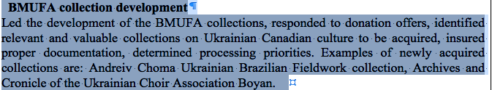
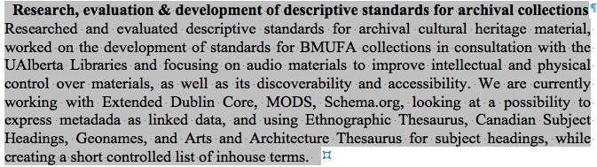
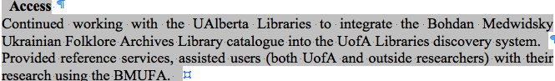

Special Projects:

- Exhibits: The 120th Anniversary of Ukrainians in Canada “Journey to Canada” exhibit and the 125th Anniversary of Ukrainians in Canada exhibit “Making a Home” was displayed from coast to coast at Canadian festivals, museums, conferences, schools, and other events including the Canadian Museum of Immigration at Pier 21 in Halifax and at the Bloor West Village Toronto Ukrainian Festival. Lynnien Pawluk oversaw the logistical arrangements for these displays. With the original exhibit tour five years ago, and this last summer’s exhibit tour, it is estimated that the displays have been seen by almost 1,000,000 people in Canada. The Ukrainian Canadian Congress in Manitoba purchased copies of our exhibit and has been instrumental in having them shown extensively throughout Manitoba. A copy of our first exhibit is currently on display in Ukraine. These exhibits have helped to establish the Kule Folklore Centre as a leading resource for high quality exhibits and research information regarding Ukrainian Canadians and Folklore, and have increased the public’s awareness of our role at the University of Alberta. We are also discussing a possibility of exhibit exchange with the Bejing Foreign Studies University of China.

PLEASE DROP IN EXHIBIT SCHEDULE HERE

- Exhibit Catalogue: An Exhibit Catalogue that compiles the information on both of the anniversary exhibits was produced. This catalogue was unveiled at the Greater Edmonton Teachers' Convention and generated great interest as a resource for school students, researchers and the general public. It also has been made available at the Alberta Genealogical Society Ye Olde Genealogy Fare.

PLEASE SHOW A COPY OF THE EXHIBIT CATALOGUE COVER HERE

- New Research Project: A new research initiative called “Love Letters from the Prairies – Stories from the Ukrainian Canadian Immigrant Community” has commenced. This project will culminate in an exhibit and exhibit catalogue that will continue telling the stories of the many waves of Ukrainian immigrants and their descendants in Canada through their own words. Work has begun on the first stages with a target date of completing an exhibit and an exhibit catalogue for show in the spring of 2018. During the Winter term 2017, three RA were working on this project. Although a SSHRC Application was not granted for this endeavor, alternative funding is being sought. KuFC is advertising for love letters to be used in this project.

PLEASE PUT IN LOVE LETTERS AD HERE

Knowledge Dissemination:

- KuFC staff have participated and presented at several national and international conferences. Maryna Chernyavska presented a paper “Describing Cultural Heritage: Subject Metadata in Folklore Archives” at the conference of the Working Group on Archives of the International Society for Ethnology and Folklore in Riga, Latvia; a paper on Ukrainian Canadian archival collections at a symposium “Crisis and Identity Conference – Cultural and Linguistic Perspectives on Ukraine and its Diaspora” at the UofA, and a paper entitled “Making a New Home: Dwelling in the Local Culture and Diversity on the Prairies Project” at the International Society for Ethnology and Folklore Congress. Larisa Cheladyn presented a paper "Creating a Sense of Place One Stitch at a Time: The role of embroidered pillows in the Ukrainian Canadian community" at the conference “Heritages of Migrations” in Buenos Aires, Argentina.

- The KuFC team and the Ukrainian Pioneers Association arranged and sponsored a book launch for Ukrainian Otherlands Diaspora, Homeland, and Folk Imagination in the Twentieth Century by Dr. Natalia Khanenko-Friesen of the University of Saskatchewan in February 2017.

- The KuFC team initiated two semesters of well-received Folklore Lunches with a wide variety of topics and speakers. Starting January 2017, the Folklore Lunches are being recorded and available on-line.

PLEASE DROP IN THE FOLKLORE LUNCH SCHEDULE HERE (Collage of posters)

- KuFC co-hosted with The Ukrainian Education Language Centre a delegation from the Dresden Technical University for a symposium “Crisis and Identity Conference – Cultural and Linguistic Perspectives on Ukraine and its Diaspora”. At the symposium, Dr. Pogosjan served as a panel discussant, and Maryna Chernyavska was a presenter.

- KuFC co-hosted with the MLCS a distinguished visitor professor Laada Bilaniuk from the University of Washington.

Associated Faculty:

Each of the faculty members associated with the Centre, Natalie Kononenko, Andriy Nahachewsky, Jelena Pogosjan, and Micah True continue to conduct research as regular professors. They publish significant academic work, attend national and international conferences, and make presentations at community events.

KuFC Donors and Endowments:

Without the generosity of our donors who have established endowments to foster student scholarships, fellowships, awards, projects, research, and the administrative operations, the KuFC would not and could not exist. KuFC recognizes and thanks the individuals and families that have established the following endowments:

- Ukrainian Folklore Program Development Fund – Huculak Endowment
- Kule Chair Ukrainian Ethnography Endowment
- Bohdan Medwidsky Ukrainian Folklore Archives Endowment
- W. and A. Kuryliw Family Endowment
- Kule Folklore Centre Endowment
- M. and E. Kawulych Family Endowment
- Pioneers Endowment

KuFC also recognizes the encouragement and financial support of the Friends of the Ukrainian Folklore Centre who without their hard work and input, the Centre would not be where it is today.

Report on Finances for 2016-2017:
PLEASE DROP IN THE KuFC STATEMENT 2016-2017 AND EXPLANATION

Budget and Scenario for 2017-2018:

PLEASE DROP IN THE KuFC BUDGET 2017-2018 AND EXPLANATION

Plans for 2017-2018:

Support for Research Projects:

- Dr. Natalie Kononenko (Kule Chair in Ukrainian Ethnography), the Sanctuary Project, An exhibit and exhibit catalogue for 2019? 2020? - (administrative support, archiving support, research assistant(s), funding for the exhibit?).
- Dr. Andriy Nahachewsky (Huculak Chair of Ukrainian Culture and Ethnography), what is the title of your project, administrative support, archiving support, research assistant(s), funding for the exhibit?
- Jelena Pogosjan (Director of the KuFC): research on the project “Love Letters from the Prairies – Stories from the Ukrainian Canadian Immigrant Community” will continue and an exhibit and exhibit catalogue will be produced for exhibition across the country for the summer of 2018 (administrative support, archiving support, research assistant(s), funding for the exhibit).

Archival Projects: Currently, the BMUFA are underused and underappreciated. We will focus on improving visibility and accessibility of the archives while continuing to work on the on-going archival projects:

- Key Priority: Core information for >100 additional collections of the BMUFA will be uploaded onto Atom webresource, for researcher access. We have recently committed to the Atom and Hydra software for our public interface. Starting in September, graduate student assistants will actively develop more metadata.

- Currently the KuFC audio-visual collection is the third largest in Alberta. Digitizing of video and audio materials will be continued.

- The development of an online archive model to make ethnographic materials of the Local Culture Project available to wide audiences will continue.

- Plans for an Archival Symposium with invited stakeholders from across the country who have archives similar to the BMUFA will commence. We hope that the first Symposium can be held in the spring of 2018.

- To celebrate our donors we plan to feature the Kules and the Kuryliws Family collections.

Teaching:

- KuFC will provide funding for 5 graduate students (MA, PhD); two of them will be funded by the Chairs.
- Graduate courses: the MLCS graduate program accommodates 2 specialization courses (directly related to the main area of students’ research). In 2016-2017, we will offer: MLCS 599 Ukrainian Folklore Theory and MLCS 599 Visual Identity and Vernacular Cultures.
- Undergraduate courses: faculty members affiliated with the KuFC will teach a wide variety of Folklore and Vernacular Culture courses. Our strategy is to include Ukrainian and Canadian folklore content while teaching courses in general or comparative folklore topics.

Instrucror | Term | Course | Enrolled  (May 1, 2017)
Natalie Kononenko | F | MLCS 204 Forms of Folklore | 80
Natalie Kononenko | F | MLCS 299 Folklore and Film | 30
Natalie Kononenko | W | MLCS 399 Folklore and the Internet | 20
Natalie Kononenko | W | Slav 204 Slavic Folklore | 19
Andriy Nahachewsky | F | MLCS 299 Graffiti | 12
Andriy Nahachewsky | F | INT D 439 Ukrainian Dance | 4
Andriy Nahachewsky | W | MLCS 599 Ukrainian Folklore Theory | (5)
Micah True | W | MLCA 205 History of Folklore Studies | 37
Jelena Pogosjan | F | SLAV 299 Witchcraft in Slavic Folklore | 12
Jelena Pogosjan | W | MLCS 599 Visual Identities and Vernacular Cultures | (5)
TBA | W | UKR 327 Early Ukrainian Canadian Culture | 3

During the period of May-December 2017, we plan to focus on promoting these courses. We are also exploring a possibility to offer UKR 327 Early Ukrainian Canadian Culture as an on-line course; and/or a possibility to teach it as a *1 module for a cluster of *1 Early Canadian Culture experiential learning courses (e.g. German, Italians, Scandinavian, etc.)

Affiliated Community Projects:

- Continuation of a partnership with the Friends of the Ukrainian Folklore Centre and their sponsorship of CFCW radio’s “Ukrainian Zabava Program” with host Steven Chwok who entertains an estimate 18,000 weekly listeners. KuFC spot may be changed from proverbs to something else of equal interest.

- The “Journey to Canada” exhibit and the “Making a New Home” exhibit will continue to be loaned out to venues across the country. The “Journey to Canada” exhibit catalogue will be promoted for sale throughout the country and will be made available to all Grade 3-4 school teachers in Alberta, if they wish to purchase it.

