- Welcome back staff and students to another fall semester on campus!
- The annual ASI Symposium is currently being planned for early 2023.
- Canada First Research Excellence Fund (CFREF) Future E-Car funding submission.

ASI NEWS
Newsletter Volume 3 Issue 1 November 2022

Research Highlight
Robot-Assisted Breast Brachytherapy Surgery
The Autonomous Systems Initiative (ASI) is a forward-thinking, multi-million dollar research program that teams up academic and industry experts across Alberta to develop automated technologies spanning key areas of health, transportation, sustainability and industry. Understanding and developing these systems will help Alberta remain economically competitive in a global context, while effectively addressing the challenges of climate change, efficient energy production and use, transportation needs, advanced manufacturing, and medical advancement. This program develops new Information, Communications and Technology (ICT)-enabled Autonomous Systems to support healthy and sustainable communities with a focus on sensing, communication, control, and computation technologies, all linked together by artificial intelligence.

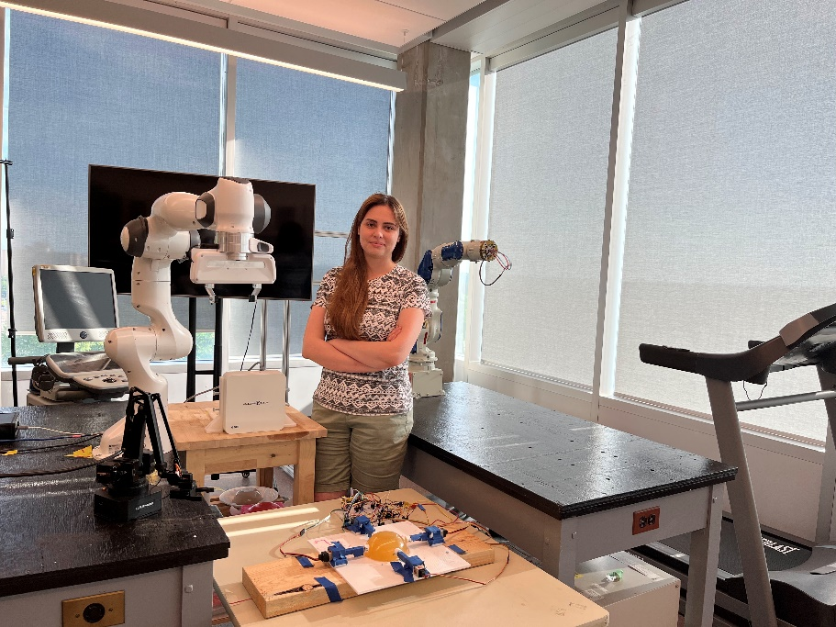
Very few groups in the biomedical and bioengineering fields in Canada focus on breast cancer surgery automation, despite the fact that this form of cancer is common in women, and automation can significantly aid treatment.
Researchers from Theme 4, the Autonomous and Semi-Autonomous Healthcare Delivery Theme, are beginning an innovative process that will greatly benefit women in Canada and globally, by investigating and developing robot-assisted breast cancer surgery solutions aimed at improving ultrasound (US) scanning, planning, monitoring, and execution of radioactive seed deposition.

Autonomous systems have revolutionized medicine, presenting opportunities that were previously unimaginable. Medical professionals today can use automated tools and systems to diagnose and treat a wide variety of diseases and conditions.
Researchers in this project, Robot-Assisted Breast Brachytherapy Surgery at the University of Alberta, produce solutions to the unique issues of breast brachytherapy using mechatronic systems and image guidance for planning, monitoring, execution of seed deposition, and autonomous ultrasound (US) scanning.
Brachytherapy is a way to deliver radiation therapy to patients with breast cancer, but rather than using radiation beams from outside the body, in this method, a device is placed into the breast tissue for a short time where the cancer is or has been removed.
Breast brachytherapy is a favorable option for women who have gone through lumpectomy, a surgery that removes cancer and a small amount of healthy tissue that surrounds it from the breast. It is a highly convenient and cost-effective option, and effectively reduces most of the disadvantages of other treatment options.
Researchers involved in this project include: Dr. Mahdi Tavakoli, the principal investigator for this project in Theme 4; Mehrnoosh Afshar, a Ph.D. student in electrical and computer engineering, who works on real-time tissue modelling, soft tissue deformation control, and US probe manipulation; Kirill Makhachev, an M.Sc. student in electrical and computer engineering who works on collaborative needle templates and US probe manipulation during the breast surgery; and Mojtaba Akbari, a Ph.D. student in electrical and computer engineering who works on 3D tumour reconstruction from US images.
The project brings together specialists in brachytherapy, including two radiation oncologists, Drs. Siraj Husain and Nawaid Usmani, and two medical physicists, Drs. Tyler Meyer and Ronald Sloboda. These specialists are active clinical researchers and leaders in transferring prostate brachytherapy techniques and
benefits to breast cancer treatment.
“The fact that our group works with oncologists at the cancer institute makes me personally proud” says Mehrnoosh Afshar.
Biomedical engineering problems involving applied interdisciplinary research makes this research innovative. Through mechatronic engineering and design, clinical problems experienced by practicing breast cancer professionals are being addressed.
While the end product from this research involves robot-assisted solutions, scientists are also examining opportunities for computer-based assistance without robots. In the future, researchers envision being able to propose refinements and enhancements to breast brachytherapy surgery even for clinicians who do not have access to or do not wish to use robots, and prefer a fully manual but computer-assisted technique. |

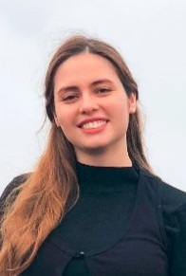
Spotlight on HQP
Mehrnoosh Afshar is a Ph.D. student at the University of Alberta. She completed her bachelor and master’s in mechanical/control engineering in Iran. To pursue her dream of working on the cutting-edge technology in autonomous systems, and after learning about the importance and challenges of robotics in surgery and healthcare, she joined Dr. Tavakoli’s Autonomous and Semi-Autonomous Healthcare Delivery research group at the University of Alberta.
Her research involves the development of mechatronic procedures for breast cancer treatment and robotic systems to assist with ultrasound scanning. She is developing an AI-based framework for personalizing treatment procedures based on patient data.
The fact that this research directly affects people’s health and quality of life is what draws Mehrnoosh towards this research, and makes its importance unquestionable.
“I hope this work will be able to improve the quality of care and healthcare outcomes for patients in the future” says Mehrnoosh Afshar.
In the future, she believes autonomous systems will play an increasing role in a variety of roles due to advancements in AI and computer vision. As autonomous systems become more prevalent in the medical industry, they are being used to detect manufacturing defects, prevent device failures, and assemble, repair, or reassemble devices autonomously.

Having enjoyed her academic life, she is eager to put what she’s learned into practice in a real industrial setting. Although she is fascinated by a variety of autonomous systems, healthcare and medicine are of particular interest to her at this time, especially during this pandemic when its importance is heightened.
Mehrnoosh plans on staying in Alberta after her Ph.D. program has ended in September 2023.
She enjoys hiking, biking, camping, and reading in her free time. |

Contact Us
For more information on ASI:
Contact us at autonomoussystemsinitiative@ualberta.ca

Visit our website at
http://uab.ca/asi

Follow us on social media:
Twitter: https://twitter.com/ASI_Alberta
LinkedIn: http://www.linkedin.com/in/autonomous-systems-initiative-alberta

