GLJE Submission
User Manual

TABLE OF CONTENTS

PART I – GLJEs processed by Faculties and Central Service Units 1
PURPOSE 1
OVERVIEW 2
APPROVALS 2
CONTACT 2
CREATING A GLJE 2
1. Download GLJE Form from Forms Cabinet 2
2. Create the Journal Lines 2
3. Obtain approval 3
4. Complete the Journal Header 3
5. Import entry 4
6. File GLJE on site 7
JOURNAL ERRORS AND CORRECTIONS 8
1. GLJE Import Errors 8
2. PS errors 9
PART II – GLJEs processed by FS-FR&A and RSO: Forms 10
PURPOSE 10
OVERVIEW 10
FORMS 10
DECISION TREE: CHOOSING A FORM 12
APPENDIX A: JOURNAL SOURCE 13
APPENDIX B: ATTACHING A PDF TO AN EXCEL DOCUMENT 14

PART I – GLJEs processed by Faculties and Central Service Units

PURPOSE
The purpose of this section is to provide instructions on how to import General Ledger Journal Entries (GLJEs) into PeopleSoft (PS) using a Google Forms submission form. Effective July 7, 2020, this process replaces the use of the GL Importer Tool. Once GLJE requests have been submitted via the Google submission form, they are imported into PeopleSoft using robotics process automation (RPA).

OVERVIEW
This section applies to all entries prepared, approved and processed by Faculties and Central Service Units (CSUs); these fall under the GLJE Request (processed by unit) section of the General Ledger Journal Entry (GLJE) Request Procedure in UAPPOL. This section does not apply to entries submitted to, approved and processed by Financial Reporting and Accounting (FS-FR&A) or RSO (see Part II).
Unit identifiers (unit IDs) have been assigned to Faculties and CSUs who have been granted approval to process journal entries without FS-FR&A; these have not changed with the removal of the GL Importer Tool. A listing of current unit IDs, as well as contacts, can be found in the Guide to Financial Management.
Continue to send GLJEs approved and processed by FS-FR&A to fsglje@ualberta.ca.

APPROVALS
Users must follow the Initiation, Review, Approve and Process (IRAP) procedure outlined in the GLJE Request Procedure in UAPPOL. Approvals must be in place prior to importing a GLJE. Per the GLJE Request Procedure in UAPPOL, FS-FR&A may request to see supporting documentation for GLJE requests processed by units, and FS-FR&A will perform compliance reviews to ensure units are following the procedure.
Individual units’ internal approval and filing processes are not impacted by the change in process from the GL Importer Tool to the Google submission form.

PS access is not required for this function; any UofA employee with a valid ccid can import an approved GLJE using the Google Forms submission form (detail on this process to follow). FS-FR&A retains an audit trail showing the user name for each submission.

CONTACT
Please send any questions to fsglje@ualberta.ca.

CREATING A GLJE

Download GLJE Form from Forms Cabinet
Users must download and use the GLJE Request by Unit form from the FS Forms Cabinet each time an entry is being prepared to ensure they are using the most current form. It is crucial that the user uses the form in the FS Forms Cabinet each time and does not make any changes to the format or structure of the form, other than adding or removing journal line rows. Format changes will cause the RPA tool to fail, and will require that the GLJE be resubmitted. Do not rename the GLJE tabs, or add new ones.

Create the Journal Lines
The journal lines contain the transactions making up the journal: the debit and credit entries.
- Add or remove lines as required for the GLJE; note that the RPA process has a limit of 2,000 lines for one GLJE. Entries with more than 2,000 lines must be split into entries less than 2,000 lines.

- Copy and paste data from GLJE source or key data directly into the form. The account, amount and description fields must always be completed. The unit and Ledger fields will be hard coded into the form. For the remaining fields either a speed code or the remaining chartfield strings must be provided.
Note that if the speedcode begins with zero, an apostrophe (‘) will need to be added to the beginning of the speedcode in order to retain the zero at the beginning of the speedcode (e.g. ‘01234).

- Once the journal is complete, verify that the total sums to $0.

Obtain approval
Obtain approval for GLJE per GLJE Request Procedure in UAPPOL. Note: the RPA process does not read the approval section of the form; this has been added to the form for units’ use and can be done electronically or on paper. If done electronically the unit must ensure that the approval is still linked to the GLJE in case of internal or external audit requests, or Financial Services compliance review.

Complete the Journal Header
The journal header contains information that uniquely identifies the journal. All fields must be completed. Unit and Ledger Group are hard coded and must not be changed.
- Unit (Business Unit): must be UOFAB
- Journal ID: *See Journal ID section below for numbering convention*
- Journal Date: date entry will be posted (MM/DD/YYYY) – must be current period
- Ledger Group: must be ACTUALS
- Journal Source: use processing unit source code. This should be provided by the approver of the entry; refer to Appendix A for list.
- Reversing: default is N (no). Select Y (yes) only if journal entry should reverse in the next period.

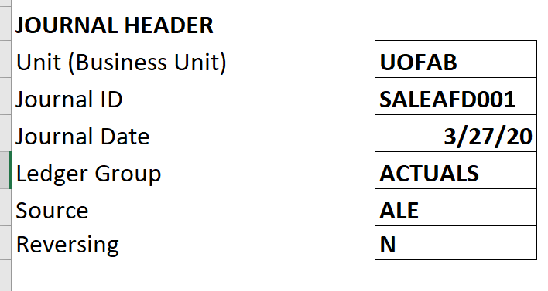

Journal ID
For GLJEs processed by unit, all journal IDs are created by the user (i.e. not system generated). Journal IDs are 10 characters and must use the following numbering convention:

Internal sales:
First 4 characters (mask) = SALE
Next 3 characters = unit ID (assigned by FS) (e.g. AFD; this is the “old” mask)
Last 3 digits = next number starting with 001*

Example:
Internal sale processed by Agricultural, Life and Environmental Sciences:
Journal ID will be: SALEAFD001

Other GLJEs processed by unit:
First 3 characters = mask (assigned by FS) (e.g. DON)
Last 7 digits = next number starting with 001*

Example:
Donation processed by Office of Advancement:
Journal ID will be: DON0000001

*Note: there are three options for the last digits:
Option 1: start at 001 (or 0000001), select next number for each journal and restart at 001 every month
The fiscal year central filing would need to take into account the date.

Option 2: start at 001 (or 0000001), select next number for each journal and restart at 001 every year
The fiscal year central filing would be numeric, as no faculty processes 999 internal sales journals in a year.

Option 3: start at 001 (or 0000001), select next number for each journal and restart once 999 is reached
The fiscal year central filing would be numeric, as no faculty processes 999 internal sales journals in a year.

Most faculties will process only once or a few times per month. FS recommends users start at “001” each month, which makes tracking the next number to use much easier. Units who process multiple entries every month will need to track last journal ID number used. Identical journal IDs will be accepted by PS provided they have different journal dates.

Please note, the university currently does not have PeopleSoft module functionality for internal sales transactions. Because of this gap, the only option is to allow users to process directly to the general ledger (GL) through the GLJE UAPPOL process directly into PS General Ledger. As a result, the user is required to assign the journal ID. PS is unable to automatically assign any portion of the journal ID.

Note: The numbering process for GLJEs under this process has not changed from the process under the GL Importer Tool process.

3rd party interfaces

Currently, there are three internal sales unit IDs for which the journal IDs are system generated (user does not assign): TMS, PVI and UTL. Because they are system generated, there is a restriction on the number of characters used at the beginning of the journal ID (6). As a result, the journal IDs for these four unit IDs will begin with SAL.
Example: SALTMS001

Import entry
Once the GLJE has been approved, it can be imported to PS.
- Save the GLJE in a location where it can be accessed in the future if needed. If submitting multiple entries on the same day, it is advised to name the GLJE files differently for troubleshooting purposes if errors occur. FS-FR&A recommends including the journal ID in the name of the file for easy cross-referencing to success/failure emails from FSBOT01 (more on this below) – e.g. SALEAFD001 June 2020.xlsx.

- Open the Google Forms submission form.
- Click “Yes” to confirm that the GLJE has been approved. Attach GLJE request(s) to the form; up to 10 can be submitted at one time.

  - Click “Add File”.
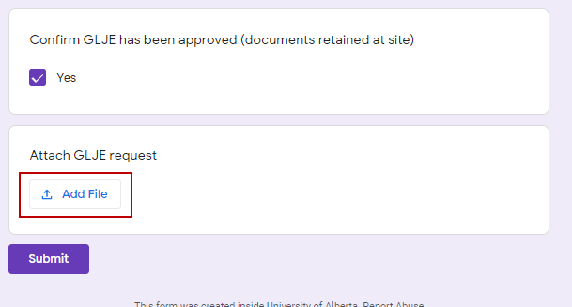

Click “Select files from your device”.

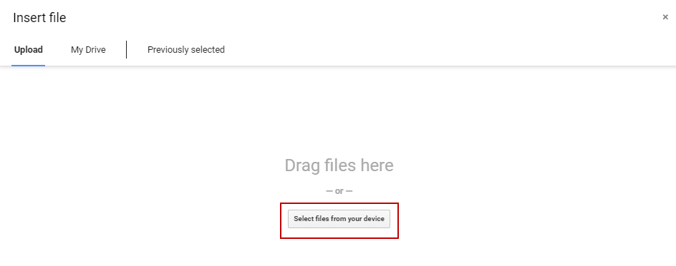

  - Navigate to the file through File Explorer. Select the file and click “Open”.

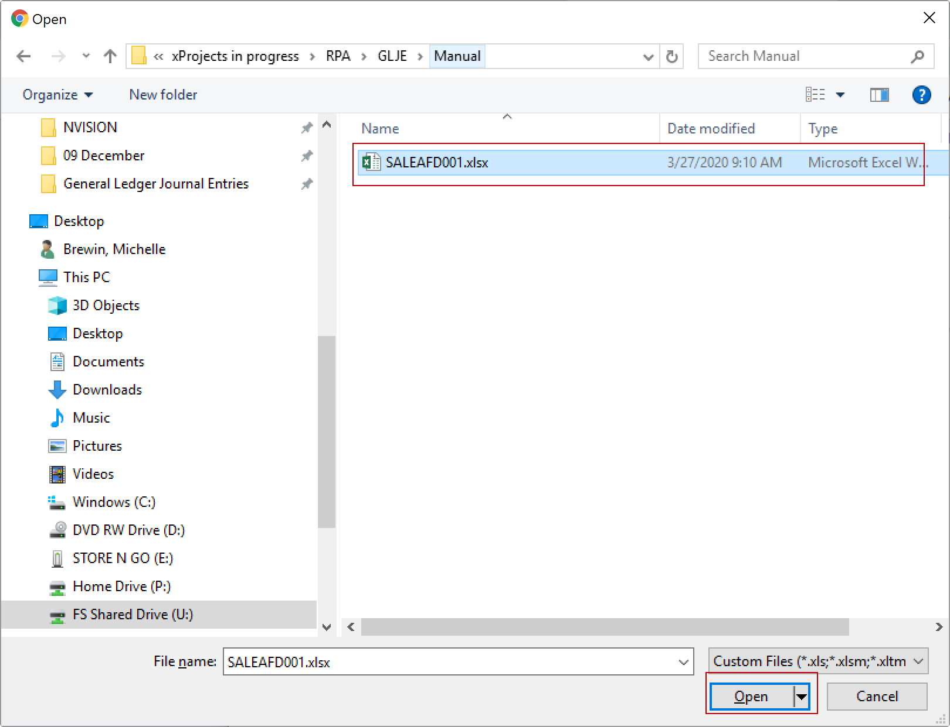

  - Click “Upload”.
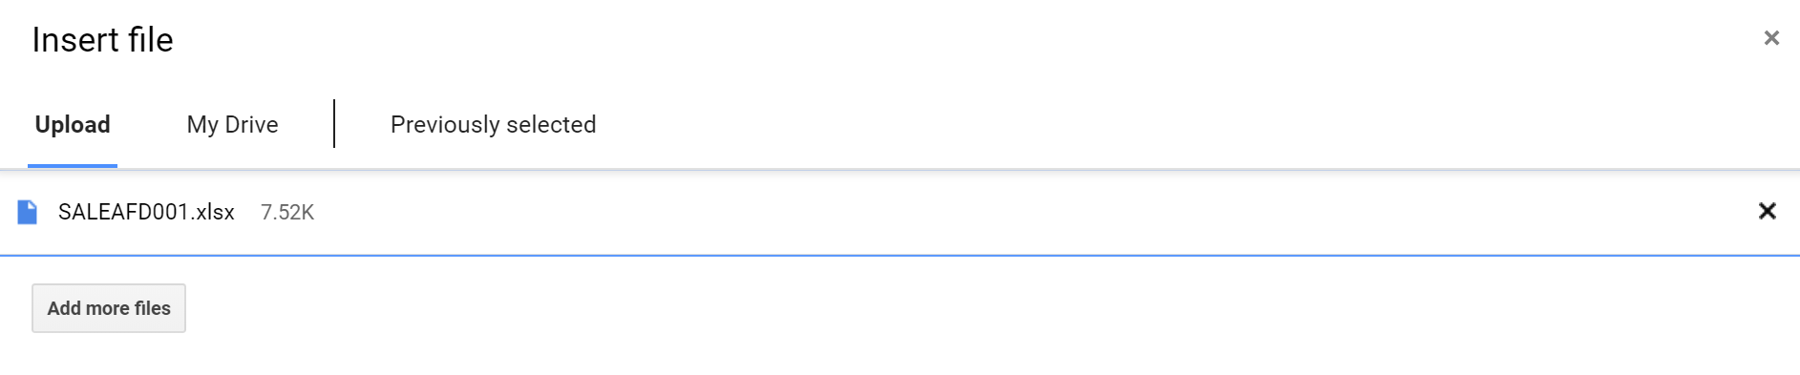

  - Click “Submit”.
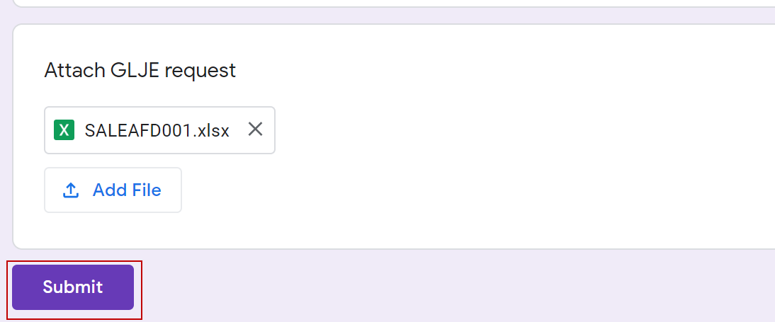

  - GLJE submission confirmation will appear as follows:
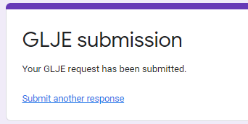

Note: Once a user uploads a journal, it cannot be changed or recalled. If a correction is required, a separate correcting entry will be required.
The RPA process runs every half hour (8am – 7pm daily); once the GLJE has been picked up, the user will receive an email from FSBOT01 indicating that the GLJE was successfully imported into PS, or an email indicating that there was an error with the GLJE. Errors messages are discussed in detail in the next section of this document.
Once the GLJE has been imported into PS, PS edit check will run and post the GLJE within one hour. It is possible that a GLJE is successfully imported into PS but goes into error status in PS; this will be discussed in detail in the next section of this document.

File GLJE on site

The unit will retain the supporting documentation for the statutory period of six years plus the current year, per the General Ledger Journal Entry (GLJE) Request Procedure.

JOURNAL ERRORS AND CORRECTIONS

GLJE Import Errors
GLJE import errors occur when the submitted GLJE cannot be imported into PS by the RPA process. Users will receive an email from FSBOT01 that the GLJE import has failed, indicating the cause of the failure. GLJE import errors always require that the GLJE be resubmitted. Because the RPA process is an automated process it is unable to troubleshoot entries and perform corrections itself. GLJE imports may fail for the following reasons:

Error message | Cause of Problem | Resolution
Invalid Chartfields (includes Account, Fund, DeptID, Program, Class, Speedtype, Project, Source) | Chartfields do not exist or are inactive in PS; the email will indicate which chartfield(s) caused the error | Correct the coding in the GLJE form and resubmit through the Google submission form.
Amounts with more than 2 decimal places | One or more amounts in the Journal Lines section of the GLJE form contains more than 2 decimal places | Correct the amounts in the GLJE form and resubmit through the Google submission form.
Missing values in journal lines | One or more fields in the Journal Lines section of the GLJE form is missing values | Complete all fields in the Journal Lines section of the GLJE form and resubmit through the Google submission form. See here for more information.
Missing values in journal header | One or more fields in the Journal Header section of the GLJE form is missing values | Complete all fields in the Journal Header section of the GLJE form and resubmit through the Google submission form. See here for more information.
More than 2,000 lines | The Journal Lines section of the GLJE form contains more than 2,000 lines. | Split the GLJE form into two (or more, as needed) separate requests. Resubmit all requests through the Google submission form.
Journal lines do not sum to $0 | Journal entry is not in balance. | Correct the amounts and ensure journal line amounts sum to $0. Resubmit through the Google submission form.
Incorrect unit ID used in SALE journal ID | Incorrect unit ID is used after SALE mask in the journal ID. | Correct the journal ID in the GLJE form and resubmit through the Google submission form. See here for more information on journal IDs, and here for a list of unit IDs.
Journal already exists | A journal with the same date and journal ID has been Posted in PS. | Correct the journal ID or journal date in the GLJE form (Journal header) and resubmit through the Google submission form.
Journal date improperly formatted | Date is not in the MM/DD/YYYY format. | Correct the journal date (Journal header) and resubmit through the Google submission form.
Journal ID not 10 characters | Journal ID is more or less than 10 characters. | Correct the journal ID and resubmit through the Google submission form.
No tab titled 'GLJE' was found in the workbook. | User has renamed the GLJE tab in the workbook. | Rename the tab with the journal lines as ‘GLJE’.

Unknown system error | Generally caused by a change in format to the form (e.g. adding or removing lines, columns, or text). Lines may only be added or removed in the Journal Lines section of the GLJE form. | Download the form from the Forms Cabinet and complete the entry again. Resubmit through the Google submission form.  If the error persists, contact the IST Helpdesk.

For any journal import error not listed above, please log a helpdesk ticket.

If a GLJE request is submitted, but the user does not receive a success or failure email from FSBOT01 within one hour of submitting during RPA processing hours (the RPA process runs every half hour from 8am – 6pm daily), please log a helpdesk ticket. Do not resubmit the GLJE request as the lack of a success or failure email is an indication that the RPA process is not running. Once the issue is resolved, the originally submitted GLJE request will be processed by the RPA process.

PS errors
Once a GLJE has been successfully imported into PS, the journal still needs to be reviewed to ensure it passes the PS budget and edit check validation processes. Under the old GL Importer Tool process users would review the status of the journal in PS. This access to perform this review was removed along with the GL Importer Tool access.
The following errors could exist and the journal will still import to PS (but the journal will not post to the GL after the validation process):
- Incorrect accounting period selected
- Chartfield combo edit error (e.g. project chartfield is missing in the restricted research fund)
FS-FR&A monitors for journals in error in PS and contacts units to provide correction details on GLJEs in error prior to month end close. FS-FR&A will review once per week and send one email to users requesting a correction. When correcting details are provided, FR&A will correct the GLJE in PS. If users do not provide the correction details to FS-FR&A by the last business day of the month, the journal will be deleted by FS-FR&A at 11:00am on the first business day of the subsequent month. FS-FR&A will not follow up with units on error corrections.

PART II – GLJEs processed by FS-FR&A and RSO: Forms

PURPOSE
The purpose of this section is to provide guidance on selecting the appropriate form to use when preparing GLJEs which are submitted to FS-FR&A or RSO for approval and processing. The process has not changed; however, the GLJE forms have changed to a format which works with the RPA.

All forms referenced in this section are found in the FS Forms Cabinet.

OVERVIEW
Users must download and use the appropriate form from the FS Forms Cabinet each time an entry is being prepared to ensure they are using the most current form. It is crucial that the user uses these forms in the FS Forms Cabinet each time and does not make any changes to the format or structure of the form, other than adding or removing journal line rows. Format changes will cause the RPA tool to fail, and will require that the GLJE be resubmitted. Do not rename any of the worksheet tabs on the forms.

Note: If you save the forms to your personal computer, you will run the risk of missing minor updates and submitting a GLJE form that will fail. If this occurs the GLJE will be returned to you and you will need to resubmit it on the proper form. FS-FR&A will not troubleshoot the form.

Support must be included within the GLJE Request form itself on the Support tab. This includes authorization (PDF of signature or PDF of email authorization). As such, only one file per GLJE Request will be sent to FS-FR&A or RSO for processing. Refer to Appendix B for detailed instructions on how to attach a PDF to an excel document.

FORMS
FORM NAME | PURPOSE
Accrual (Revenue or Expense) ⁽¹⁾ | Use this form for any accrual – regardless of the fund.  Expense: To record expense of product/service received for which payment will be processed in the next period. Most faculties only process accruals at year-end.  Revenue: To record revenue for product/service delivered to customer for which the billing or cash sale will be processed in the next period. Most faculties only process accruals at year-end.
Chartfield String Correction | To process chartfield string corrections that cannot be processed in the originating module/system.  Note: Corrections within the same faculty in F210 (excluding Asset/Liability/Net Asset accounts) can be made by units using their unit IDs and do not need to be submitted to FS-FR&A for approval and processing.  Note: Regardless of whether the error is due to incorrect coding or a keying error, the faculty must submit a correction via GLJE Request (Chartfield String Correction form).
Transfer | To transfer funds between operating funds, within one operating fund, or between an endowment (Exxxx) and an operating fund (F210, F100, F310). This includes Standard Template GLJE Requests which use transfer accounts.  Use when a transaction cannot be processed in uPlan (i.e. non-budgeted program, class or project in F210).  Do not use this form if the transfer entry includes a transfer to/from a Research fund. For these entries use the Research GLJE form.
Internal Sale | To process internal sales where the selling unit does not have a unit ID.
Other | To request a GLJE for which no other form is appropriate. This includes Standard Template GLJE Requests which do not use transfer accounts.  It is rare that this form would be used; contact FS-FR&A with any questions.
Research GLJE | To:  - Transfer funds to research project (cash-based research projects);  - Correct research project COA coding errors that cannot be corrected in the originating module/system.  - Recover expenses from a research project where the recovery:  - could not be directly charged in the first instance in Accounts Payable (AP)  - cannot be processed by an AP Journal Voucher (APJV) as the charge is made up of costs on multiple invoices (e.g. charges by the department for photocopying);  - is based on a shared expense agreement (e.g. charges recovered by one research project from other research projects);  - Transfer a research project balance and close the project.  - Transfer funds between an endowment (Exxxx) and a research project (F53x).

Authorization must be provided in the Support tab of the GLJE request form. Refer to each individual GLJE form for specific support requirements.

DECISION TREE: CHOOSING A FORM

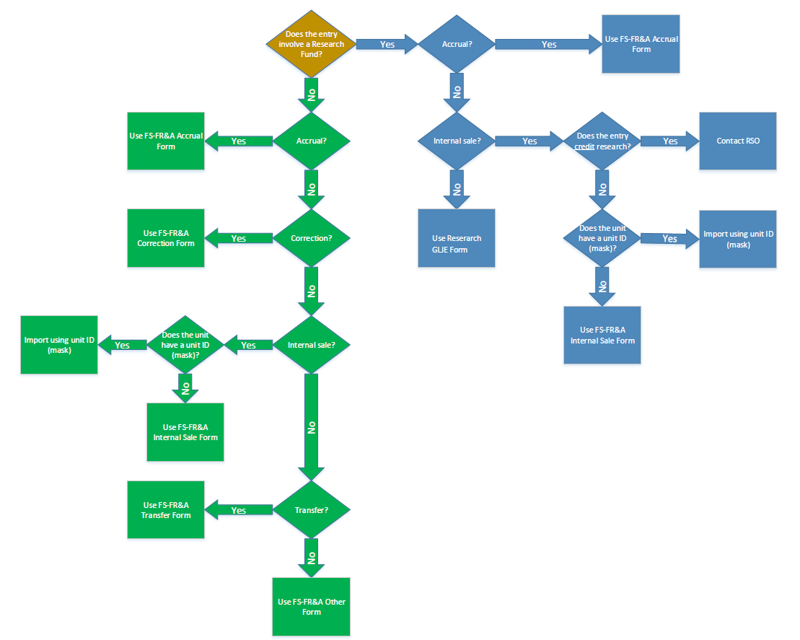

APPENDIX A: JOURNAL SOURCE

The following Sources are to be used when completing the Journal Header for internal sales.

 | Source | Faculty
Faculties
 | ALE | Agricultural, Life and Environmental Sciences
 | ART | Arts
 | AUG | Augustana
 | BUS | Business
 | EDU | Education
 | ENG | Engineering
 | EXT | Extension
 | KSR | Kinesiology, Sport and Recreation
 | MED | Medicine and Dentistry
 | NUR | Nursing
 | PPS | Pharmacy and Pharmaceutical Sciences
 | REM | Rehabilitation Medicine
 | SCI | Science
Central Service Units
 | ANC | Ancillary Services
 | BKS | Bookstore
 | DVO | Office of Advancement
 | FS | Financial Services
 | HRS | Human Resource Services
 | HSC | Health Sciences Council
 | IST | Information Services and Technology
 | LSV | Learning Services
 | OPR | Operations and Physical Plant
 | PRS | President, Secretariat, VPs
 | RMS | Risk Management Services
 | RO | Registrar’s Office
 | RSO | Research Services Office
 | SMS | Supply Management Services
 | STS | Student Services

See here for guidance on the Journal ID.

APPENDIX B: ATTACHING A PDF TO AN EXCEL DOCUMENT
All GLJE requests sent to FS-FR&A and RSO must include the supporting documents and approvals in the Support tab of each form. Required support is detailed here, as well as in the forms themselves.
The steps to attach a PDF document to an Excel document are as follows:
- Navigate to the Support tab in the GLJE request.
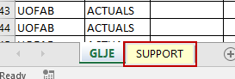
- Select Insert from the Excel menu. Select Object.
- Select Create from File. Browse to add your file.
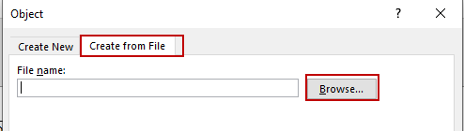
- Once a file has been added, select Display as icon. Select OK.
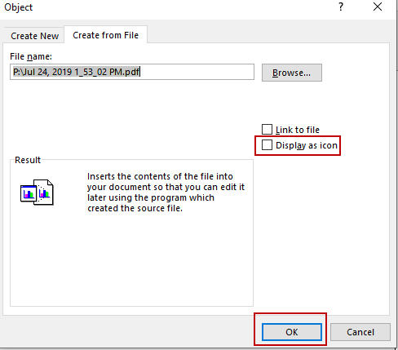

Once this has been done, the file will appear in the Excel document:
