Completing ATS Appointments Effective On or After July 1, 2019
As noted in the recently ratified Collective Agreement, there are some changes to the ATS Salary Scales and Appointments. The new Agreement, salary scales and appointment letters have been posted to the website.
If you have questions or need further information, please contact Employment Services.

Links for Updated Information
Collective Agreement https://www.ualberta.ca/faculty-and-staff/my-employment/collective-agreements-and-handbooks
ATS Salary Scales https://www.ualberta.ca/faculty-and-staff/pay-tax-information/salary-scales
Please note the following changes:
- There is now one AASUA collective agreement with Common Provisions and separate Schedules for each category of staff member. For Academic Teaching Staff (ATS) please refer to the Common Provisions and Schedule D. When referencing the Agreements, Articles that start with a number are from the Common Provisions and those starting with a letter are found in that Schedule.

- As per Article D1.01 and Appendix D.1, you will note that the Contract Statuses of Instructor and Term 8 have been removed. These have been replaced with the Contract Status of Term as defined in D1.01 g). If you have already submitted new appointments for a Term employee using the previous Instructor or Term 8 template, they will automatically become Term status and you will not be required to submit an amended letter. Going forward you will be required to use the new template.
“Term” means an appointment to a full-time or part-time position, and either within a single teaching term (Fall, Winter, Spring, or Summer), or within 2 or 3 consecutive teaching terms where the total appointment period is less than 12 months

- In the event that a course is cancelled to which an ATS Member with an appointment to Term (part-time) or Term (with an appointment period of less than 8 months) has been assigned, the ATS Member shall be paid a cancellation stipend of:
a) $500 if the notice of cancellation is given less than 4 weeks prior to the scheduled start of classes; or
b) $1,000 if the notice of cancellation is given after the start of classes. (The ATS Member shall also be paid salary earned from the date the appointment takes effect to the date of cancellation).

- A new salary scale has been approved effective July1, 2019 however, this scale will not be fully implemented until July 1, 2020 (see the Notes in Appendix D.5 and on the posted ATS salary scale). This new scale will be implemented as follows:
  - All Faculties that have previously approved salary scales which are above the posted minimum will continue to apply.
  - The new minimum salary effective July 1, 2019 for a full time ATS Member without a PhD or equivalent will be $63,152 per annum ($6,315) per course. If Employment Services has already received an appointment which is below this new minimum, the salary will be adjusted accordingly and you will be notified. All appointments submitted from today forward must have the correct salary.
  - The minimum salary for a full time ATS Member with a PhD or equivalent remains $73,360 ($7336 per course).
  - All appointments and increments prior to July 1, 2020 will follow the 2018-2019 (current) salary scale.
  - Changes to the calculation of the Per Course Rate are effective July 1, 2020, please continue to use the 2018-2019 per course rates (or your Faculty specific rate) for all appointments prior to July 1, 2020

- We will be streamlining the HCM structure for ATS appointments over the coming months in conjunction with the changes to the Agreement and the establishment of ATSEC’s. You will see the following changes:

  - The Contract Status (Career, Term 12, Recurring and Term) will be noted on the Job Junior panel in the Job Config 1 field.
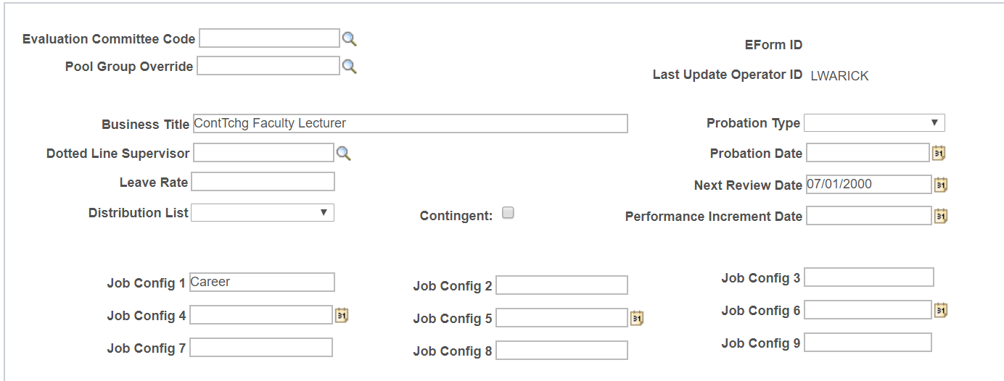

  - Faculty specific Working Title (Clinical Lecturer, Faculty Lecturer, Coach etc) will be captured in the Business Title on the Job Junior panel. You will need to type this in on the eform for those hires without a position

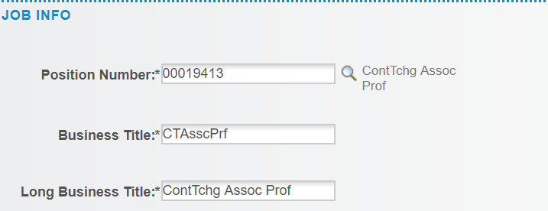

  - Rank (Assistant, Associate and Full) will be noted in the Job Code. We will be eliminating all of the title based Job Codes. Once all Faculties have finalized their ATS standards, we will place all ATS Members in a rank that is reflected by the new Job Codes as follows:

A0700 ATS Assistant Lecturer A0701 ATS Associate Lecturer A0702 ATS Full Lecturer

These Job Codes are currently active and if you have already finalized your ranks you can start using them now

  - In order to better identify those ATS who are on Phased Post Retirement, the Status of PPR will be noted on the Job Junior and you are now required to use the following Job Codes:

A0703 Phased Post Retirement – Faculty A0704 Phased Post Retirement – FSO

