Date | Permit Holder | Permit No. | Department | Building | Rooms | Nuclear Substances

A | Identification | Compliance Criteria | yes | no | n/a | Comments / Corrective Action Taken | Date | initial
1 | Entrance doors | Nuclear substance laboratory doors have the sign specified in the attachment to this checklist
2 | Stock containers | Containers used to store nuclear substances have the label specified in the attachment to this checklist
3 | Refrigerators  / freezers | Refrigerators and freezers used for nuclear substance storage have the sign specified in the attachment to this checklist
4 | Waste containers | Containers used for nuclear substance waste storage have the sign specified in the attachment to this checklist
5 | Equipment | Equipment used to handle or manipulate nuclear substance have the label specified in the attachment to this checklist
6 | Sinks | Sinks used for the decontamination of items have the sign specified in the attachment to this checklist
7 | Fume hoods | Fume hoods used for nuclear substance experiments have the label specified in the attachment to this checklist
8 | Work benches | Areas on work benches used for nuclear substance experiments are identified using the label specified in the attachment to this checklist
9 | Removal/  defacement  of labels | Nuclear substance labels have been removed from any item, equipment or boxes not currently in use and which have been checked to be free of nuclear substance contamination.
10 | Nuclear Substance  Permit | A copy of the current Radionuclide Permit is posted in each lab listed on the Permit.
11 | Lab rules | A copy of the CNSC lab rules is posted in each lab listed on the Permit.
12 | Wipe test  requirements | A copy of the wipe test requirements shown in the attachment is posted on the liquid scintillation and/or gamma counter.

B | Containment | Compliance Criteria | yes | no | n/a | Comments / Corrective Action Taken | Date | initial
1 | Absorbent  bench-cote | Absorbent bench-cote is used to cover lab benches where nuclear substances are handled or stored. The absorbent side is facing up and the plastic side of the bench-cote is facing down.
2 | Fume hood use | Work that generates volatile radioiodine and other gases is conducted in a fume hood.
3 | Fume hood  air flow | Items stored in the fume hood do not adversely affect the fume hood air flow.
4 | Fume hood  certification | Fume hoods that are designated for work with volatile nuclear substances are certified and tested annually.
5 | Charcoal traps | Charcoal traps are used to absorb nuclear substance gases generated during cell incubation and other processes that are not performed in a fume hood.
6 | Freezers | Freezers used to store Tritium and other nuclear substance compounds are free of ice build-up.
7 | Shielding | The radiation exposure rate from any source is ≤ 2.5 uSv/hour in occupied areas.
8 | Contamination  control | Surface contamination is less than 100 cpm/wipe above background on floors, bench tops, equipment and other items.
9 | Room security | The door(s) to the lab are closed and locked when the room is unoccupied. Only authorized persons have a key to the room.
10 | Nuclear substance  security | Nuclear substance stocks are stored in a locked container that cannot be easily removed from the nuclear substance laboratory and are accessible only to persons listed on the permit.
11 | Authorized  laboratory | Nuclear substance and potentially contaminated items are used and/or stored only in laboratories listed on the Radionuclide Permit.
12 | Authorized  nuclear substances | Only nuclear substances listed on the Radionuclide permit are stored or used.
13 | Nuclear substance  limits | The amount of nuclear substance stored or used does not exceed the limits that are specified on the Radionuclide permit.

C | Waste  Management | Compliance Criteria | yes | no | n/a | Comments / Corrective Action Taken | Date | initial
1 | Solid waste  containers | Solid nuclear substance waste is stored in containers lined with clear, plastic bags.
2 | Liquid waste  containers | Liquid nuclear substance waste is stored in reagent bottles with tight-fitting caps.
3 | Nuclear substance  segregation | Nuclear substance waste is segregated according to the nuclear substance (except liquid scintillation fluor).
4 | Biohazard  segregation | Nuclear substance biohazard waste is segregated from nuclear substance non-biohazard waste.
5 | Sharps  segregation | Syringes/needles and other sharp objects are disposed of into sharps containers.
6 | Label  defacement | Nuclear substance labels are defaced on all items placed in nuclear substance waste containers.
7 | Waste container  storage | Waste containers are stored in a safe and secure area of the laboratory.
8 | Container  inventory | The amount of activity in each waste container is recorded and kept up-to-date.
9 | Disposal records | Nuclear substance waste disposal records are retained.

D | Personal  Protection | Compliance Criteria | yes | no | n/a | Comments / Corrective Action Taken | Date | initial
1 | Lab coats &  gloves | Lab coats and gloves are worn when handling nuclear substances or contaminated items.
2 | Food/beverage  restriction | There is no food, beverages, cups, eating utensils or other items associated with eating or drinking in the nuclear substance lab.
3 | Emergency eye  wash | An emergency eyewash station is provided in the lab or in close proximity to it with unimpeded access.
4 | Emergency  shower | An emergency shower is provided in the lab or in close proximity to it with unimpeded access.
5 | Emergency  spill kit | An emergency spill kit is readily available and the staff is aware of its location.

E | Laboratory  space | Compliance Criteria | yes | no | n/a | Comments / Corrective Action Taken | Date | initial
1 | Adequate work  space | There is sufficient floor space (i.e. at least 3 square meters of free floor space per person)
2 | Segregated  work areas | Nuclear substance work areas are segregated from non-nuclear substance work areas, desks and offices.
3 | Housekeeping | The laboratory is free from excessive clutter on the floors, counter spaces and fume hoods.
4 | Safe Storage | Nuclear substances and other hazardous material are safely stored within the laboratory.
5 | Emergency exits | Emergency exits are not blocked.

F | Radiation  Detection | Compliance Criteria | yes | no | n/a | Comments / Corrective Action Taken | Date | initial
1 | Whole-body  dosimeter | Persons working with nuclear substances that emit penetrating radiation (i.e. gamma, x-ray, high energy beta or neutron) wear a whole-body radiation dosimeter.
2 | Extremity  dosimeter | Persons working with greater than 50 MBq of P-32, Sr-90, Y-90, Sm-153 or Re-186 wear an extremity (ring) dosimeter.
3 | Thyroid  monitoring | Thyroid monitoring is performed between 1 to 5 days after handling > 50 MBq of volatile radioiodine.
4 | Survey meter  available | An appropriate survey meter (e.g. Geiger counter, scintillation detector) is available for use during nuclear substance work
5 | Survey meter  calibrated | The instrument has been calibrated within the date indicated on the calibration sticker.
6 | Survey meter  functional | The survey meter is functioning properly.
7 | Wipe test  performance | Contamination wipe tests have been properly carried out within 7 days of performing any nuclear substance work.
8 | Wipe test adequate | An adequate number of wipe tests have been taken (i.e. at least 5 per bench area) and recorded.
9 | Wipe test blank | A blank (background) count-rate has been determined for each series of wipe tests.
10 | Follow-up wipe  tests | Wipe tests have been taken and recorded following the decontamination of surfaces.

G | Stock  Inventory | Compliance Criteria | yes | no | n/a | Comments / Corrective Action Taken | Date | initial
1 | Complete &  legible | All sections of the nuclear substance stock inventory record are filled out completely and legibly.
2 | Up-to-date | Nuclear substance stock inventory records are up-to-date.
3 | Full names used | The full name of persons withdrawing aliquots are recorded on the nuclear substance stock inventory record.
4 | Proper units | Activity amounts are indicated using proper units (i.e. uCi, mCi, kBq, MBq)
5 | Disposal date  indicated | The date the stock was disposed is indicated on the nuclear substance stock inventory record.
6 | Stock verified  quarterly | Quarterly stock verification forms are submitted to the Radiation Safety Office.

H | Training | Compliance Criteria | yes | no | n/a | Comments / Corrective Action Taken | Date | initial
1 | Worker  certification | Persons handling nuclear substances have been certified by the Radiation Safety Committee.
2 | Worker  authorization | Persons handling nuclear substances are listed as authorized users on the Radionuclide Permit.
3 | Refresher  training | Persons handling nuclear substances have had refresher safety training within the last 2 years.
4 | TDG certification | Persons receiving nuclear substance packages have a valid Transportation of Dangerous Goods (TDG) Certificate.
5 | Awareness  training | Persons working in the lab who are not radiation safety certified have read the Radiation Safety Guidelines for Non-users.

I | Accountability | Compliance Criteria | yes | no | n/a | Comments / Corrective Action Taken | Date | initial
1 | Deficiencies  corrected | Deficiencies that have been previously identified have been corrected.
2 | Self-audit | Self-audits at annually using the Radiation Safety Compliance Check-List.

ADDITIONAL COMMENTS _______________________________________________________________________________________________________________________________________________________________________________________________________________________________________________________________________________________________________________________________________________________________________________________________________________________________________________________________________________________________________________________________________________________________________________________________________________________________________________________________________________________________________________________________________________________________________________________________________________________________________________________________________________________________________________________________________________________________________________________________________________________________________________________________________________________________________________________________________________________________________________________________________________________________________________________________________________________________________________________________________________________________________________________________________________________________________________________________________________________________________________________________________________________________________________________________________________________________________________________________________________________________________________________________________________________________________________________________________________________________________________________________________________________________________________________________________________________________________________________________________________________________________________________________________________________________________________________________________________________________________________________________________________________________________________________________________________________________________________________________________________________________________________________________________________________________________________________________________________________________________________________________________________________________________________________________________________________________________________________________________________________________________________________________________________________________________________________________________________________________________________________________________________________________________________________________________________________________________________________________________________________________________________________________________________________________________________________________________________________________________________________________________________________________________________________________

RADIONUCLIDE PERMIT HOLDER ______________________________________

SIGNATURE __________________________________ DATE _________________

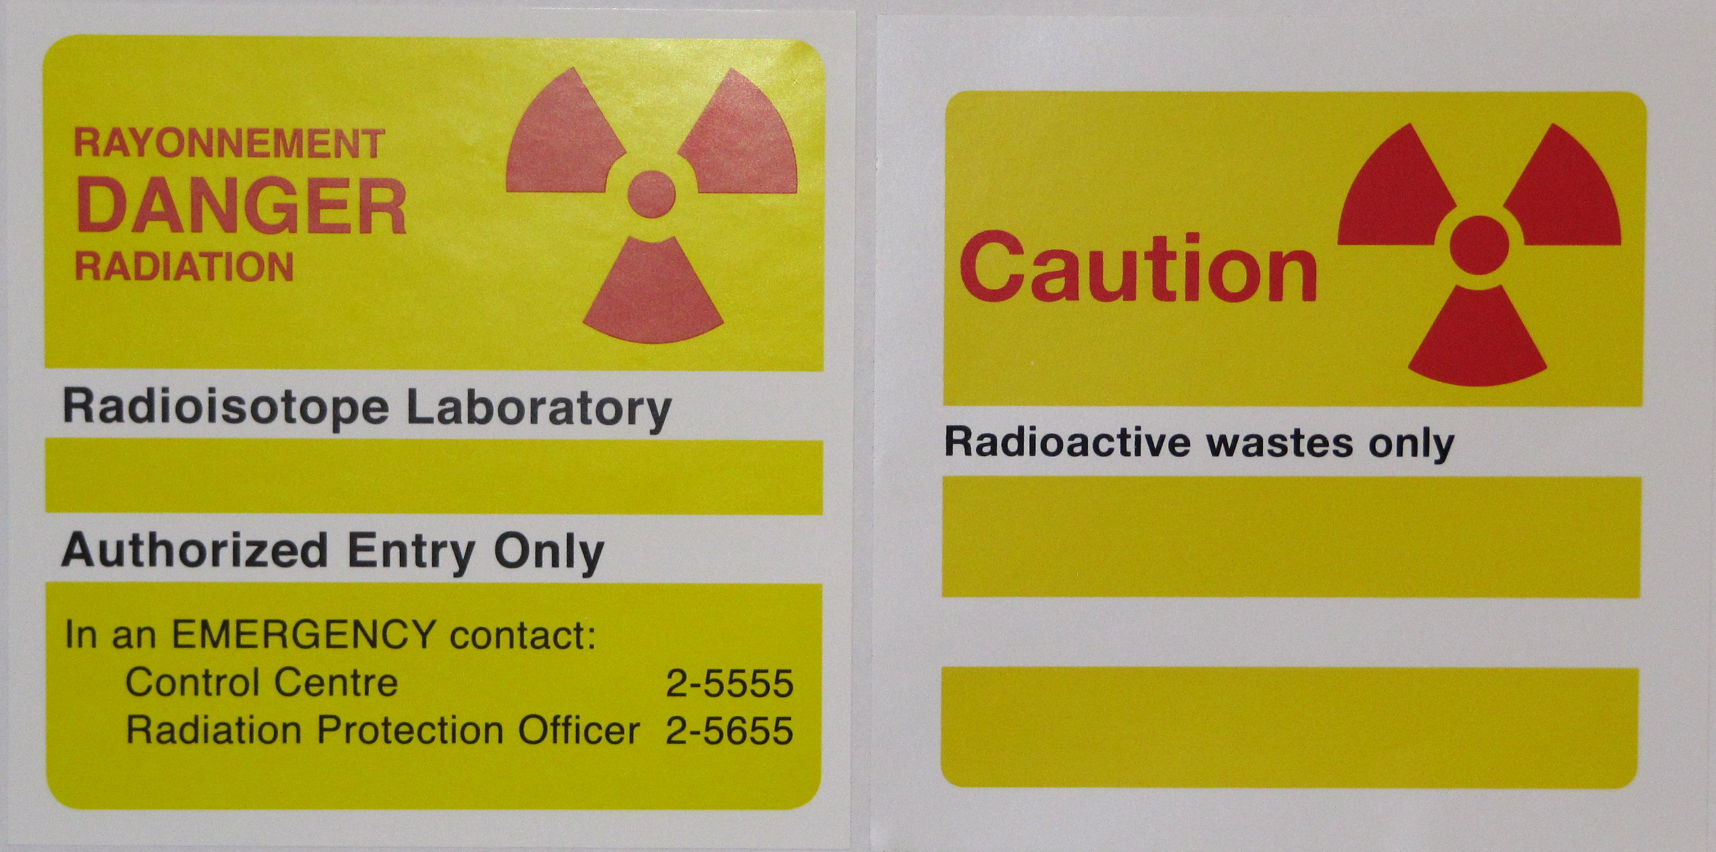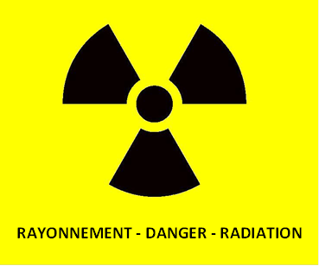

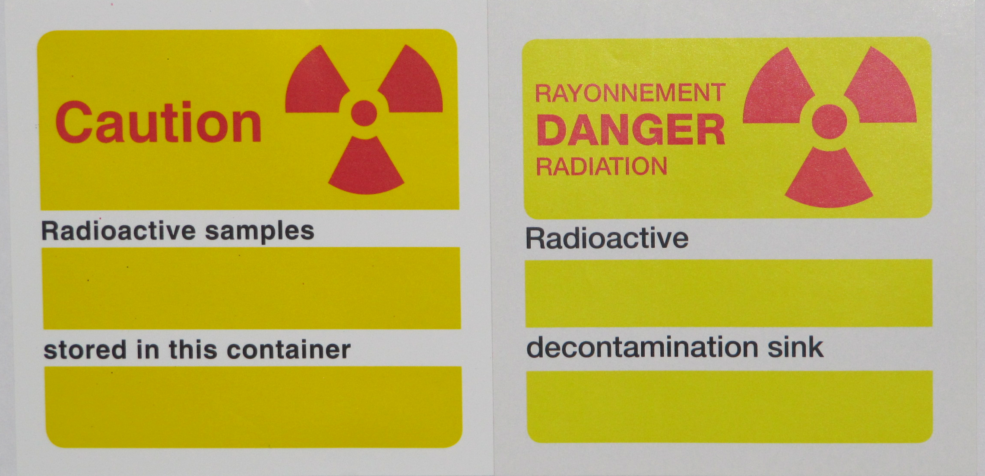

WIPE TESTS REQUIREMENTS

Perform Within 7 Days Of Nuclear substance work

If Results > 900 CPM (0.3 Bq/cm²) Above Background:
wipe

DECONTAMINATE AND REPEAT WIPE TEST

If Results > 9,000 CPM (30 Bq/cm²) Above Background:
wipe

REPORT IMMEDIATELY TO RADIATION SAFETY OFFICE

Month | Days Nuclear Substance Was Dispensed
January | 1 2 3 4 5 6 7 8 9 10 11 12 13 14 15 16  17 18 19 20 21 22 23 24 25 26 27 28 29 30 31
February | 1 2 3 4 5 6 7 8 9 10 11 12 13 14 15 16  17 18 19 20 21 22 23 24 25 26 27 28 29
March | 1 2 3 4 5 6 7 8 9 10 11 12 13 14 15 16  17 18 19 20 21 22 23 24 25 26 27 28 29 30 31
April | 1 2 3 4 5 6 7 8 9 10 11 12 13 14 15 16  17 18 19 20 21 22 23 24 25 26 27 28 29 30
May | 1 2 3 4 5 6 7 8 9 10 11 12 13 14 15 16  17 18 19 20 21 22 23 24 25 26 27 28 29 30 31
June | 1 2 3 4 5 6 7 8 9 10 11 12 13 14 15 16  17 18 19 20 21 22 23 24 25 26 27 28 29 30
July | 1 2 3 4 5 6 7 8 9 10 11 12 13 14 15 16  17 18 19 20 21 22 23 24 25 26 27 28 29 30 31
August | 1 2 3 4 5 6 7 8 9 10 11 12 13 14 15 16  17 18 19 20 21 22 23 24 25 26 27 28 29 30 31
September | 1 2 3 4 5 6 7 8 9 10 11 12 13 14 15 16  17 18 19 20 21 22 23 24 25 26 27 28 29 30
October | 1 2 3 4 5 6 7 8 9 10 11 12 13 14 15 16  17 18 19 20 21 22 23 24 25 26 27 28 29 30 31
November | 1 2 3 4 5 6 7 8 9 10 11 12 13 14 15 16  17 18 19 20 21 22 23 24 25 26 27 28 29 30
December | 1 2 3 4 5 6 7 8 9 10 11 12 13 14 15 16  17 18 19 20 21 22 23 24 25 26 27 28 29 30 31

Note: Wipe tests must be performed within 7 days of dispensing aliquots from nuclear substance stock and within 7 days of any nuclear substance work.

O - days on which aliquots were dispensed from nuclear substance stocks

X - days on which wipe tests were performed

Wipe Test Compliance ________ %

