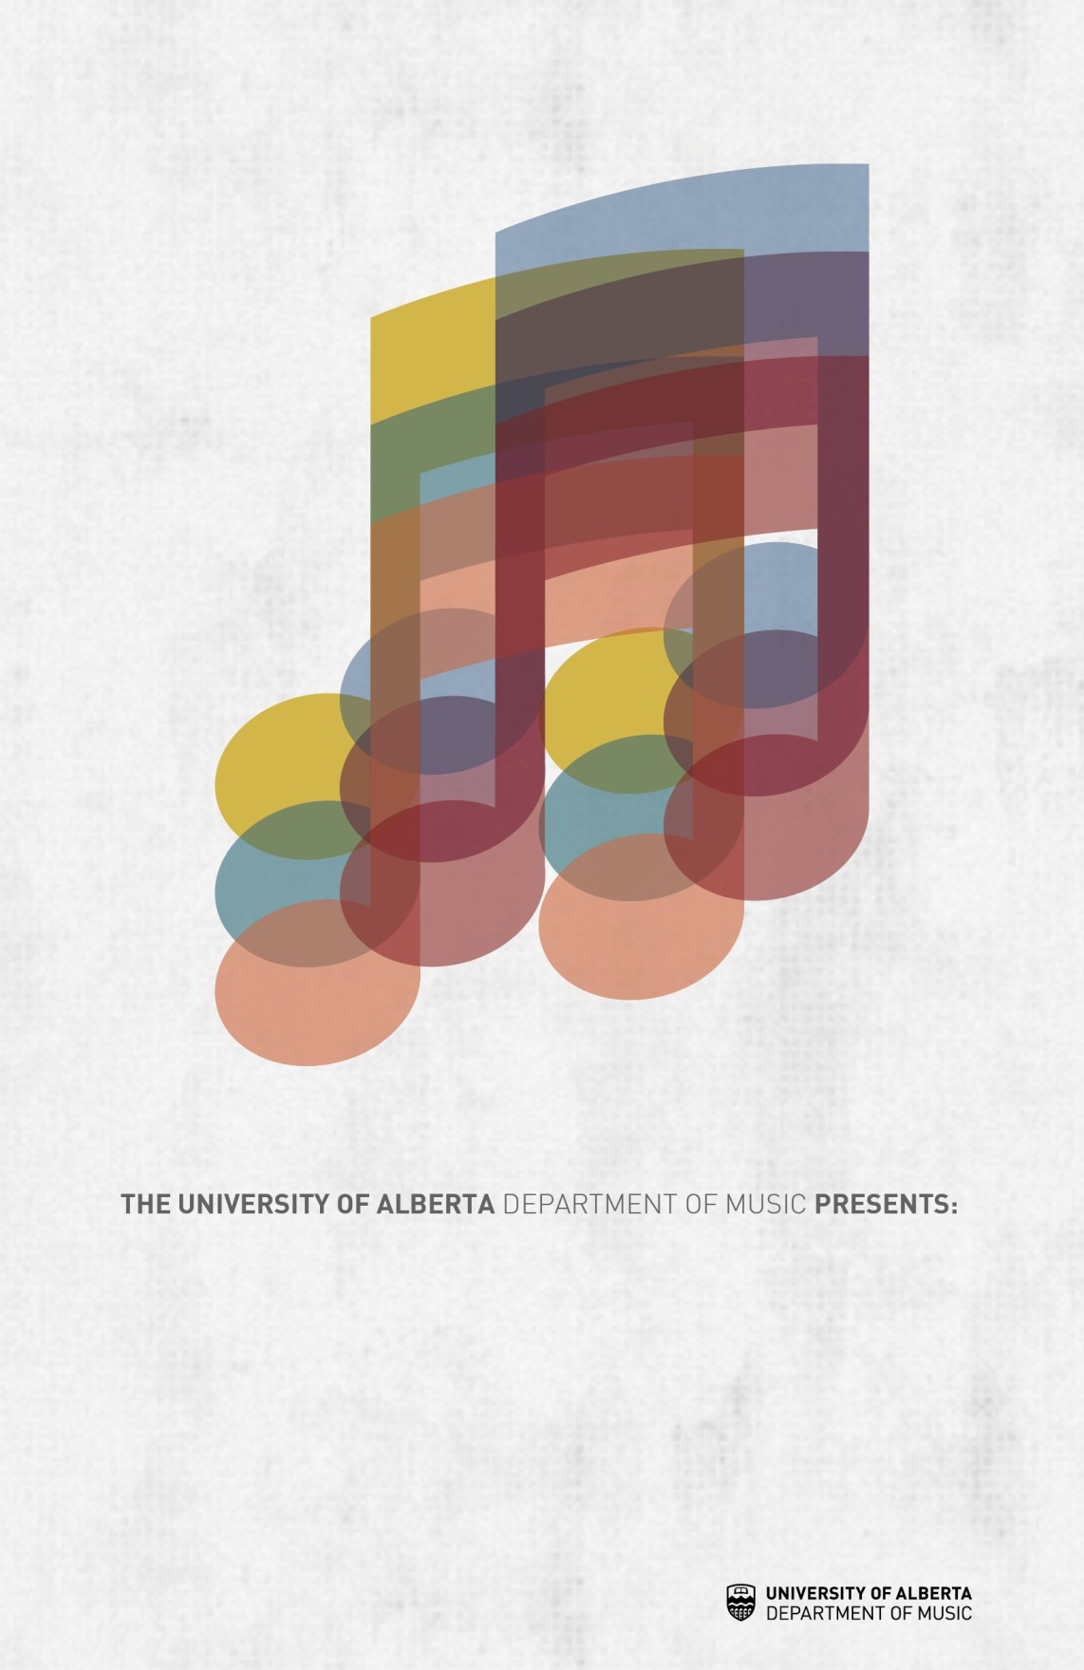

[Enter program notes, texts, bios, etc. here]



[Enter program notes, texts, bios, etc. here]

**[Concert Title Goes Here]**

[Concert date, location and time go here]

[Insert main musicians, or other important event details here]

[Enter program notes, texts, bios, etc. here]

[Enter program notes, texts, bios, etc. here]