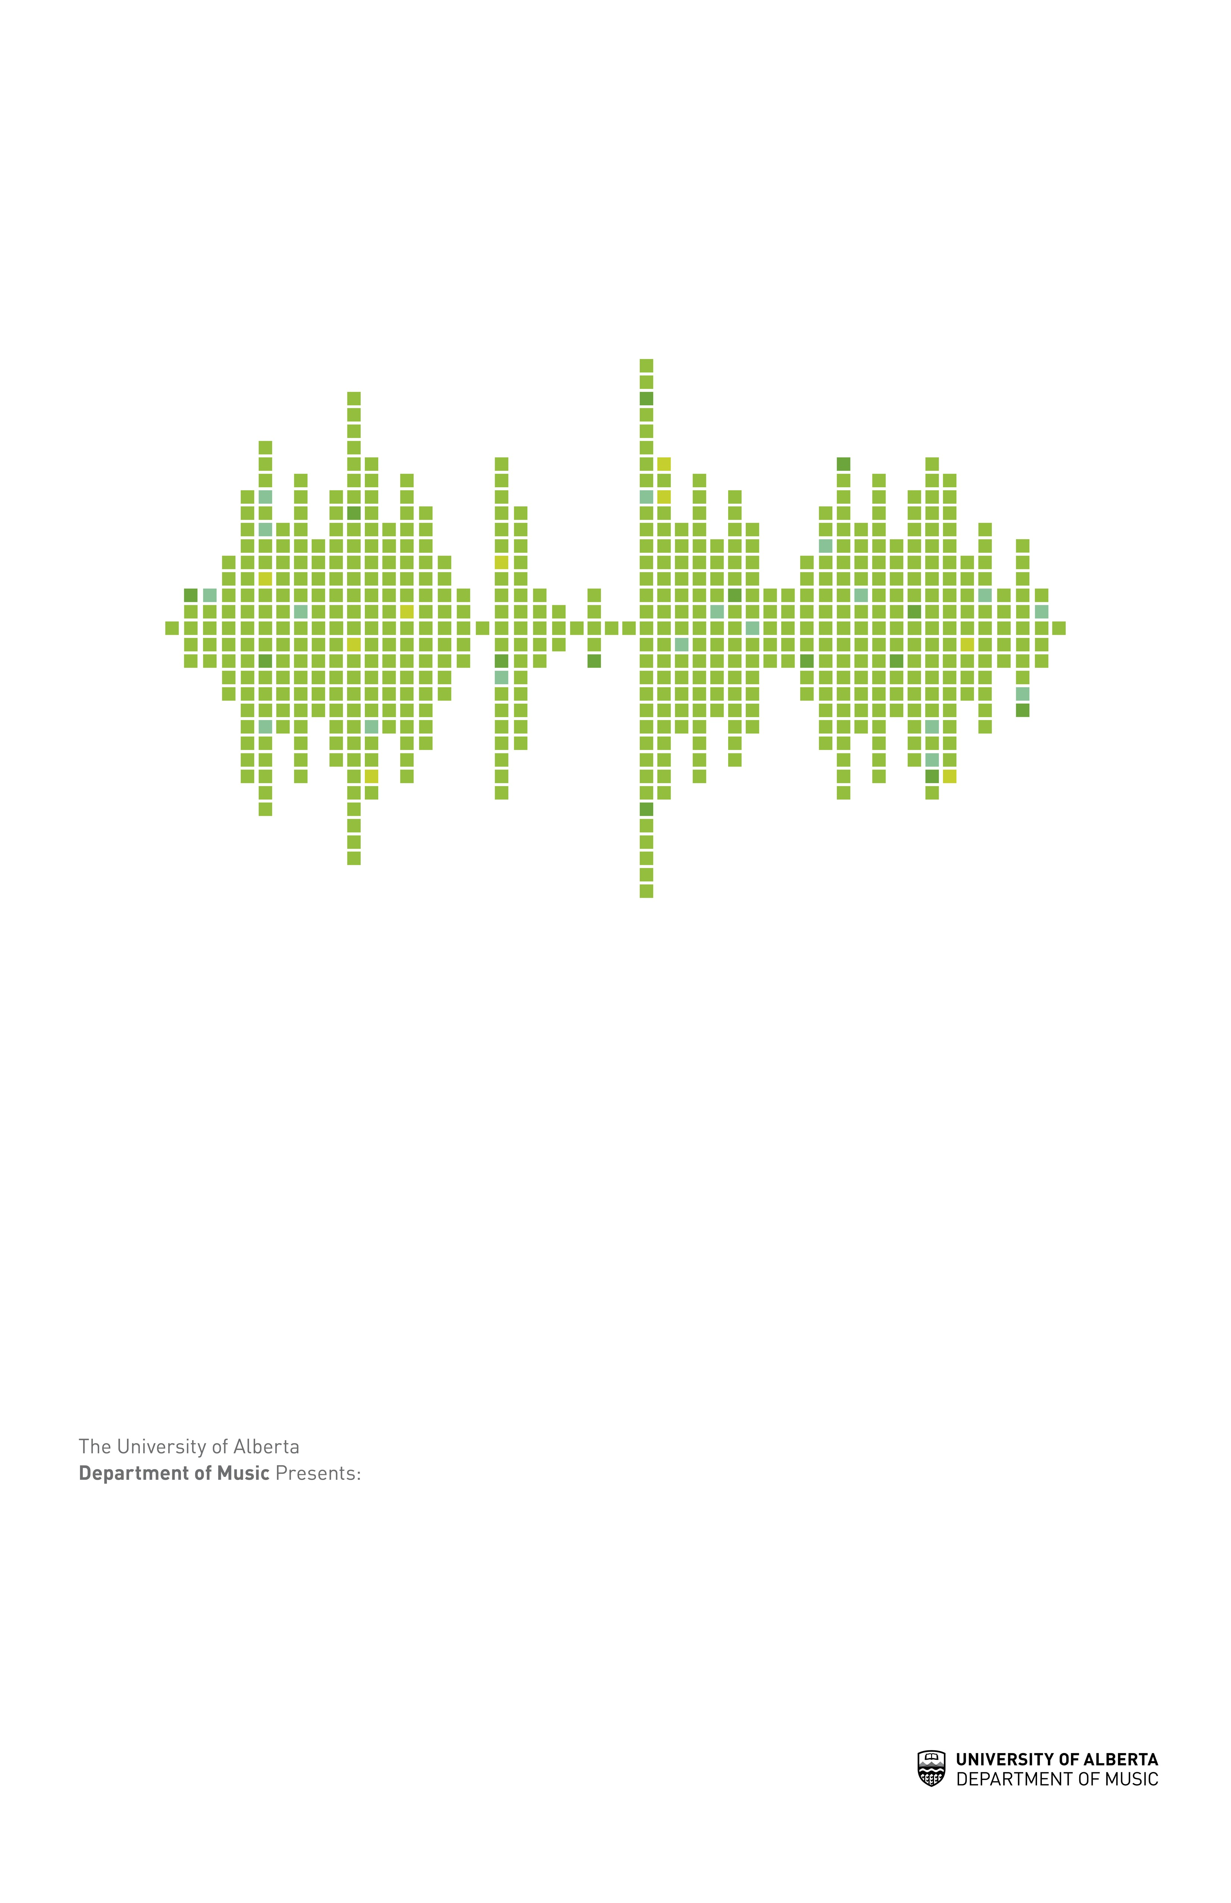

Performance Title Goes Here

Venue/Location | Time & Date

Other information goes here

