Mobile and Computer Requirements, Login Instruction, and Contact Information for

University of British Columbia (UBC) E-Tips

This course has been updated in 2014 to allow for ipad and smart phone usage. These modules have been programmed for responsive design based on the browser and operating system it automatically detects; in some cases there will be limitations on mobile devices.
- MOBILE REQUIREMENTS:

Content Format
Flash: | Flash Player 10 or later (http://www.adobe.com/go/getflash), and one of the following browsers:  - Windows: Internet Explorer 6 and later, Firefox 1.x and later, Safari 3 and later, Google Chrome, Opera 9.5 and later  - Mac: Safari 3 and later, Firefox 1.x and later, Google Chrome  - Linux: Firefox 1.x and later
HTML5: | - Google Chrome 14 or later on Windows or Mac  - Safari 5.1 or later on Windows or Mac  - Mobile Safari in Apple iOS 5.0 or later on iPad
Apple iOS: | Articulate Mobile Player; Apple iOS 5.0 or later on iPad  iPad is an amazing device that can deliver wonderfully rich, multimedia-based e-learning. However, iPad’s mobile Safari browser currently has inherent limitations that impact how multimedia appears and operates. In order to view these modules you will need to download the Articulate Mobile Player app to circumvent these limitations for the best possible experience on iPad.  Will not display correctly on mini-iPod touch
Android: | Will not display on some mini-Android screens.

- COMPUTER REQUIREMENTS:

 | PC or MAC computers will work with these modules.
Internet Access: | Broadband is recommended. 56K dialup access will work but you may notice a slighter slower speed loading the modules.
Flash Player: | Flash player is required and can be downloaded for free from Adobe.com
Adobe Reader: | Adobe Reader is required and can be downloaded for free from Adobe.com
PopUp Blockers: | You may need to turn off any pop up blocker that you have on your browser to use some sections of the courses.

C) ACCESS:

- Open your web browser

- When you click on the link provided by your organization, you will be directed to the following page. We have opened the course to everyone so no login ID is required. Click on “Login” OR “Get Started”:

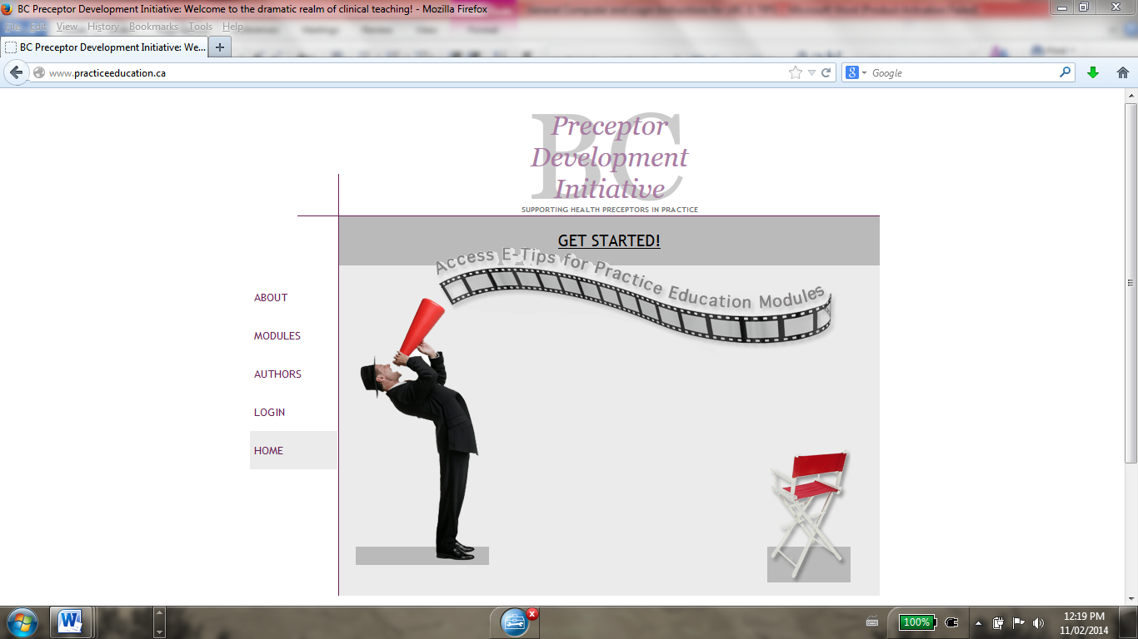

Please note, E-TIPs can also be entered from the portal www.preceptoreducation.com which is a portal to preceptor courses.

- You will then be re-directed to the course site. Click on “E-Tips for Practice Education” to launch the modules.
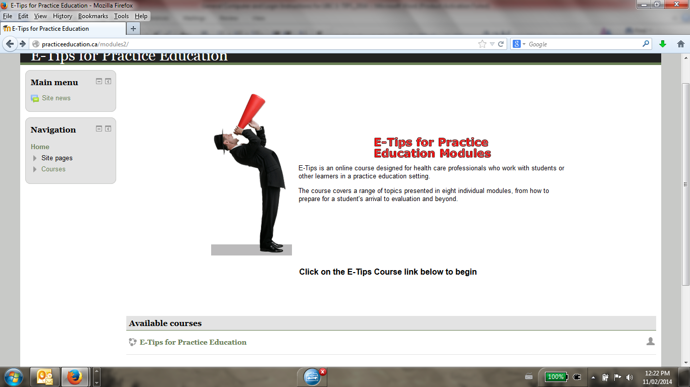

D) ERROR MESSAGES AND SECURITY SETTINGS:
If you receive an error message when trying to get to the course site, you will likely have to modify your computer’s security settings to access this site.
  - Ensure you have enabled cookies for this site in your browser. Depending on which search engine you use, the directions to enable cookies will look something like this:
  - Click the Tools menu. (On a MAC, click the Firefox menu.)
  - Select Options. (On a MAC, select Preferences.)
  - Click the Privacy tab.
  - Select the 'Accept cookies from sites' checkbox.
  - Click the OK button.
  - Once you have allowed cookies for this site, try to go into the site.
D) CONTACT INFORMATION

If you have any questions or are having problems connecting on this course, please contact the Project Lead and Primary Investigator:
Rosemin Kassam, B.Sc. Pharm, PharmD, ACPR
Associate Professor
Faculty of Medicine, School of Population and Public Health
University of British Columbia
Contact information: rosemin.kassam@ubc.ca

Permission is also required from the Project Lead to copy, modify or replicate any part of this program. This program is available free of cost. If you are an individual, organization, or a school interested in using all or part of this material for teaching and learning purposes we ask that you register with the Project Lead to allow us to provide you with periodic updates of material and/or of new courses. Your personal information will not be shared with any third parties.

