Functions in Excel
The objective here is to give you exposure to different kinds of functions in excel and give you a strategy and some tactics to find the function to do the math you want.
Can Excel do the math you want? Yes, hands down. The challenge is to find the function to do it.

Using Logical Functions (IF and SUMIF)
The IF function is a conditional function or logical function because it will evaluate a condition you specify and return one value if the condition is true and another value if the condition is false.
For example, you could use the IF function to determine a salespersons bonus of 5% but only when they qualify by having a total more than a certain amount. IF will look at the total sales, determine if it is more than the required benchmark, calculate the bonus if they reached the benchmark, or do nothing if they don’t.
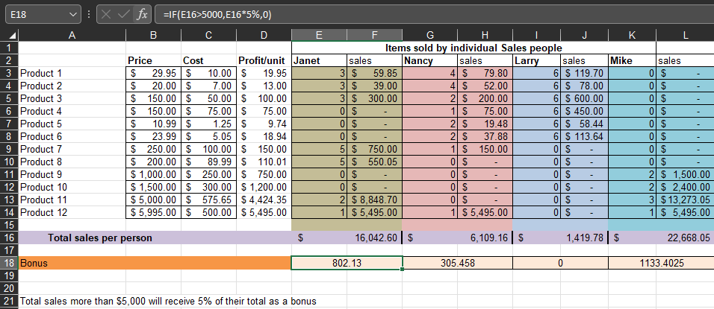
The IF function is one of the more difficult functions, but it’s also very powerful.
=IF(E16>5000,E16*5%,0)
Logical Test
Value or expression that can be evaluated to True or False
Value if False
Value that is returned if Logical Test is False
Value if True
Value that is returned if Logical Test is True

Sumif adds the cells specified by a given condition or criteria.
=SUMIF(G4:G27,"bob",F4:F27)
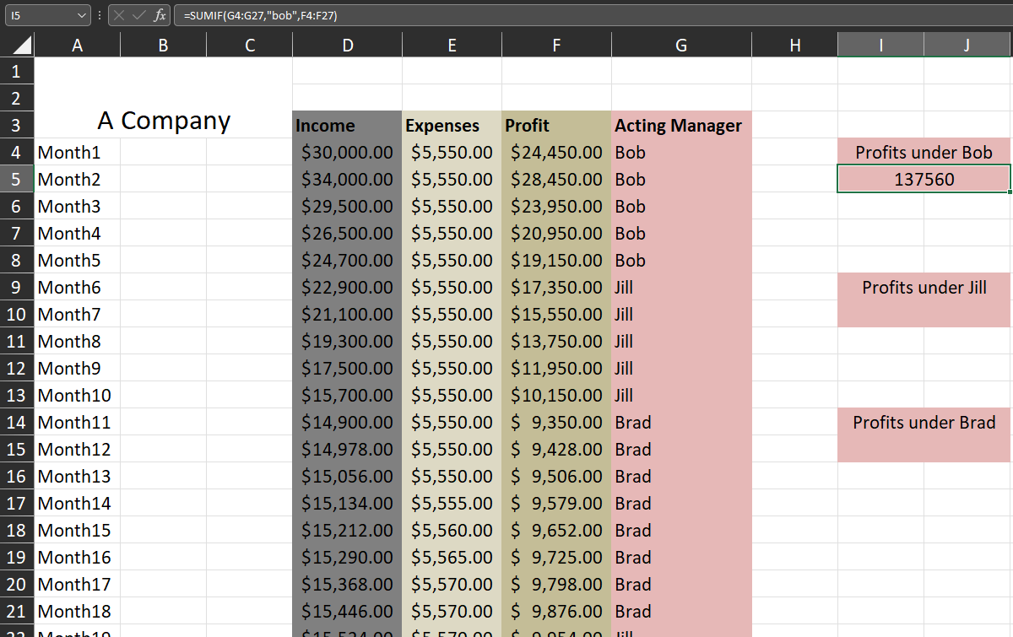
This is a small dataset. Imagine if you had 250,000 rows with Bob’s name appearing throughout the column G and you needed to add up his profit. No sorting allowed!

Using Database Functions (DSUM)
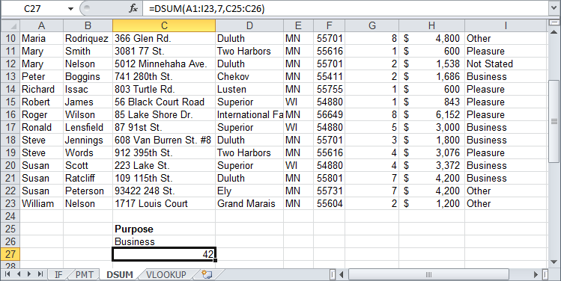
Excel’s database functions perform calculations only for records that meet the criteria you specify. All the database functions use the same basic syntax: =Function(database, field, criteria). These arguments (parts) of a database function include:
C27 displays the number of records in the Annual Trips column (column I) that match the criteria in C26.
=DSUM(A1:I23, "Annual Trips", C25:C26)
Field
the name or number of the column that is used in the function
Criteria
the range of cells that contains the conditions you want to specify
Database
the range of cells that make up the list

Using Lookup Functions (VLOOKUP)
The VLOOKUP function looks up information in a worksheet. The VLOOKUP searches vertically down the left most column of a cell range until it finds the value you specify. When it finds the specified value, it then looks across the row and returns the value in column you specify. The VLOOKUP function works a lot like looking up a number in a phonebook: first you look down the phonebook until you find the person’s name, then you look across to retrieve the person’s phone number.
Tip: It’s important to understand that VLOOKUP only looks down the column that is farthest left in the specified table array. In then looks across that row.
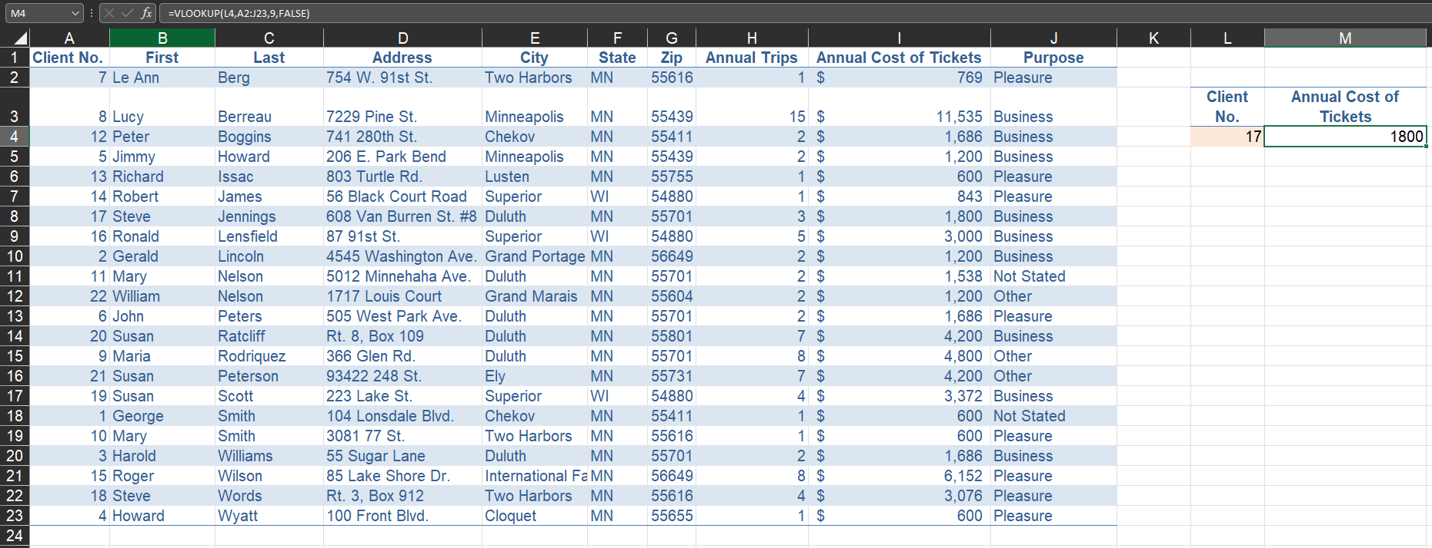
Range Lookup [optional]
Determines whether the lookup value can be an approximate or must be an exact match
=VLOOKUP(L4,A2:J23,9,FALSE)
Table Array
The cell range in which data is looked up
Lookup Value
The value to be found in the first column of the table array
Column Index Number
The number of the column from which the matching value must be returned

Finding the “right” Function
There are several hundred functions available in Excel. Some are simple, such as the SUM function. Others are much more complex and contain several different arguments.
Fortunately, the Insert Function command is available to help you find, select, enter, and edit worksheet functions.

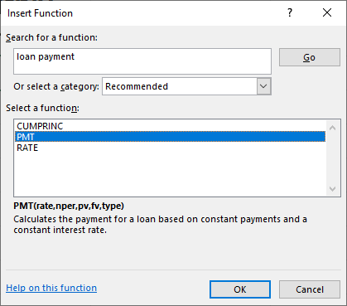
To find the “right” Function in the Insert Function Dialog Box:
Type a description of the function in the “Search for a function” text box and click Go. The related functions appear in the “Select a function list.”
Select a function in the “Select a function” list and read the definition provided. Further, look at the arguments illustrated in brackets above the definition.
This is the beginning of your research to find the function that you need to do the math that you want.
Notice the link Help on this function.
Use the link to further research and watch Youtube videos to help determine if you have the “right” function.
When you click on OK the Function Arguments dialog box appears. Here you need to enter the arguments, which are the values or cell references needed to calculate the function.
Tip: Instead of typing argument values into the dialog box, you can click a Collapse Dialog button, select a cell range in the worksheet, and then click the Expand Dialog button.
Enter the arguments in the text fields and click OK.

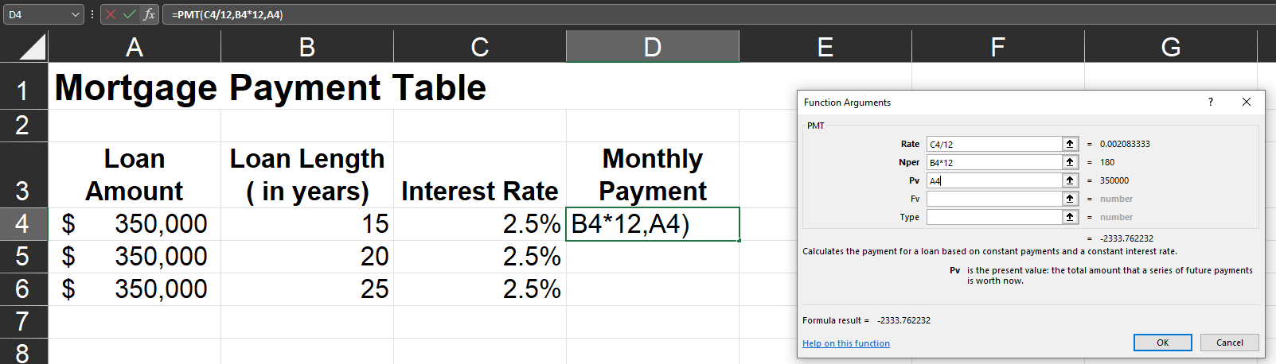
The function is inserted into the cell.

Using Financial Functions (PMT)
The PMT function is a very valuable function if you work with real estate, investments, or are considering taking out a loan. The PMT function calculates the payment for a loan based on periodic payments and a constant interest rate. For example, say you want to take out a $10,000 car loan at 8% interest and will pay the loan off in four years. You can use the PMT function to calculate that the monthly payments for such a loan would be $244.13.
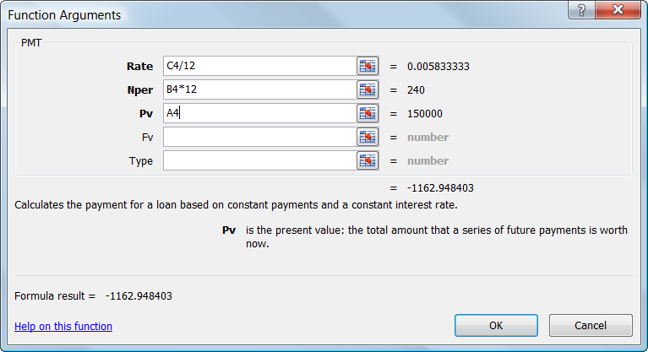
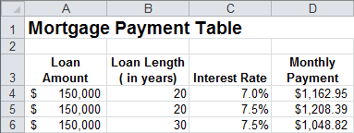
You can also use the PMT function to determine payments to annuities or investments. For example, if you want to save $50,000 in 20 years by saving the same amount each month, you can use PMT to determine how much you must save.
=PMT(C4/12,B4*12,A4)
Rate
The interest rate per period
Nper
The number of payments
Pv
The present value of loan amount, or principal

Date & Time Functions (TODAY)
You can use dates and time in your formulas just like any other value. For example, if cell A1 contained the entry 5/1/12 you could use the formula =A1+100 to calculate the date 100 days later, which is 8/9/12.
One very important thing to know about working with date and time functions: while Excel can display dates and times using just about any format, it actually stores dates as chronological numbers called serial values. Day number 1 was January 1, 1900. So when you think of dates as months, days, and, years, such as May 1, 2012, Excel thinks of dates in terms of serial numbers, such as 36281.
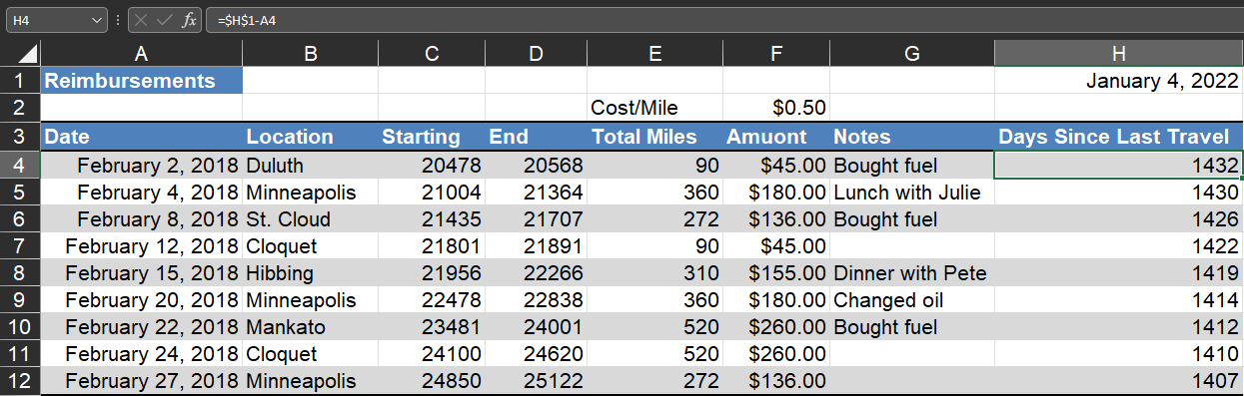
Since the date and time formulas often return serial number values, you should format any cells with date or time formulas with data and time formats that you can easily understand. You can also create custom number formats to display the results of date formulas. For example, the custom format dddd would display only the day, Monday, instead of the entire date, 8/9/2012.
In the example above, H1 contains the formula =TODAY(). The TODAY function with no arguments will always show the current date.
Because =TODAY() is a serial number we can use it in a formula. The formula in H4, =$H$1-A4, determines how many days have gone by since February 2, 2018
=$H$1-A4

Text Functions (CONCAT)
Excel offers a category of functions aimed at working with text. These functions allow you to remove, combine, and replace different pieces of text in a worksheet.
The function CONCATENATE may appear in your list of functions. Note that it will be phased out and replaced with CONCAT. If you have both, use CONCAT.
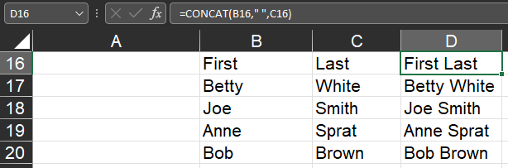
=CONCAT(B16," ",C16)

