Notes for video 2.1.: http://tinyurl.com/rr480/videos/datatables

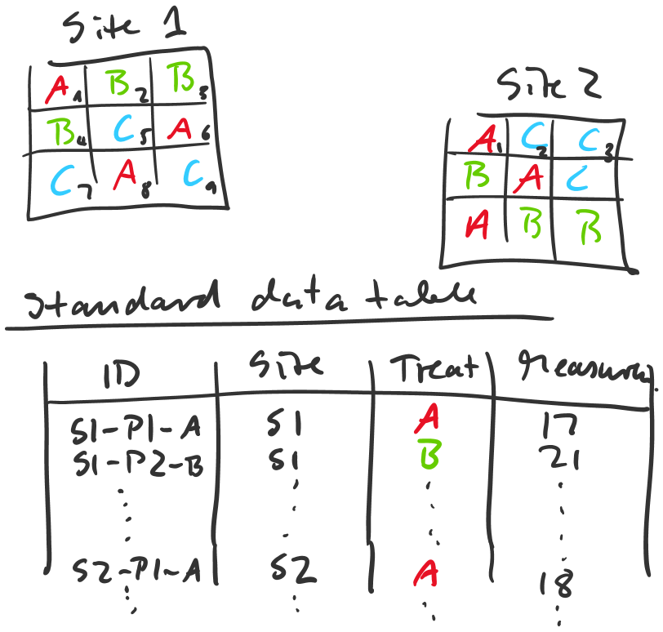

 | S 1 |  |  |  | S 2 |  |  |  | S 3
17 | 21 | 23 |  | 18 | 6
20 | 13 | 9 |  |  | 8
16 | 6 | 21
 |  | Harvesting treatment A |  |  |  |  | Recorded: Occurrence of red-listed species
 |  | Harvesting treatment B
 |  | Harvesting treatment C

Example for a standard data table with order column, informative ID, independent and dependent variables, all in separate columns. Simple variable names facilitate programming. This data table is saved in CSV format. A second Excel spreadsheet with the same name may contain the same data table with more elaborate variable names, color coding and formatting, and additional worksheets for metadata, comments and experimental layout maps and information.
ORDER | ID2 | SITE | REP | SEEDLOT | TREAT | TREAT2 | DBH2008 | HT2008
1 | 1-S10-R1-Lot772-W3-ll | S10 | R1 | Lot772 | W3 | ll | 0 | 4.45
2 | 2-S10-R1-Lot789-E2 | S10 | R1 | Lot789 | E2 |  | 0 | 4.2
3 | 3-S10-R1-Lot787-K3-lll | S10 | R1 | Lot787 | K3 | lll | 0 | 6.4
4 | 4-S10-R1-Lot776-A2-lll | S10 | R1 | Lot776 | A2 | lll | 0 | 0
5 | 5-S10-R1-Lot779-A5-lll | S10 | R1 | Lot779 | A5 | lll | 0 | 5.25
6 | 6-S10-R1-Lot778-A4-lll | S10 | R1 | Lot778 | A4 | lll | 0 | 4.8
7 | 7-S10-R1-Lot793-B1-l | S10 | R1 | Lot793 | B1 | l | 0 | 4.1
8 | 8-S10-R1-Lot774-W5-ll | S10 | R1 | Lot774 | W5 | ll | 0 | 5.8
9 | 9-S10-R1-Lot788-E1 | S10 | R1 | Lot788 | E1 |  | 0 | 5.9
10 | 10-S10-R1-Lot791-E4 | S10 | R1 | Lot791 | E4 |  | 0 | 6.3
11 | 11-S10-R1-Lot769-M5-ll | S10 | R1 | Lot769 | M5 | ll | 0 | 5.3
12 | 12-S10-R1-Lot783-P4-lll | S10 | R1 | Lot783 | P4 | lll | 0 | 4.85
13 | 13-S10-R1-Lot777-A3-lll | S10 | R1 | Lot777 | A3 | lll | 0 | 5.1
14 | 14-S10-R1-Lot770-M6-ll | S10 | R1 | Lot770 | M6 | ll | 0 | 6.6
15 | 15-S10-R1-Lot786-K2-lll | S10 | R1 | Lot786 | K2 | lll | 0 | 5.75
16 | 16-S10-R1-Lot773-W4-ll | S10 | R1 | Lot773 | W4 | ll | 0 | 5.85
17 | 17-S10-R1-Lot777-A3-lll | S10 | R1 | Lot777 | A3 | lll | 0 | 5.05
18 | 18-S10-R1-Lot787-K3-lll | S10 | R1 | Lot787 | K3 | lll | 0 | 5.7
19 | 19-S10-R1-Lot779-A5-lll | S10 | R1 | Lot779 | A5 | lll | 0 | 5.45
20 | 20-S10-R1-Lot770-M6-ll | S10 | R1 | Lot770 | M6 | ll | 0 | 6.4
21 | 21-S10-R1-Lot767-M3-ll | S10 | R1 | Lot767 | M3 | ll | 0 | 5.45
22 | 22-S10-R1-Lot779-A5-lll | S10 | R1 | Lot779 | A5 | lll | 0 | 3.75
23 | 23-S10-R1-Lot763-T3-l | S10 | R1 | Lot763 | T3 | l | 0 | 2.6
24 | 24-S10-R1-Lot781-P2-lll | S10 | R1 | Lot781 | P2 | lll | 0 | 0
25 | 25-S10-R1-Lot773-W4-ll | S10 | R1 | Lot773 | W4 | ll | 0 | 5.7

