Notes corresponding to video http://tinyurl.com/mv690/video/distance

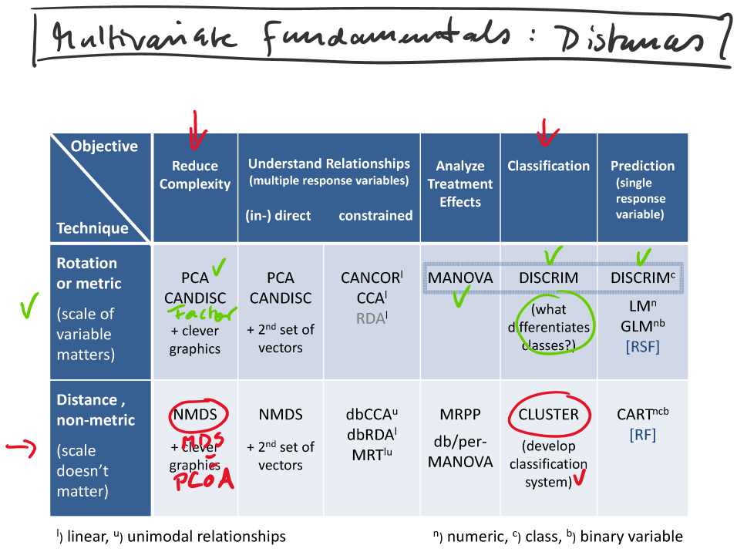

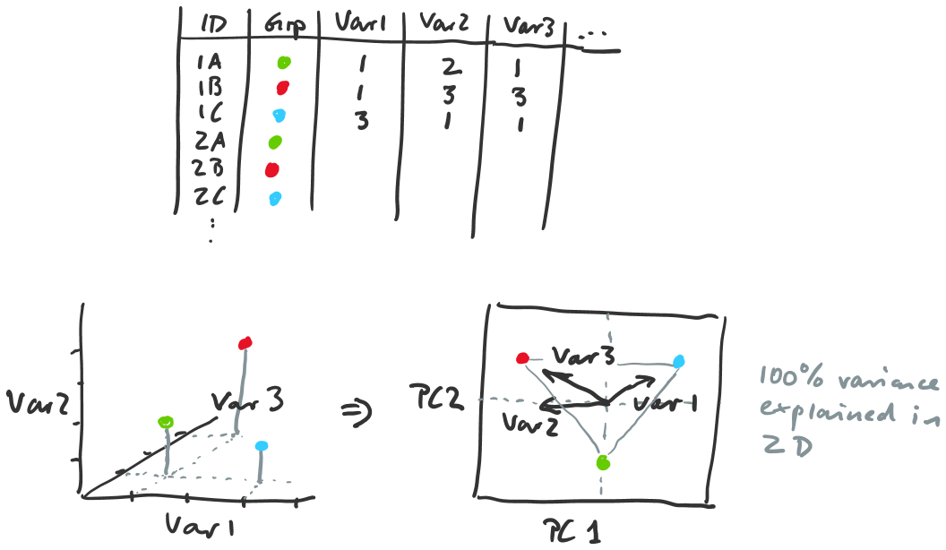

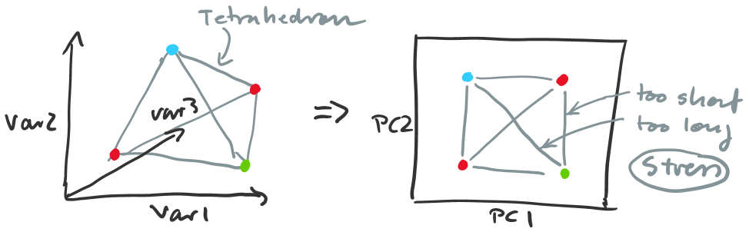

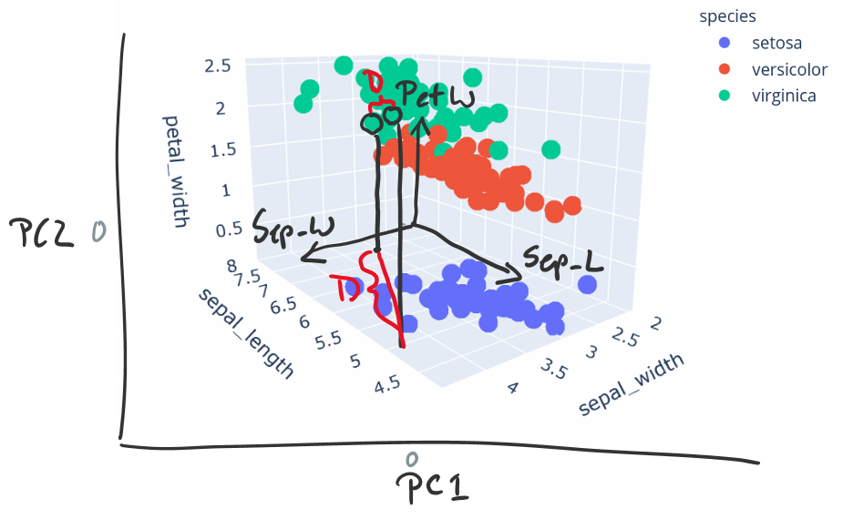

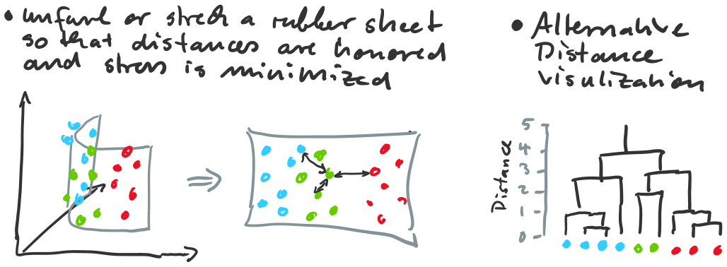

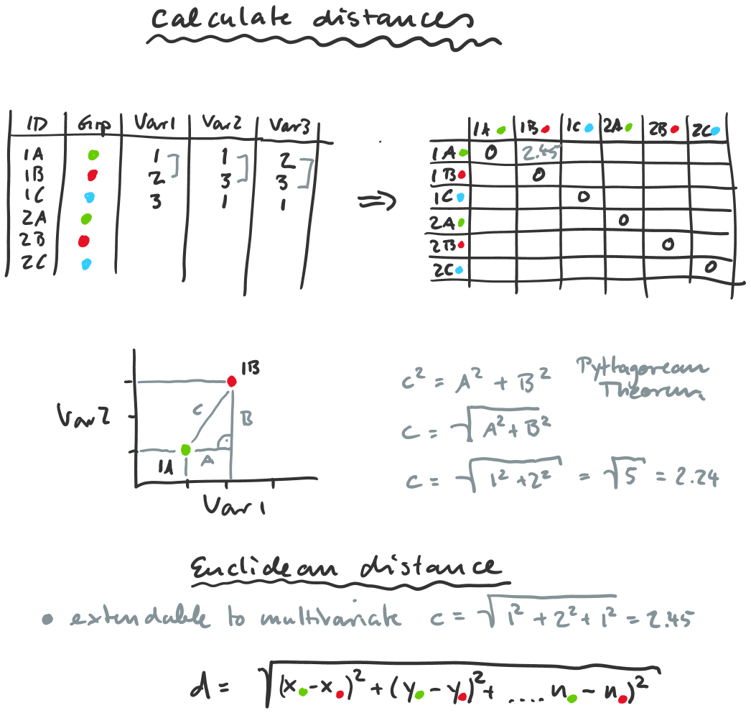

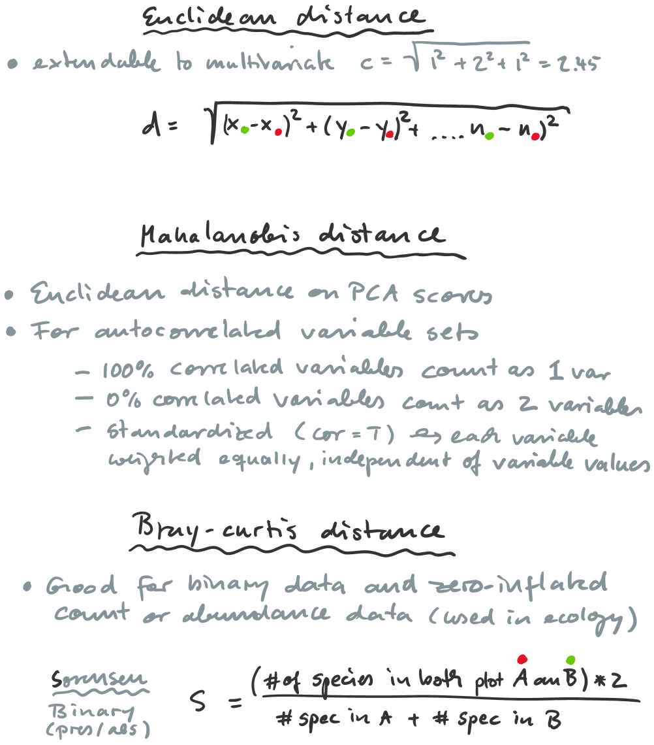

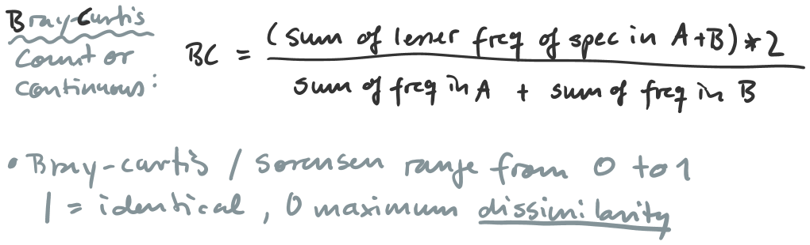

library(ecodist)

dm = distance(dat1[,3:5], method="euclidean")
dm = distance(dat1[,3:5], method="mahalanobis")
dm = distance(dat1[,3:5], method="bray-curtis")

dm_sq = dm^2
dm_sqrt = sqrt(dm)

