**Notes corresponding to video** <http://tinyurl.com/mv690/video/cluster>



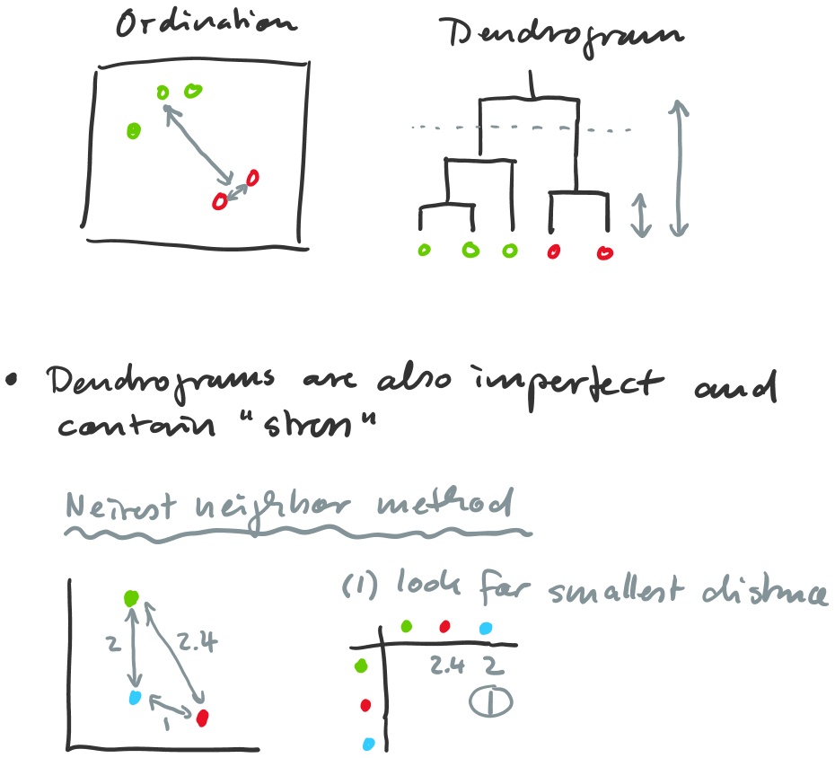

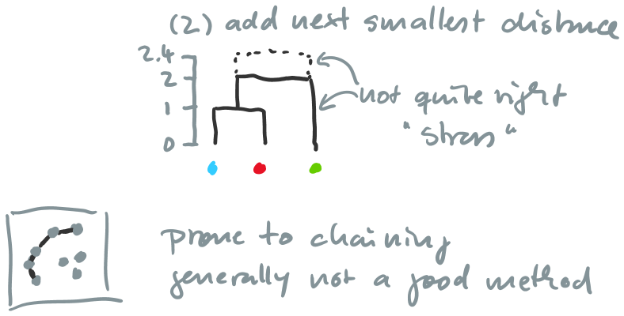

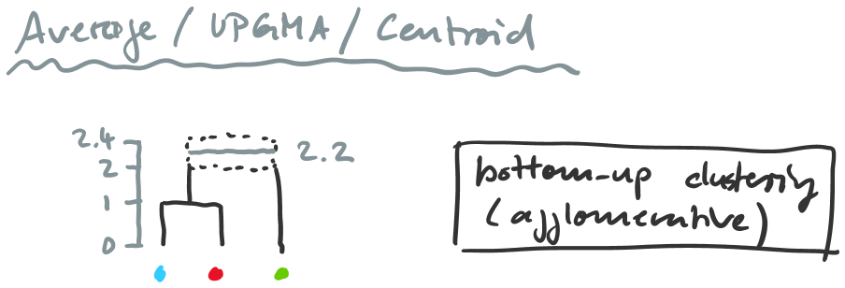

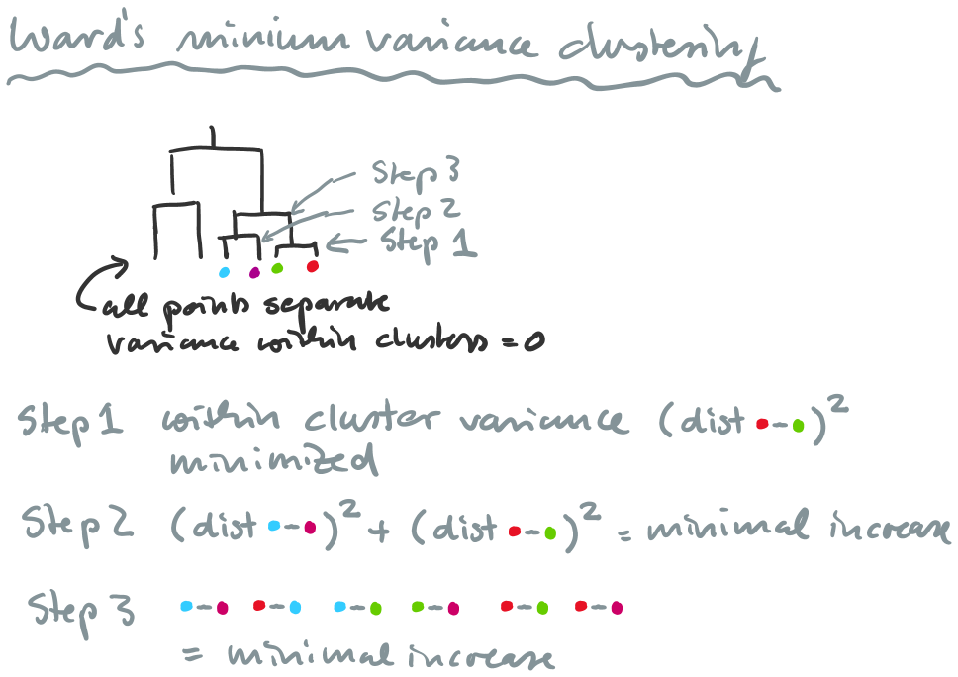

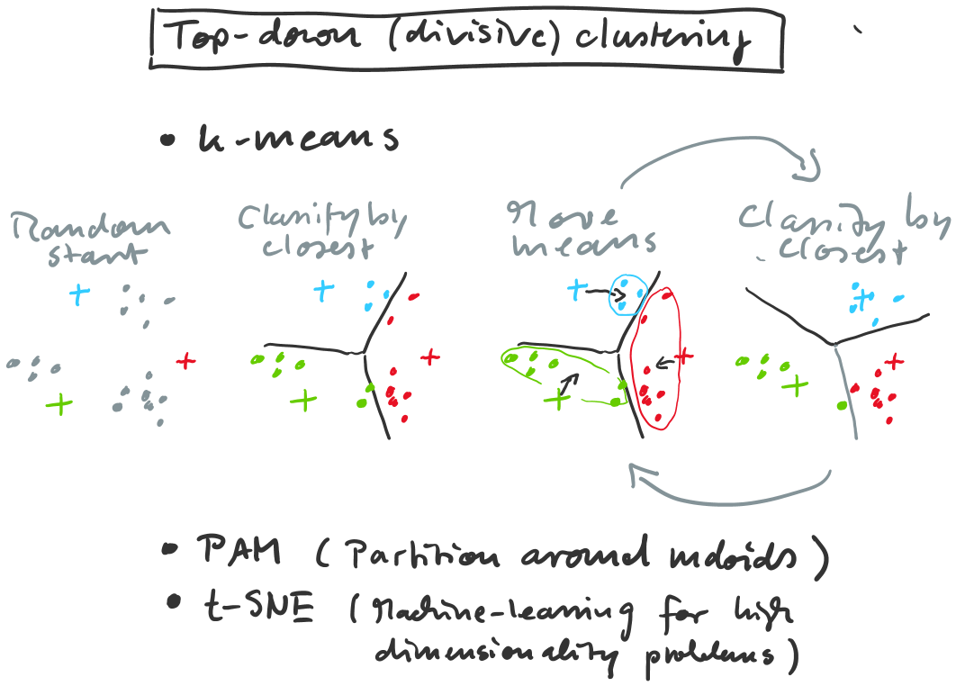

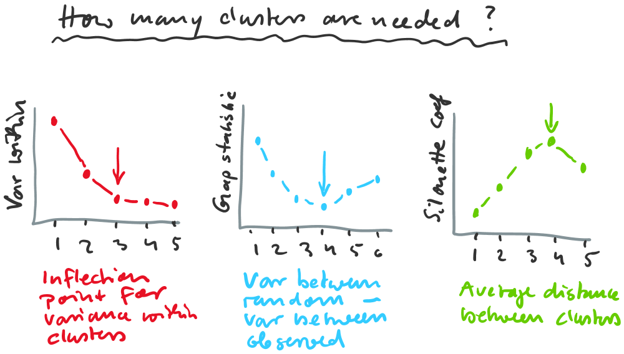

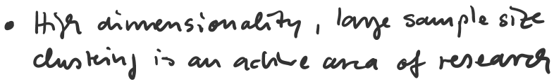

MiniBatchKMeaMinityPropagation MeanShift SpectralClustering 
.01s 
6.88s 
.18s 
.45s 
Ward AgglomerativeClusterin$)BSCAN 
.13s 
.lls 
.01s 
OPTICS 
1.54s 
Birch 
GaussianMixture 
.03s 
.01s 
.02s 
4.33s 
.23s 
.15s 
.82s 
.64s 
.02s 
1.51s 
.04s 
.01s 
.01s 
.01s 
3.51s 
3.09s 
.29s 
.18s 
.27s 
.21s 
.16s 
.15s 
.13s 
.10s 
.03s 
.02s 
1.59s 
1.58s 
.04s 
.04s 
. oos 
.01s 